2022

Hari Krishna

1/27/2022

Jenkins Lab



First Install the Jenkins & Maven & Java 8 and tomcat servers for this lab.

Maven sample project downloaded from <https://github.com/gabrielf/maven-samples>

I had forked the git project to my github repository.

<https://github.com/harikrishna83/maven-samples>

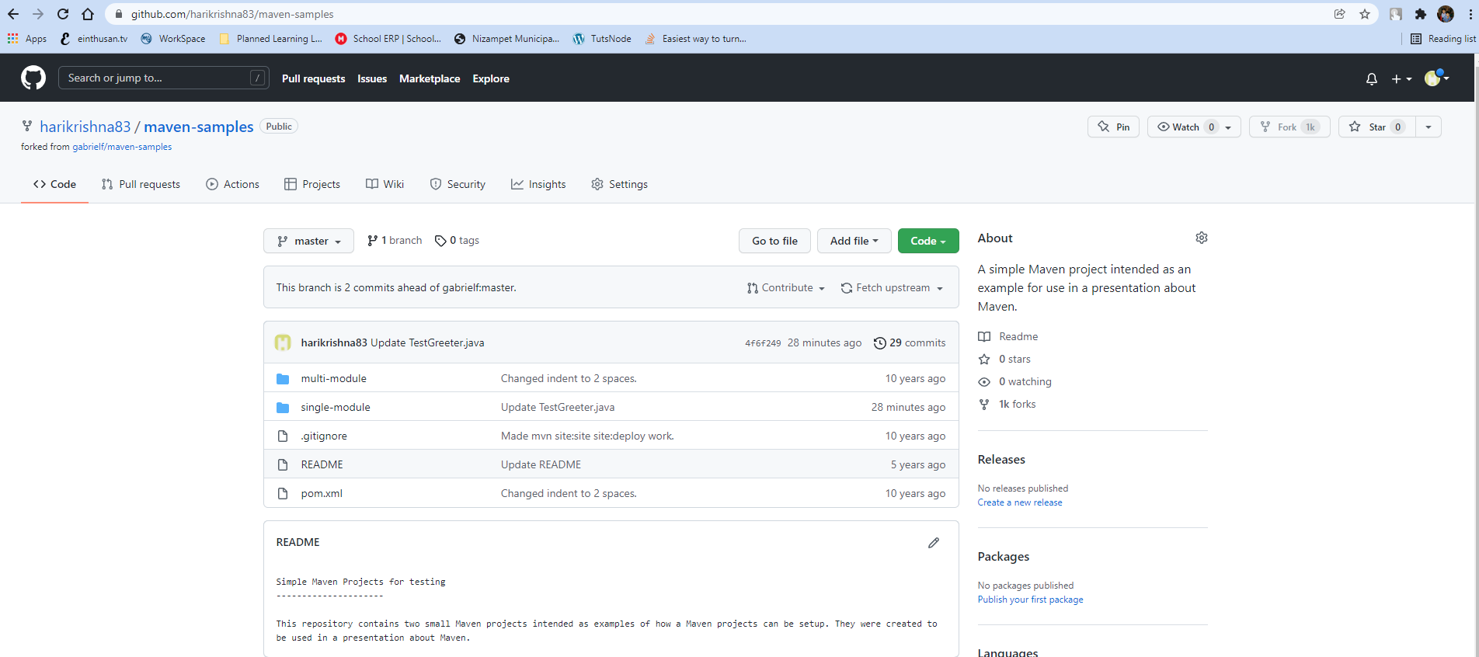

Installed Java 11 (jdk-11.0.13) at the path C:\Program Files\Java and configure system variables.

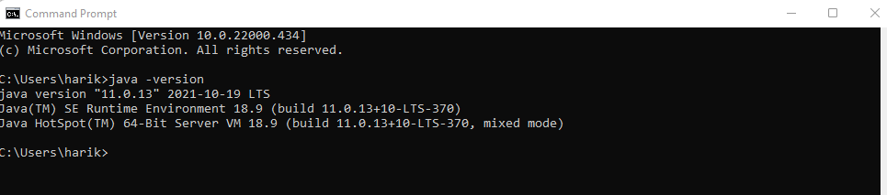

Installed Maven at the following location (D:\Maven_server\Maven), also configured MAVEN_HOME and other variables.

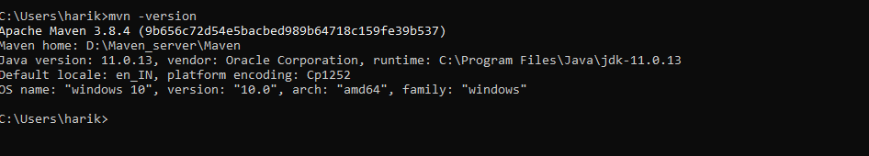

Installed latest Jenkins on windows (Note: I had download generic war file) and started the Jenkins with the below command:

D:\Jenkins_server> java -jar Jenkins.war--httpPort=9090

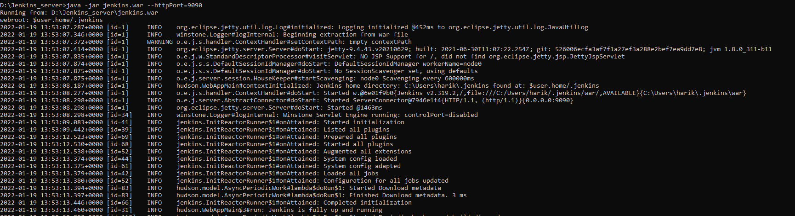

Now login to Jenkins with the below URL:

<http://localhost:9090>

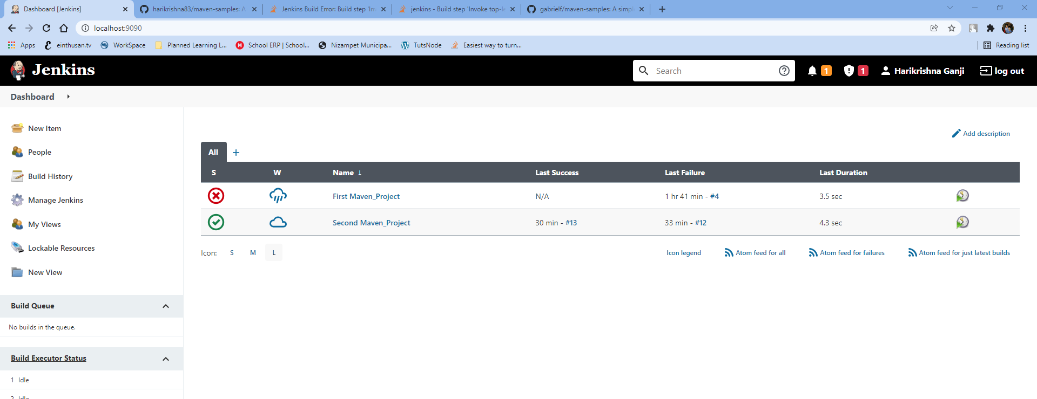

Now you need to configure the new jobs by clicking on “New Item”, but before that configure the global parameters. Once you logged in configure the Jenkins Global parameters by clicking on “Manage Jenkins” as shown below.

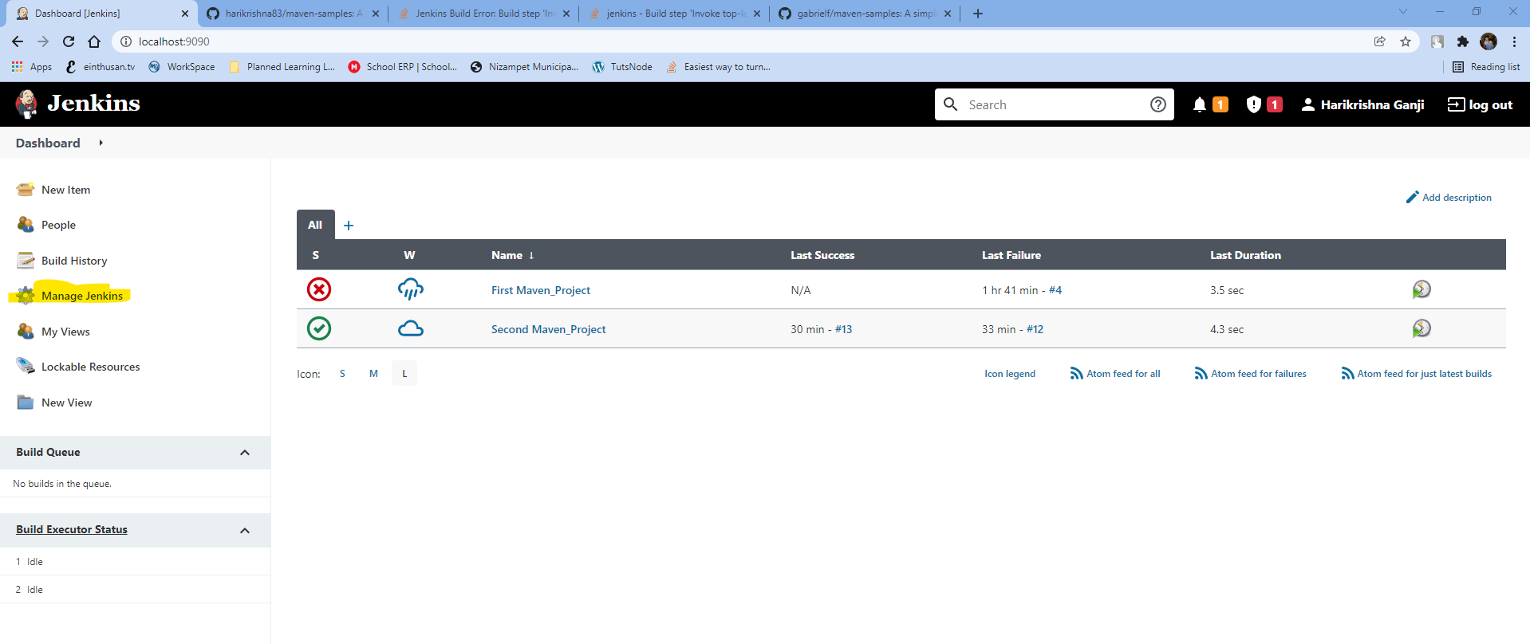

Then click on “Global Tools Configuration” as shown below.

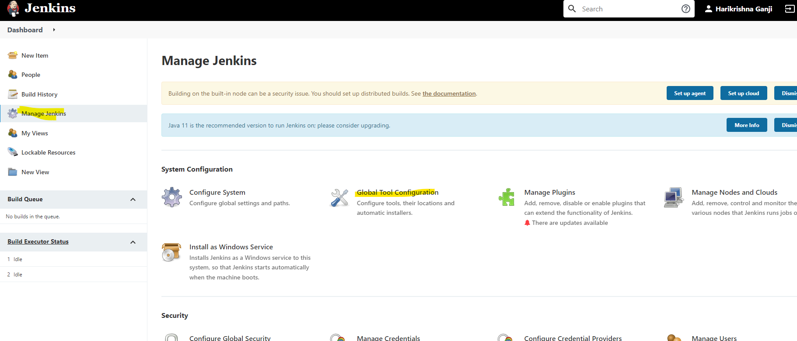

Now you need to link java, GIT, Maven with your Jenkins servers, for that follow it as shown below.

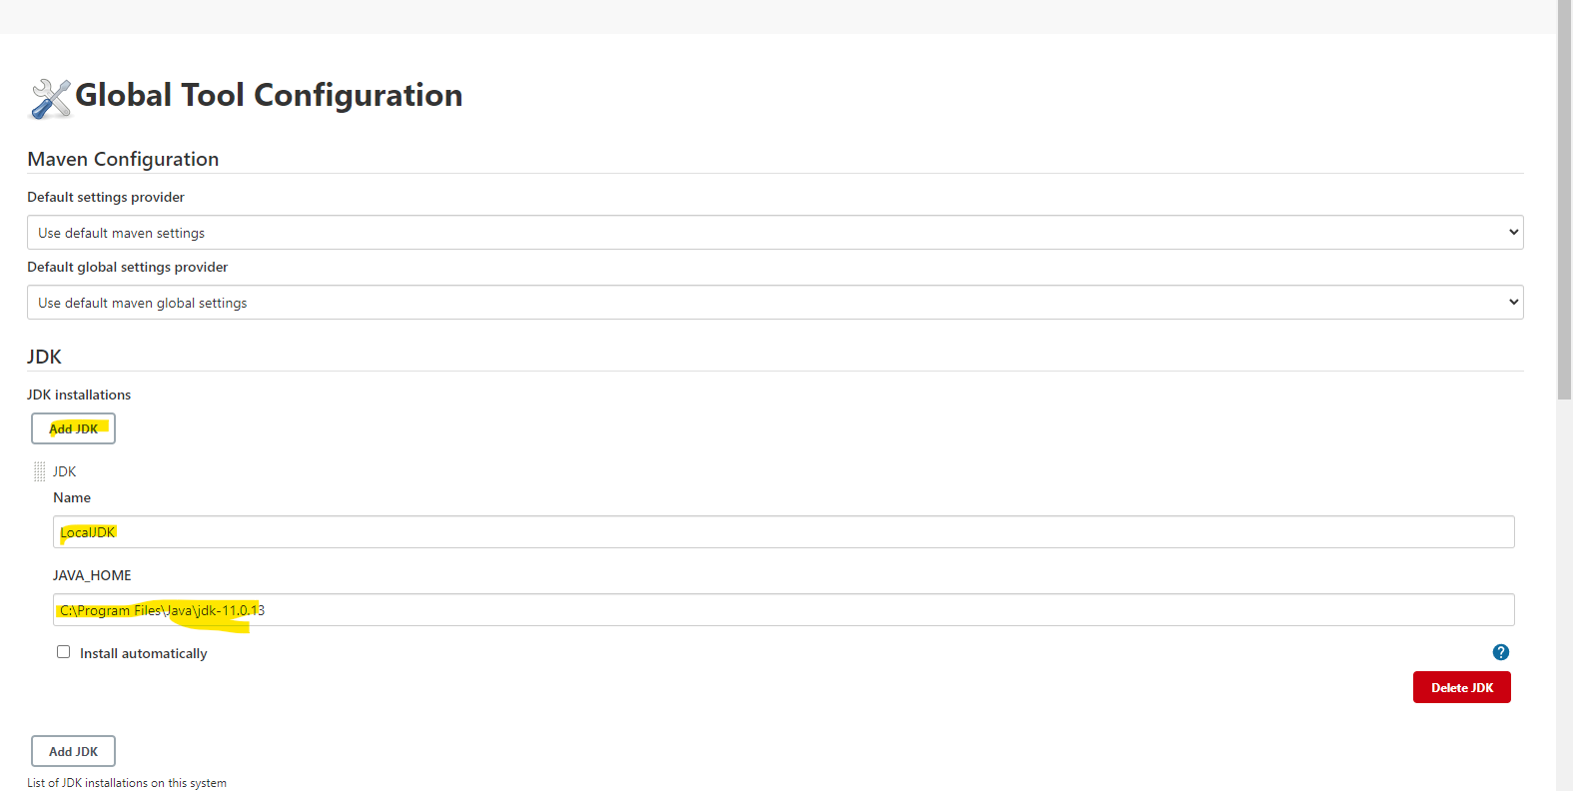

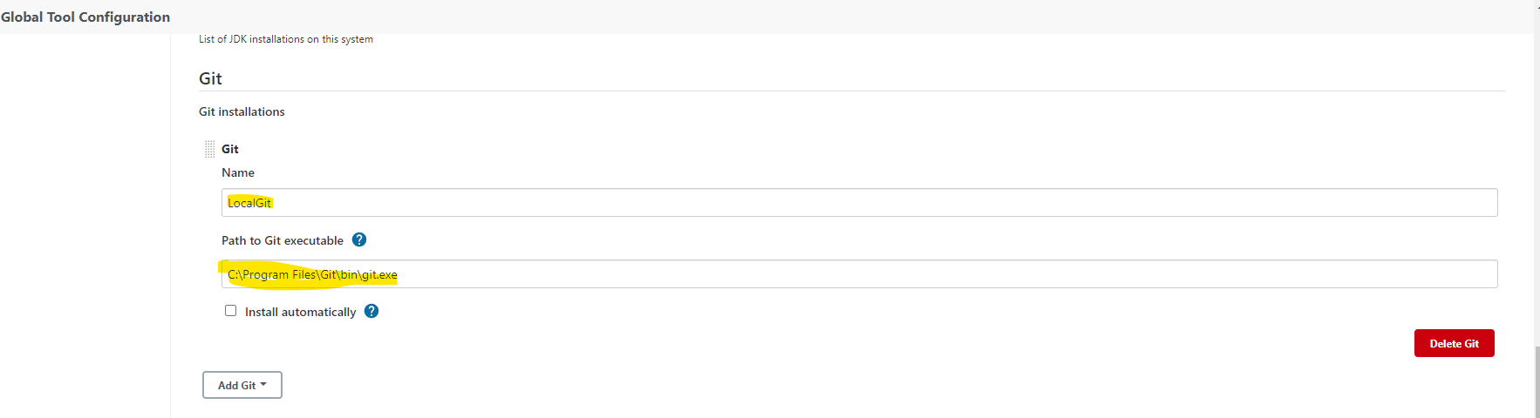

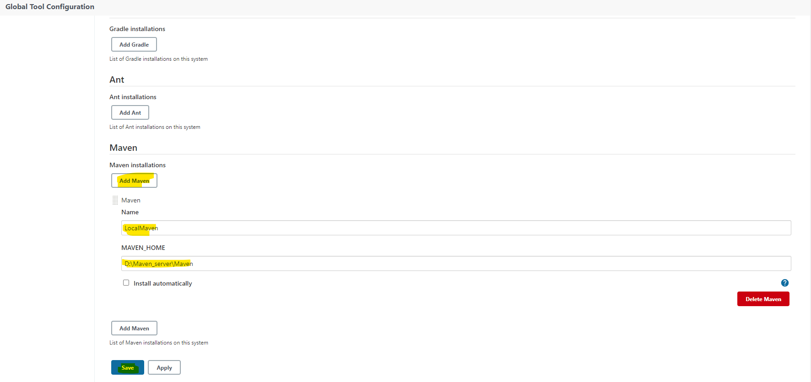

Once you configured without any error, click on save.

Now it’s time to configure the new job on Jenkins by clicking on “new Item” as shown below.

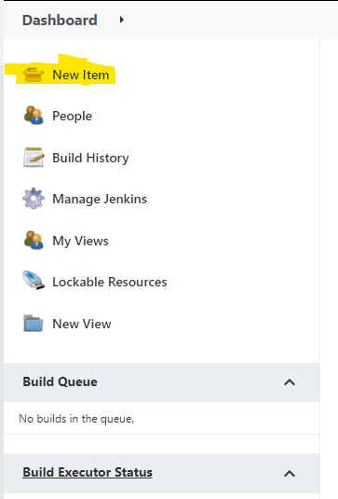

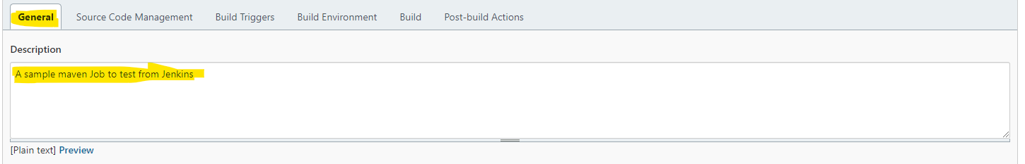

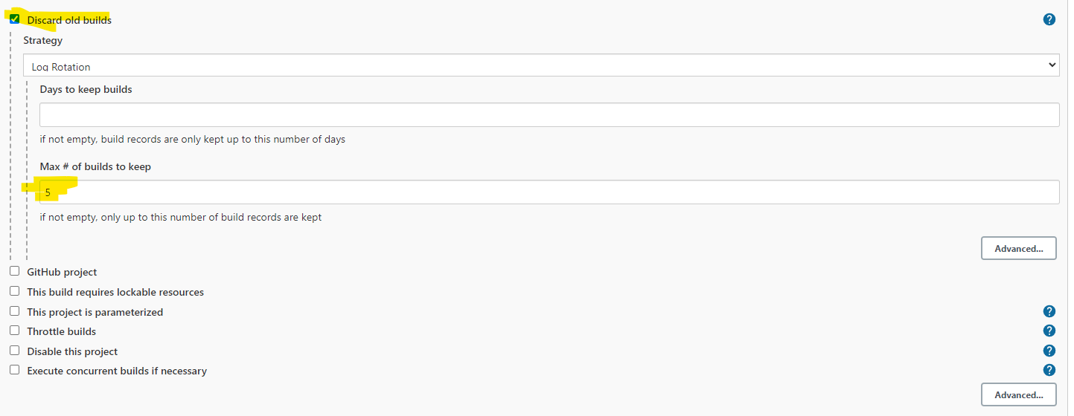

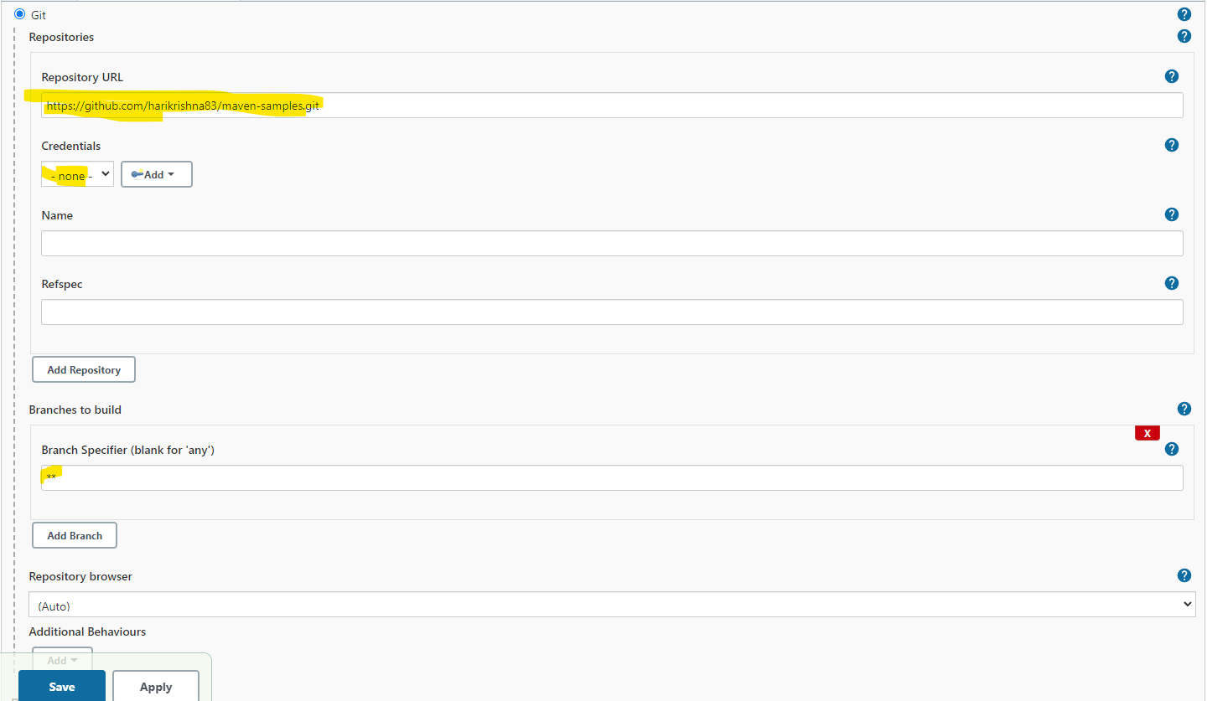

Now we are choosing the option “Poll SCM”, with a schedule of every Minute. So it will keep on checking GIT SCM repository for committed changes. Once it finds it will immediately trigger the build without any manual intervention.

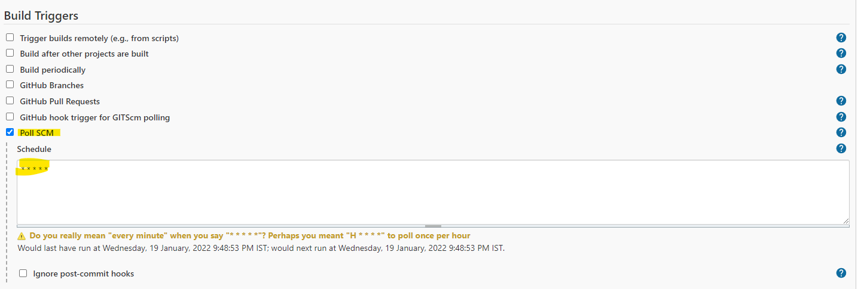

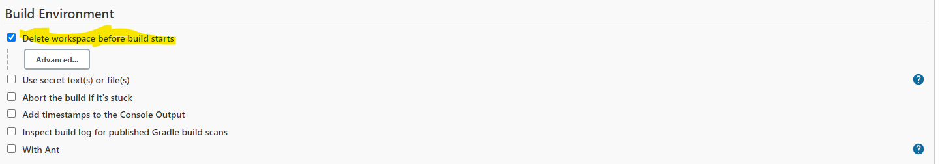

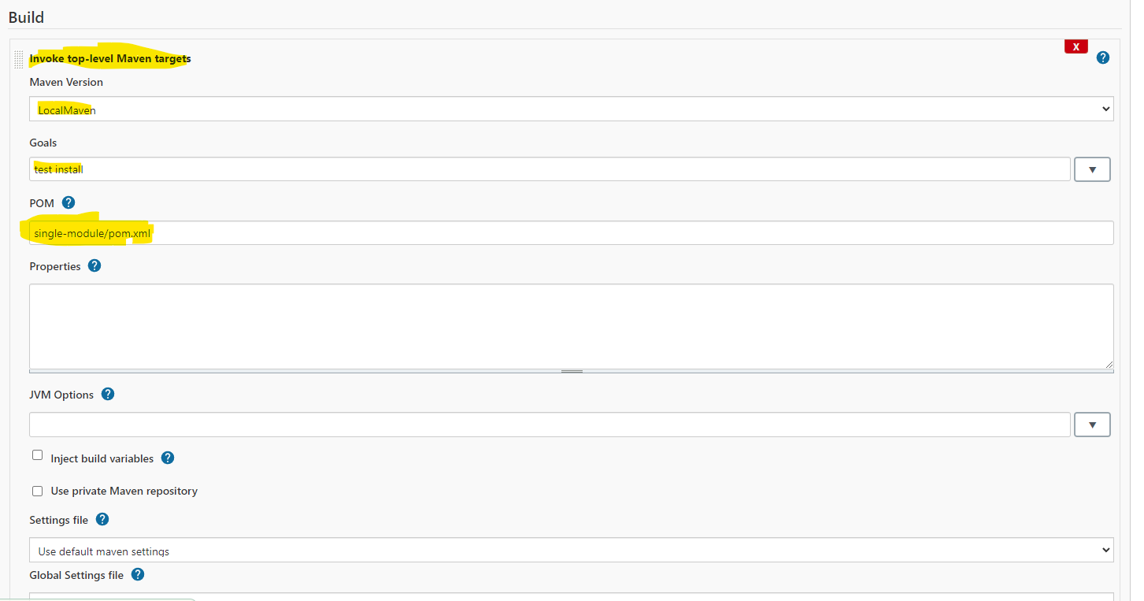

Finally click on Save.

Now you need to build the project by clicking on “Build Now” button as shown below.

Note: You can review/ modify the configuration of the build again by clicking on “Configure”.

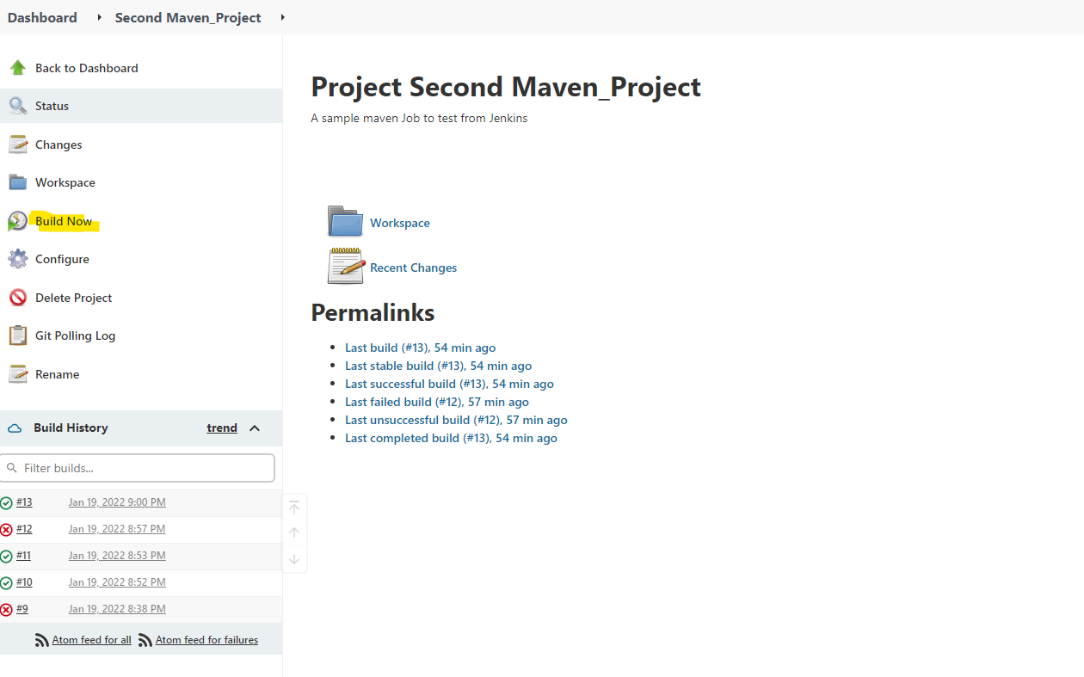

Now I had started the build.

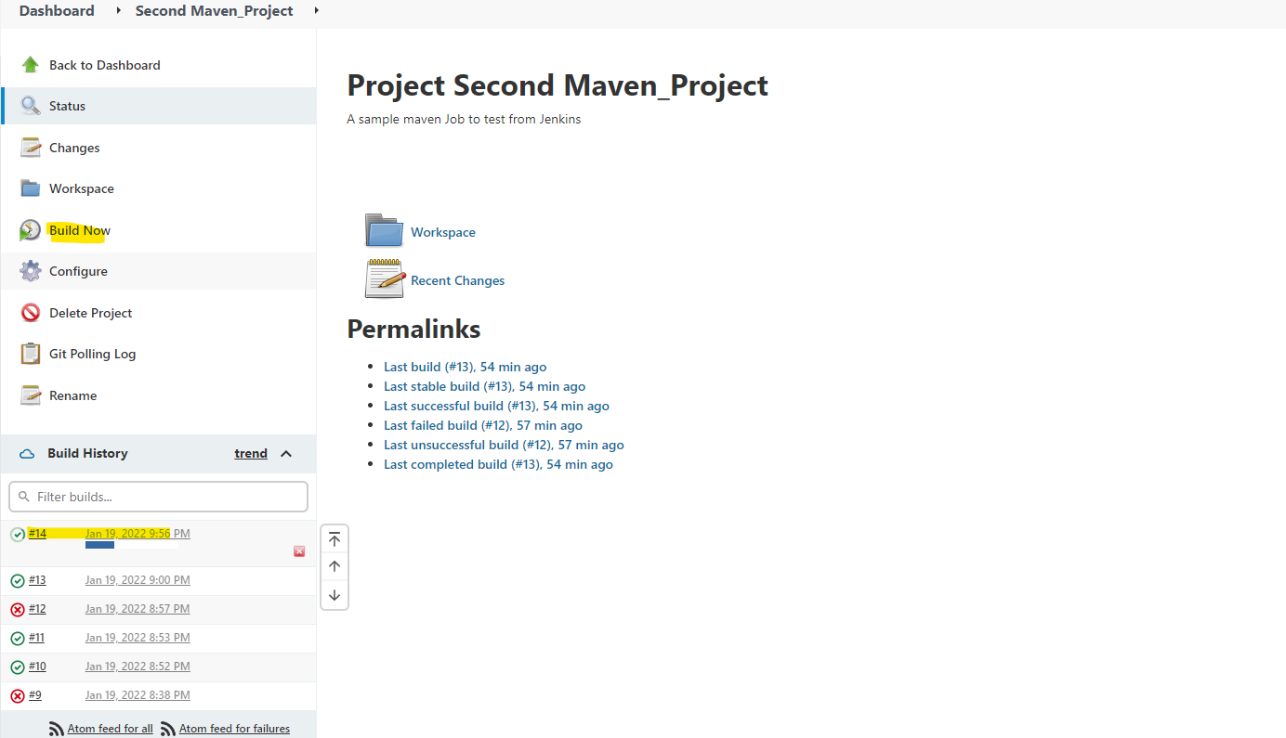

You can verify the output of the build by clicking on the build number and click on “Console Output”.

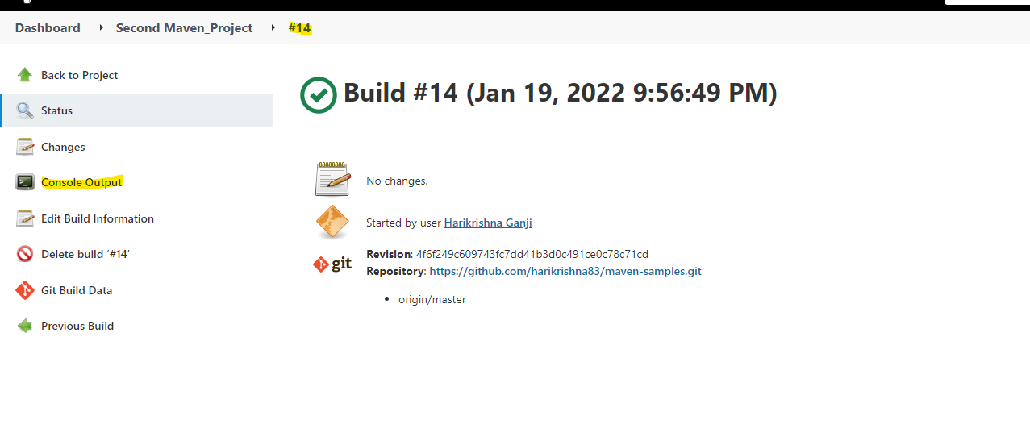

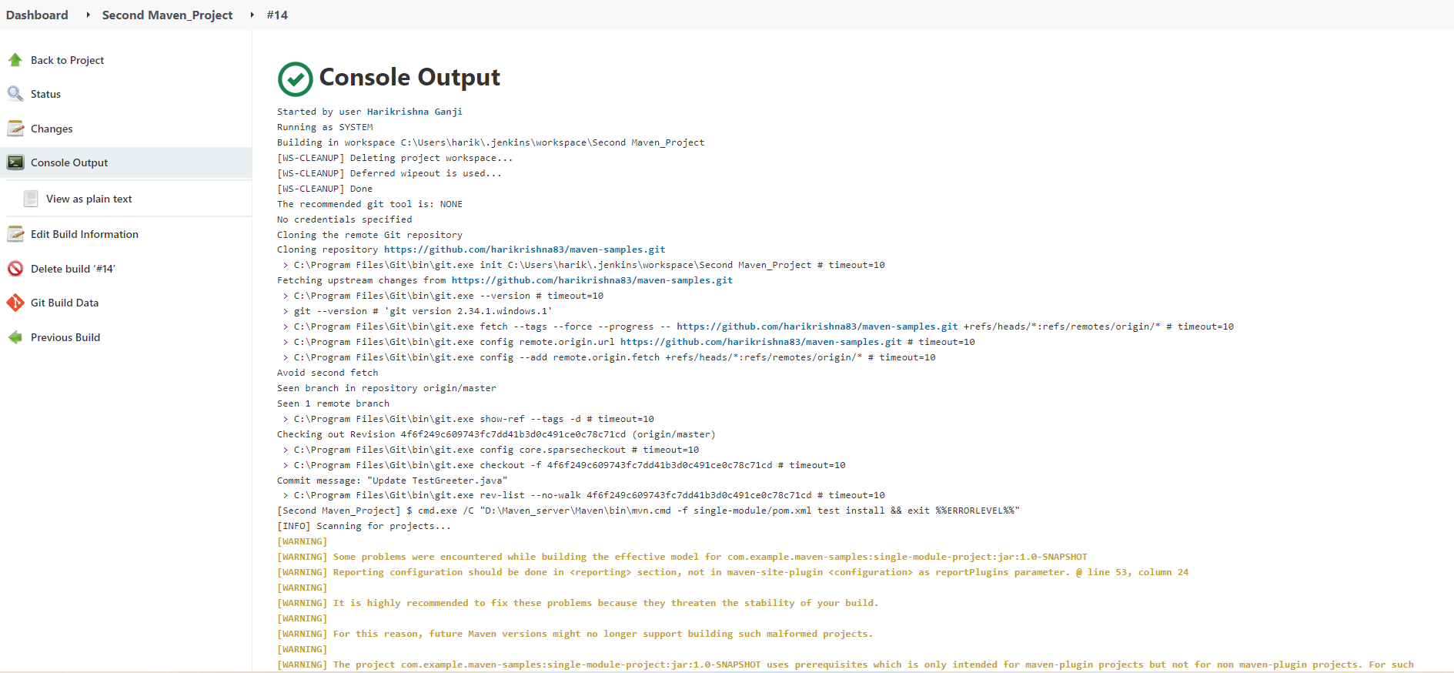

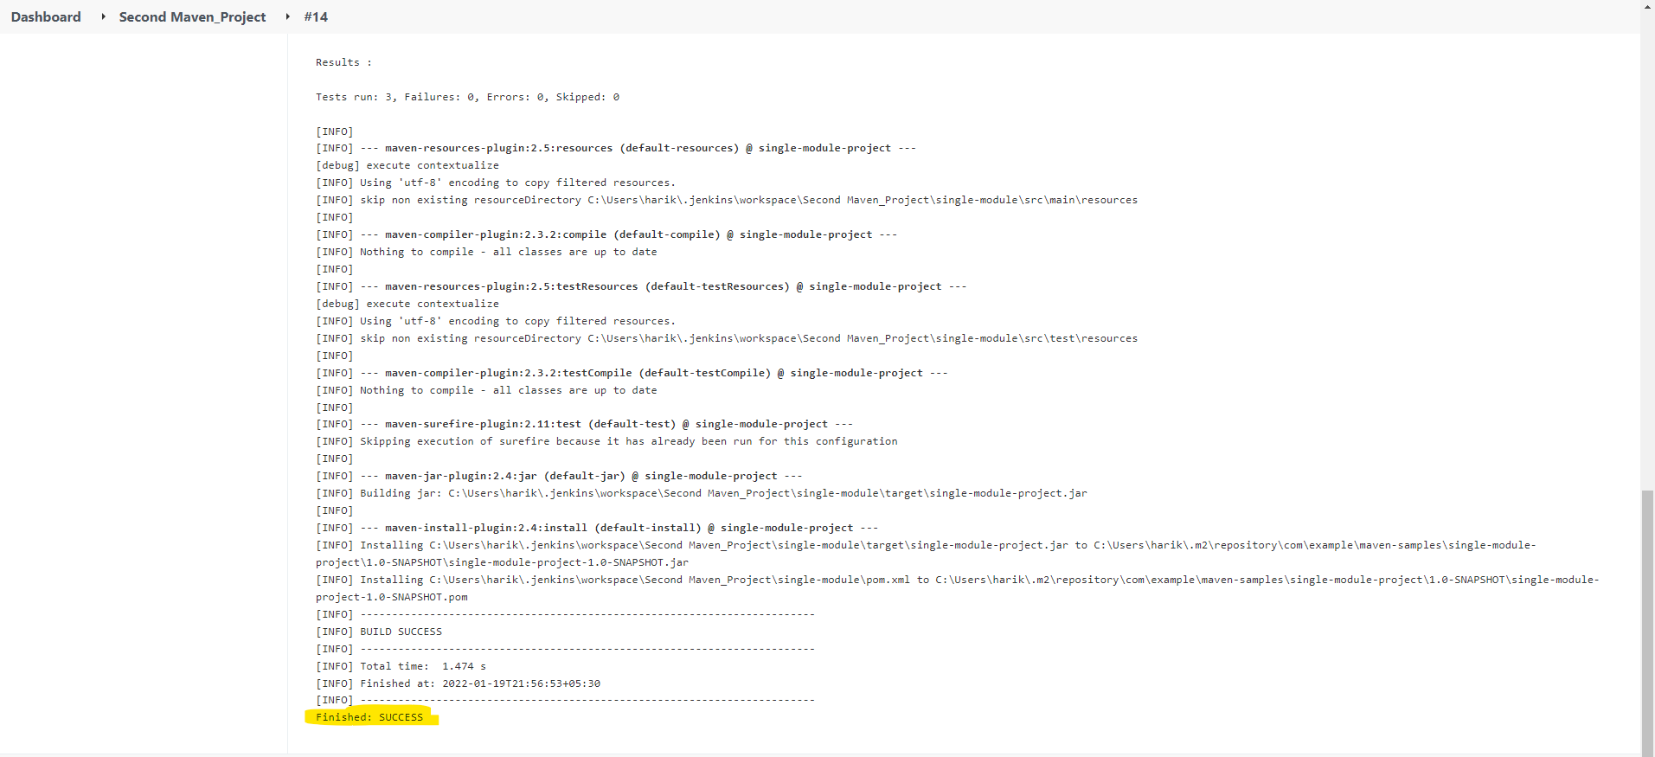

Now change the goals to “clean package” for maven as shown below and execute the build once again.

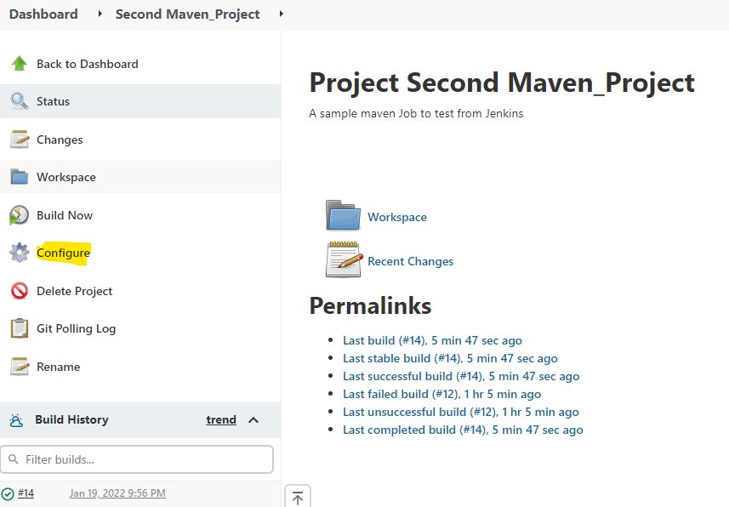

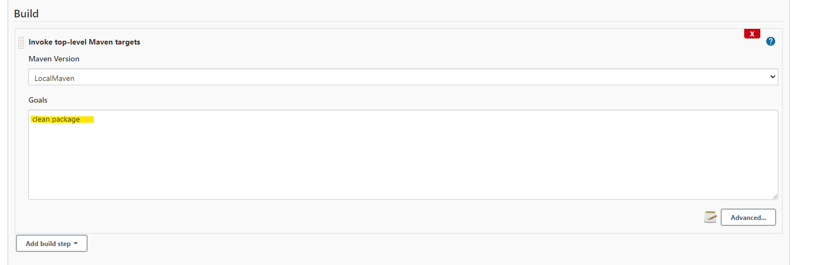

Click on Save and execute the build again.

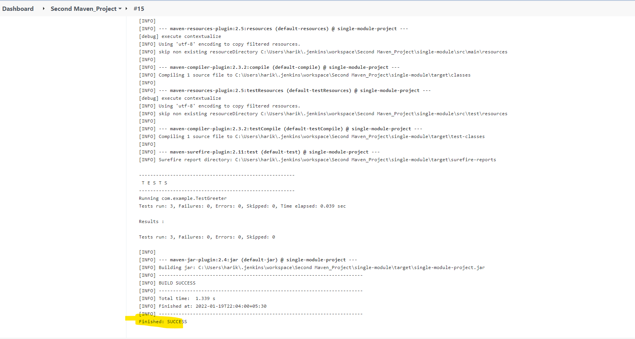

**Trigger Jenkins Build from remote (via Scripts or UI Action etc)**

Here I am using the project First Maven_Project to trigger it from remotely.

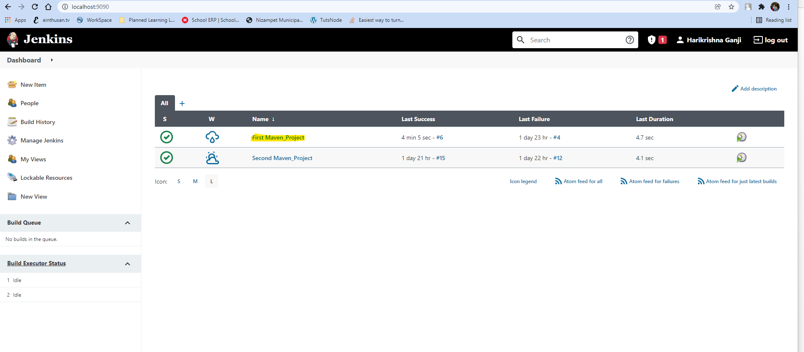

Open the project and click on Configure option.

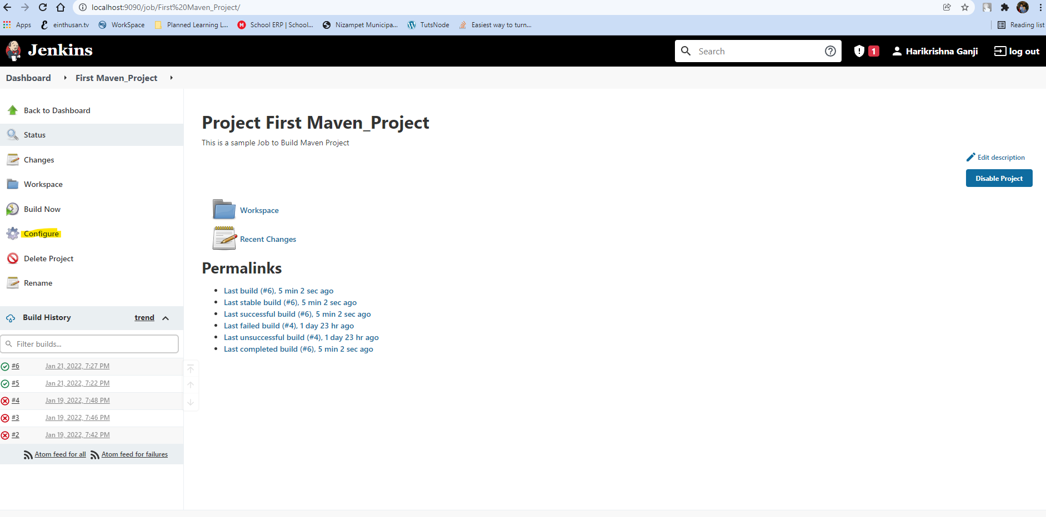

Click on option “Build Triggers” and configure it. Mention any name on the Authentication Token as shown below.

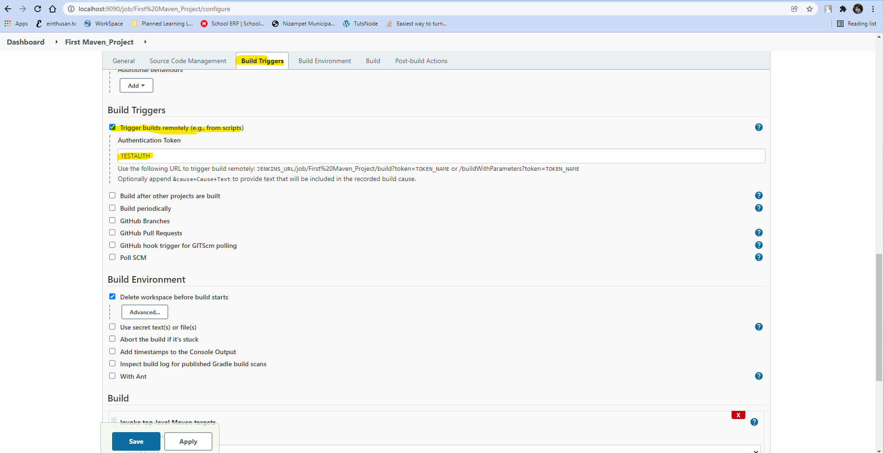

Once you are done by providing the authentication token click on Save. Once you save again open the project and copy the url as shown below.

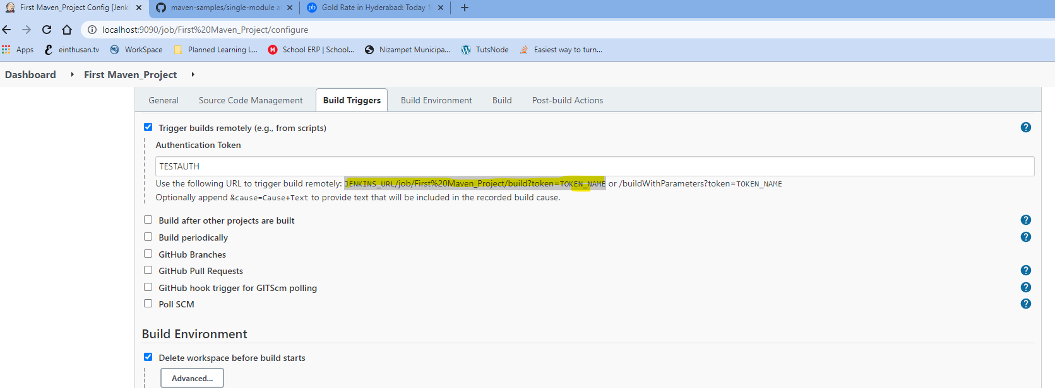

Open any other browser and paste the replace the parameter “JENKINS_URL” with your hostname and port and replace the keyword TOKEN_NAME with the Authentication token as shown below.

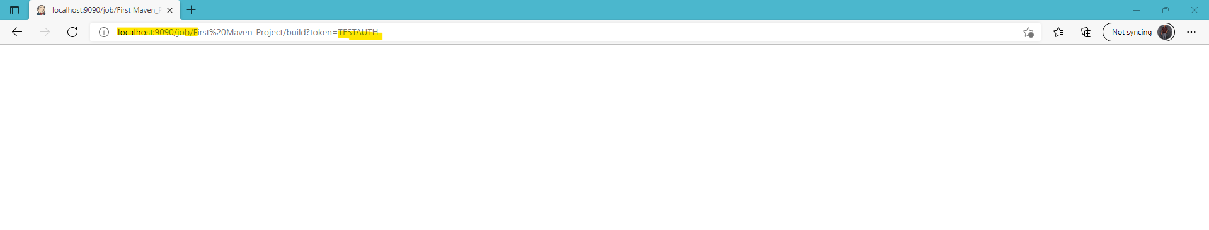

Now you can login into your Jenkins server and see on your project a build will be triggered remotely.

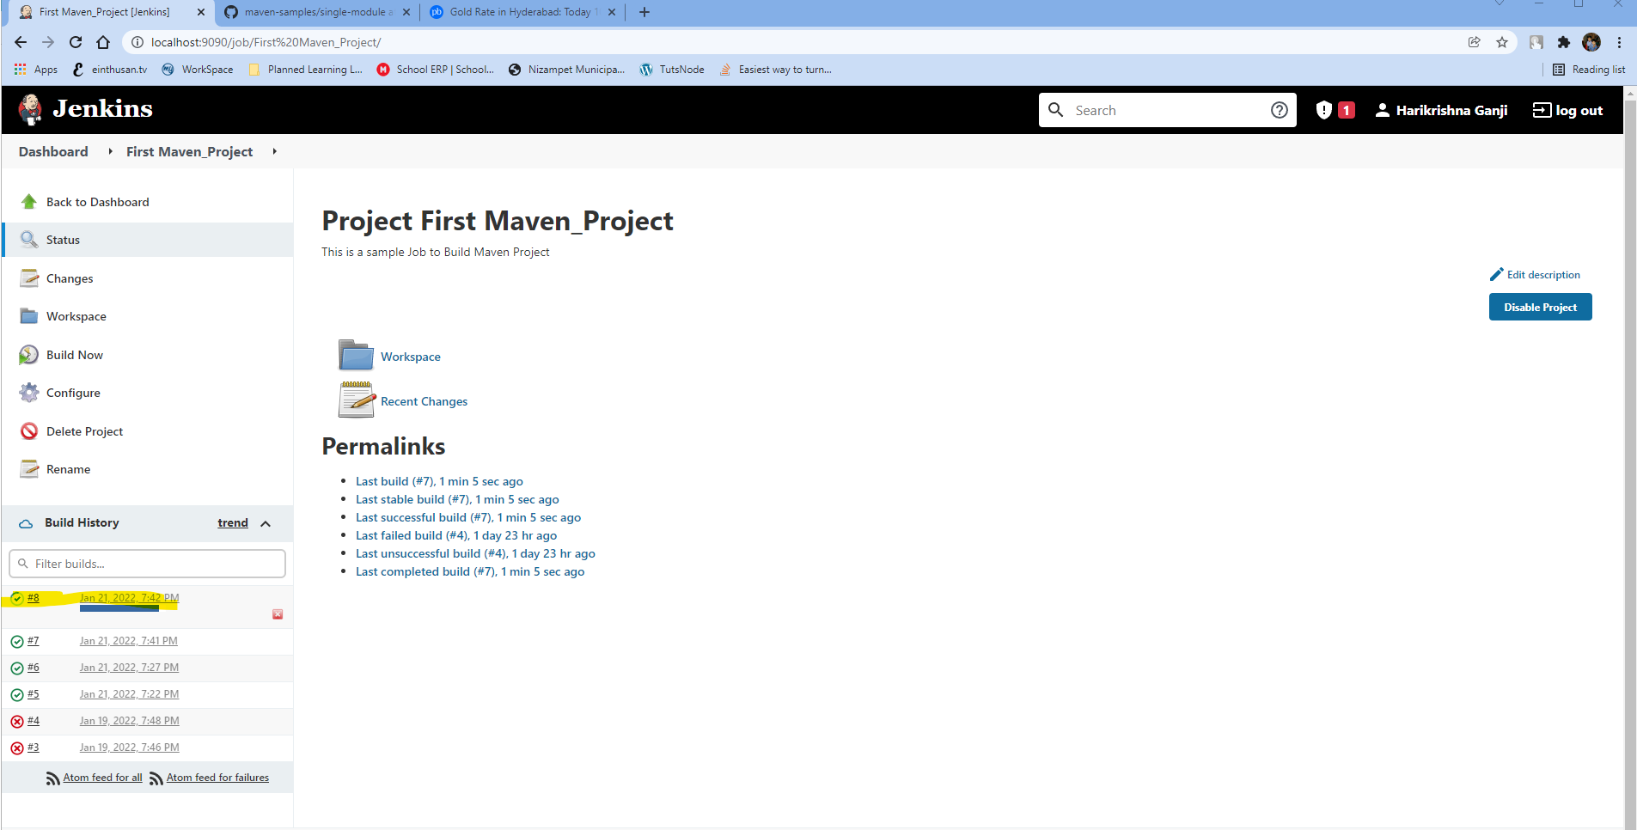

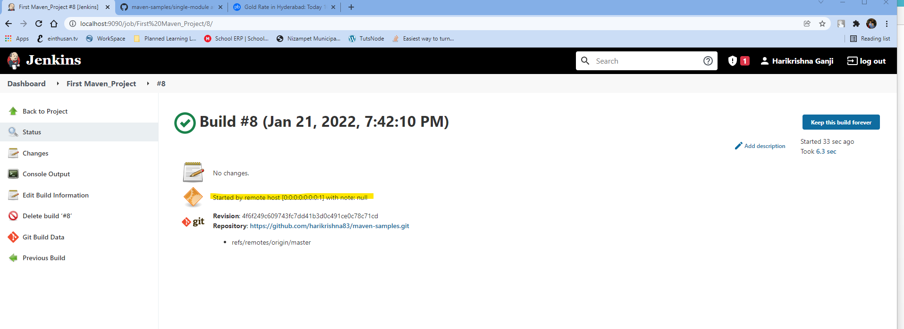

**Archiving Artifacts on Jenkins:**

Normally after build Jenkins will build some artifacts on the workspace example are Jar files and other supporting files. If you don’t archive them properly it will consume a lot of space over the consecutive builds.

So in order to archive the builds, click on Configure and click on post-build Actions and click on Add post-build action as shown below.

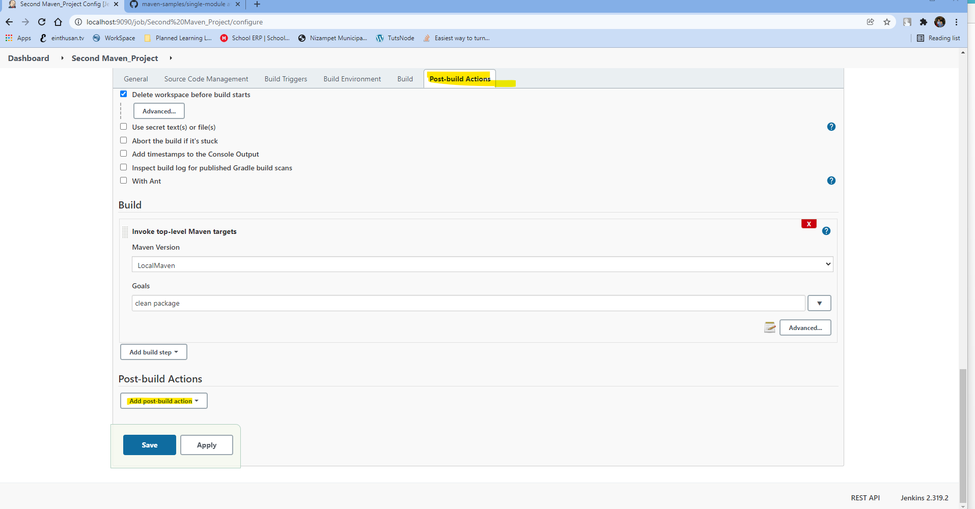

Select the option “Archive the artificats” option as shown below.

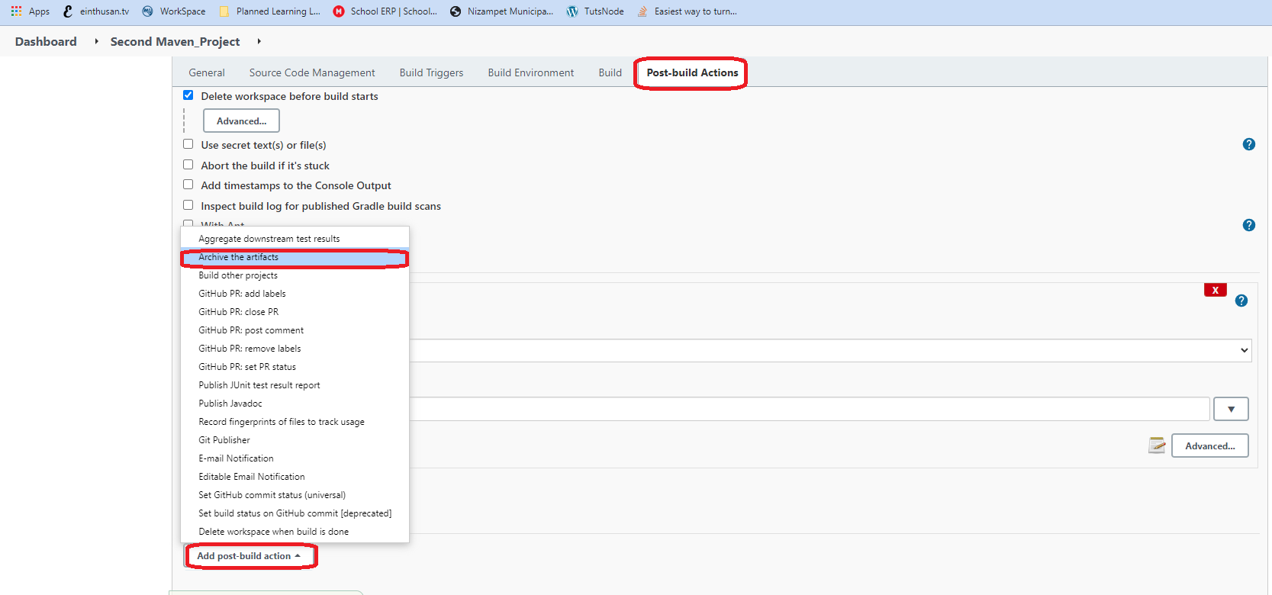

Now give the syntax as shown below, here the first two stars means any path that your workspace exists and the second *.jar is to archive any jar if it build while building the project.

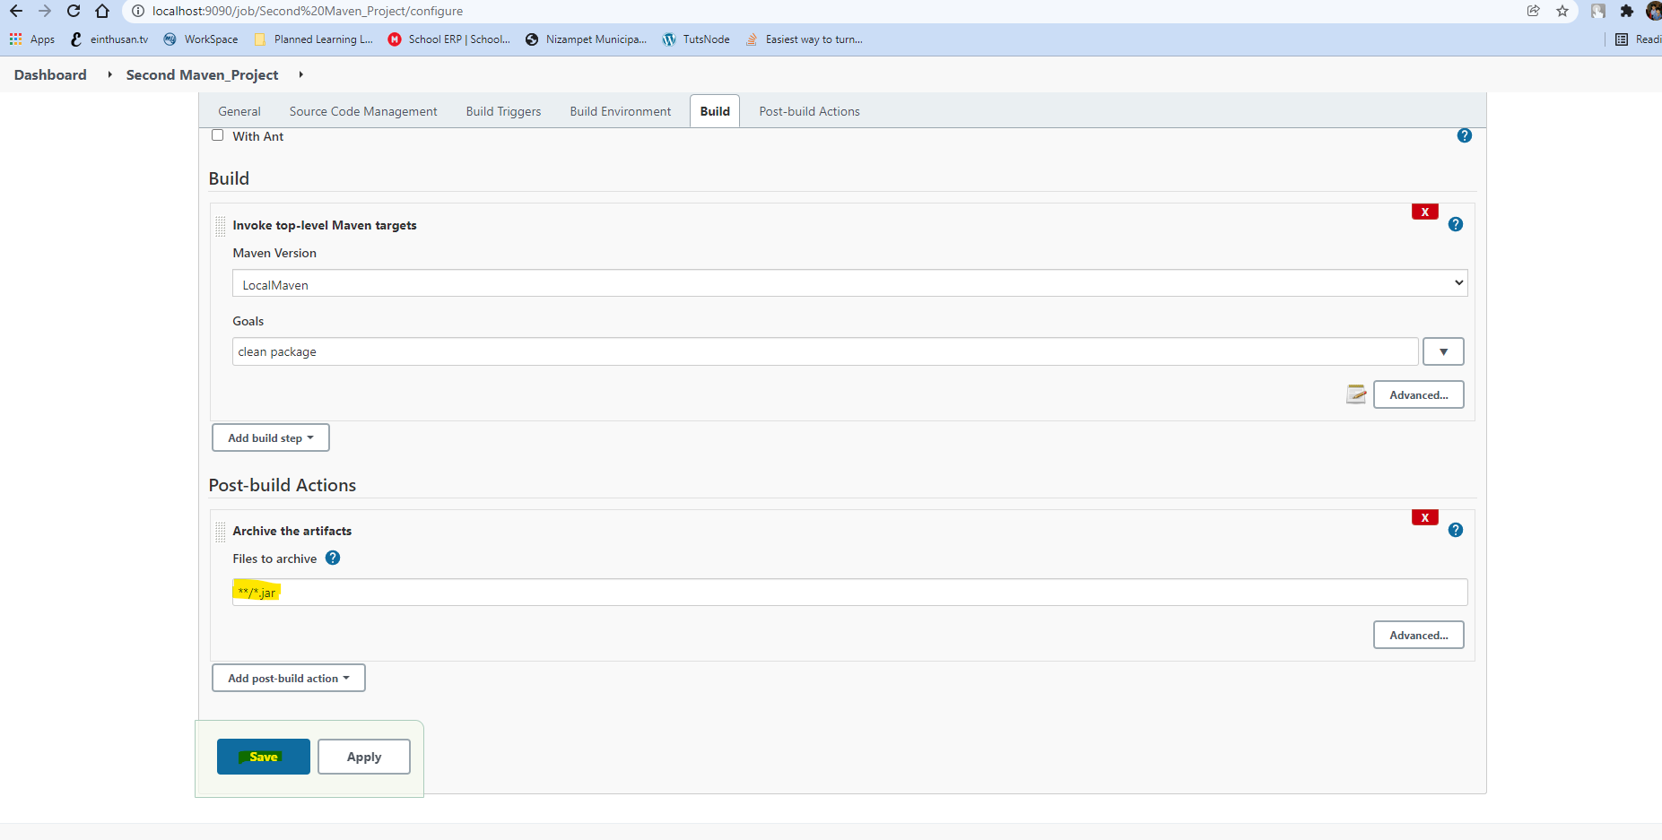

Once you had configured, start your build once again and see if it is archiving the jar file or not.

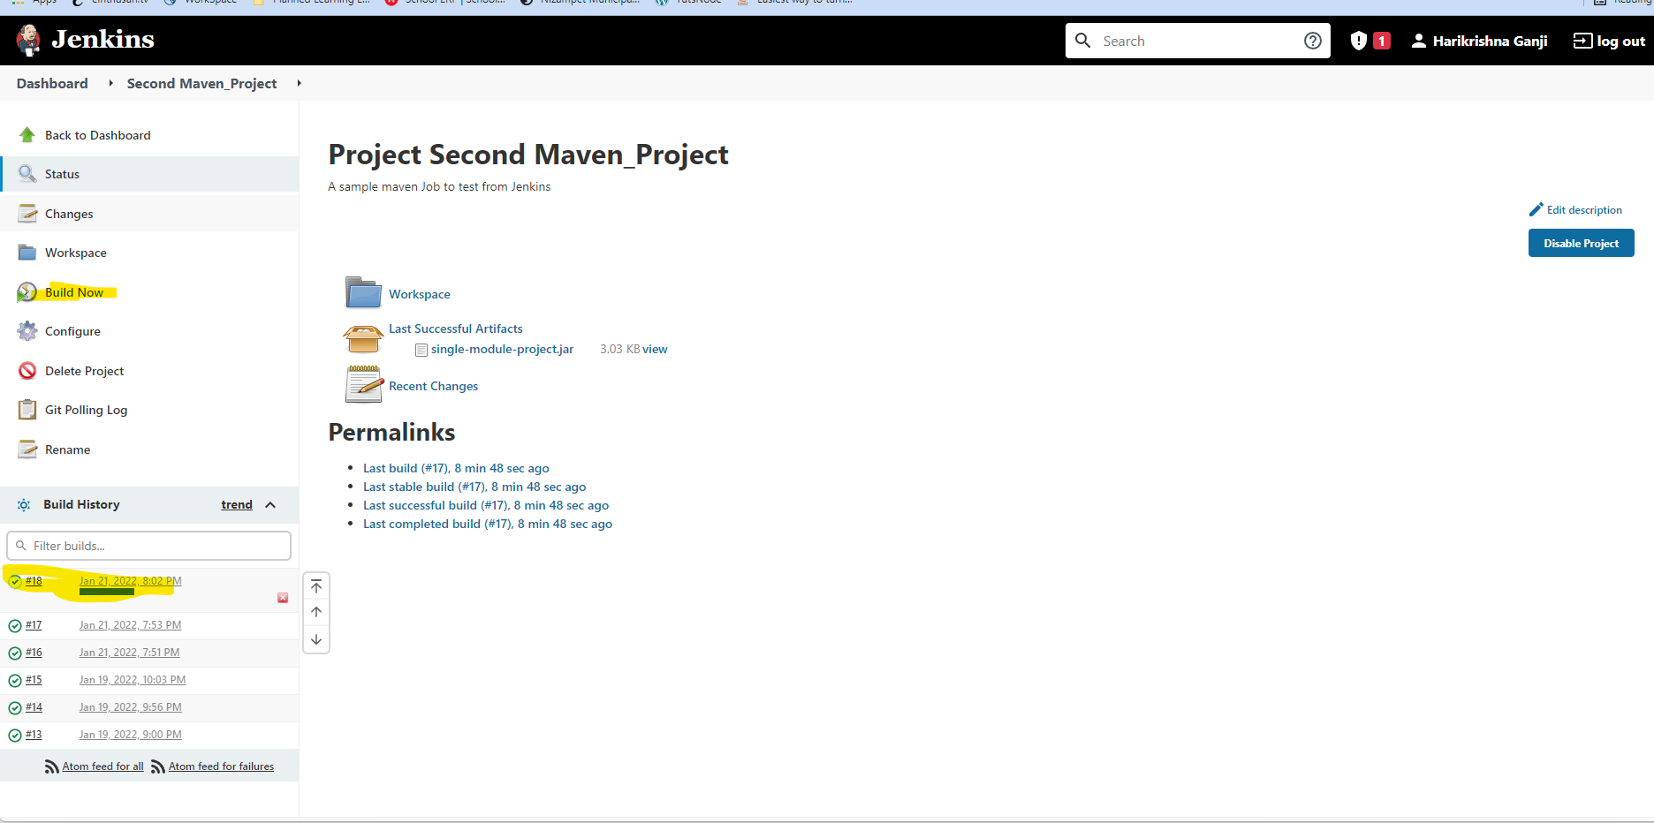

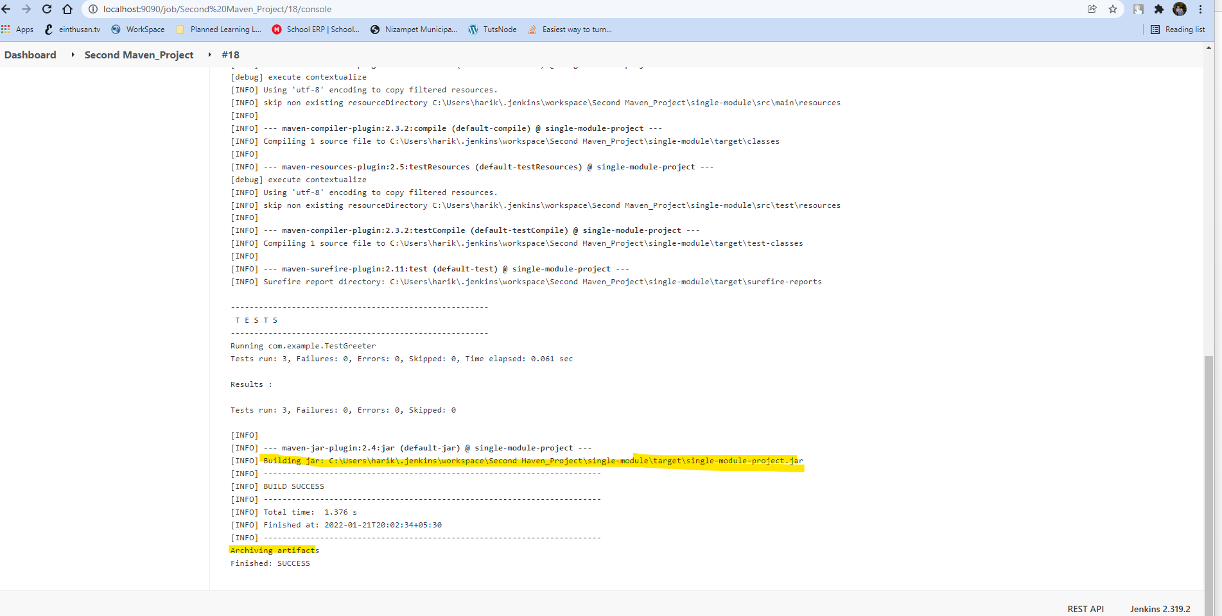

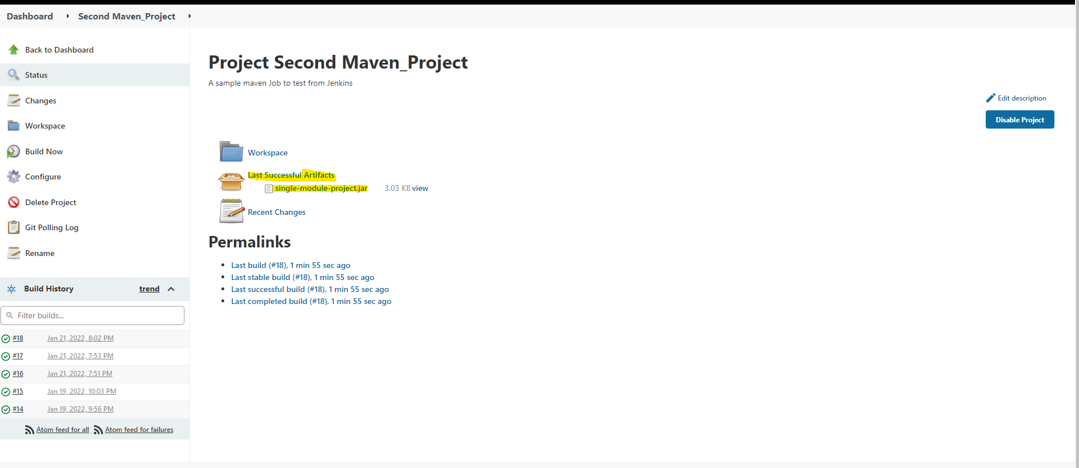

Now if you want to remove every artifact files from your workspace, mention the code as shown below.

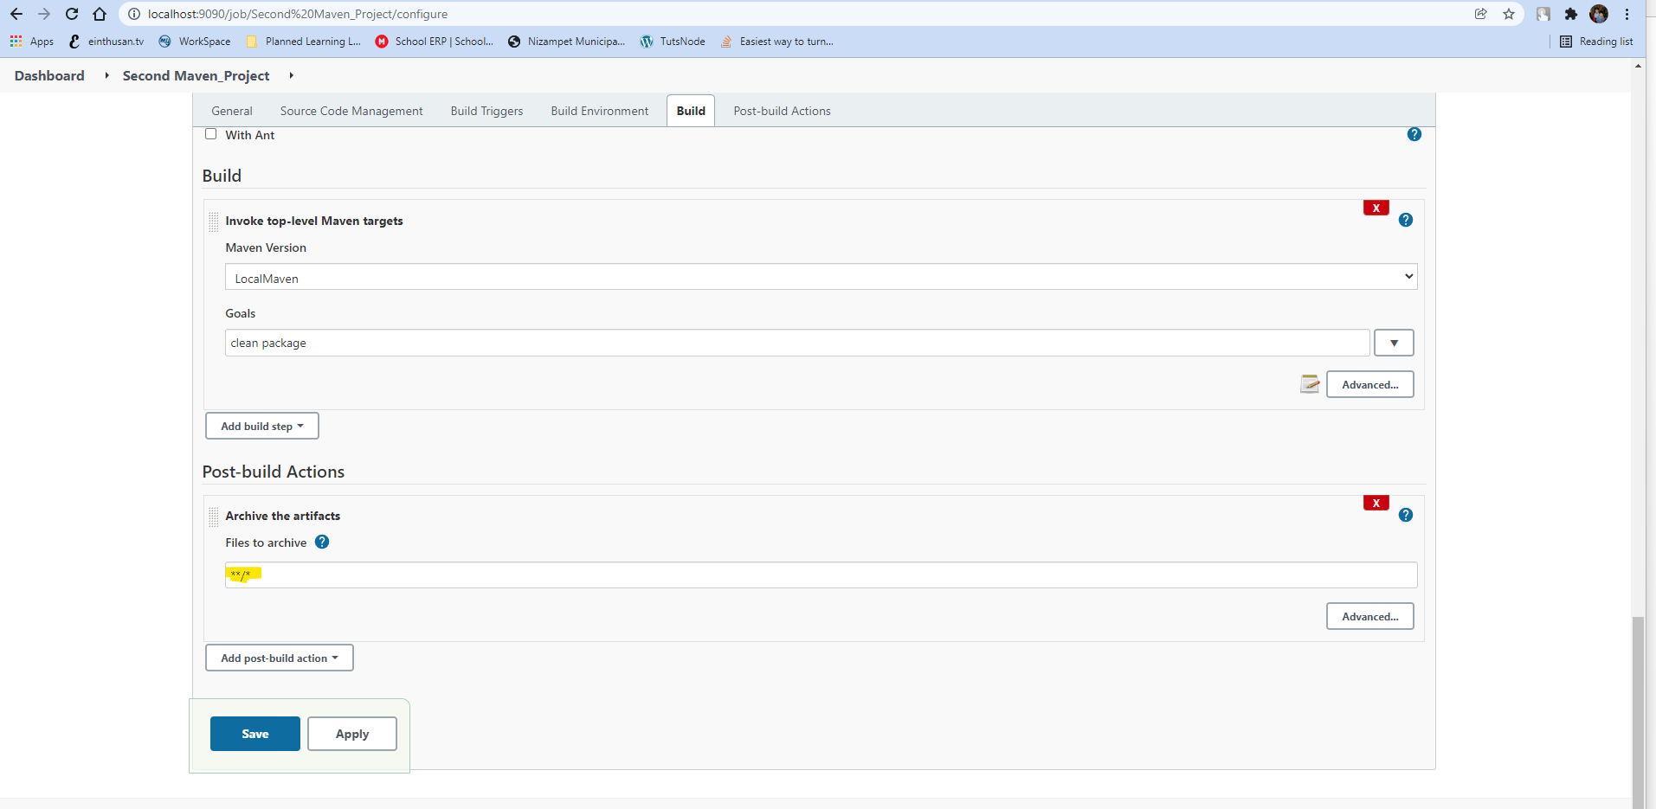

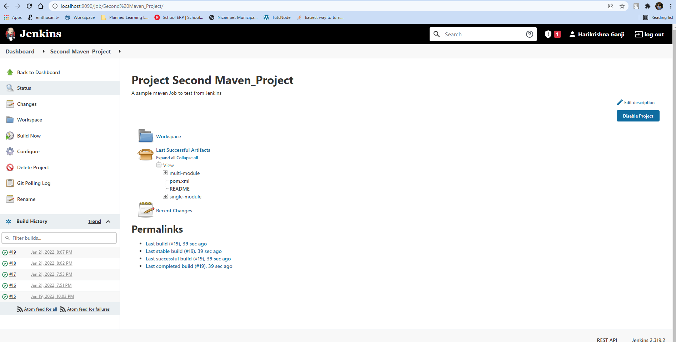

**Installing Tomcat and configuring Roles**

You can download the latest tomcat stable release zip file from the following location.

<https://dlcdn.apache.org/tomcat/tomcat-9/v9.0.58/bin/apache-tomcat-9.0.58-windows-x64.zip>

Now unzip the file and configure the following files

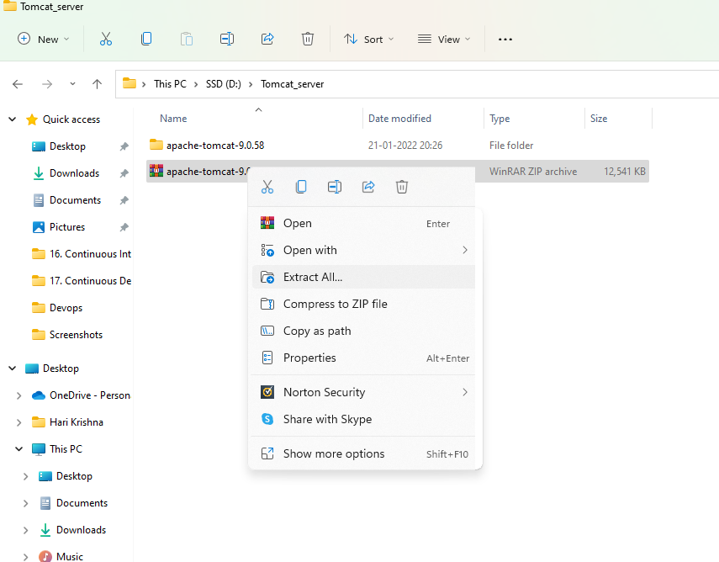

Configure the tomcat-users with some roles as shown below:

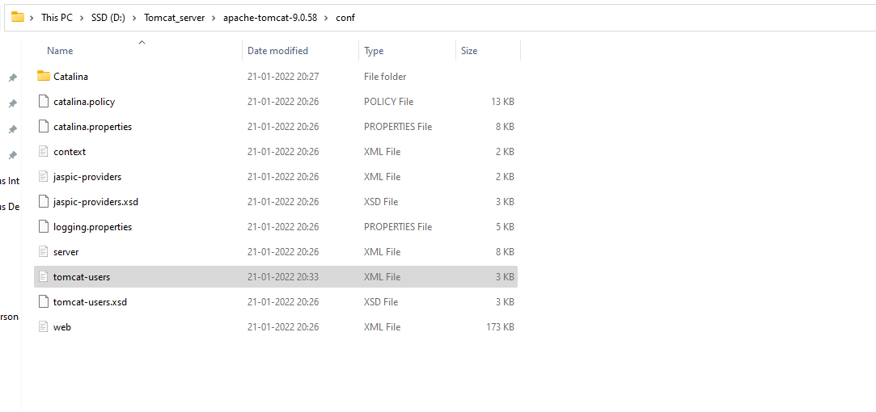

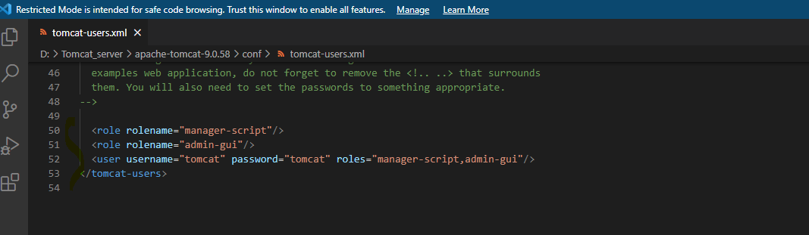

Now start the tomcat server by using the startup.bat script as shown below

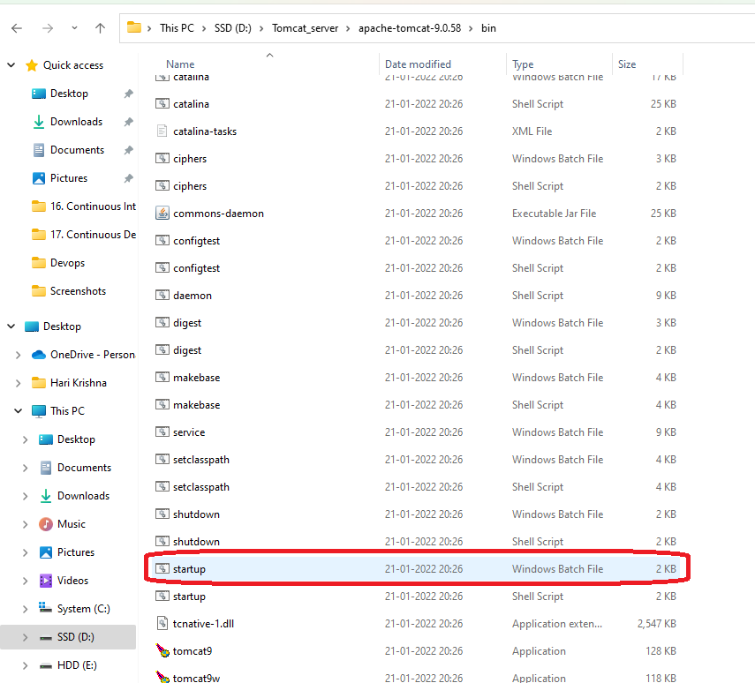

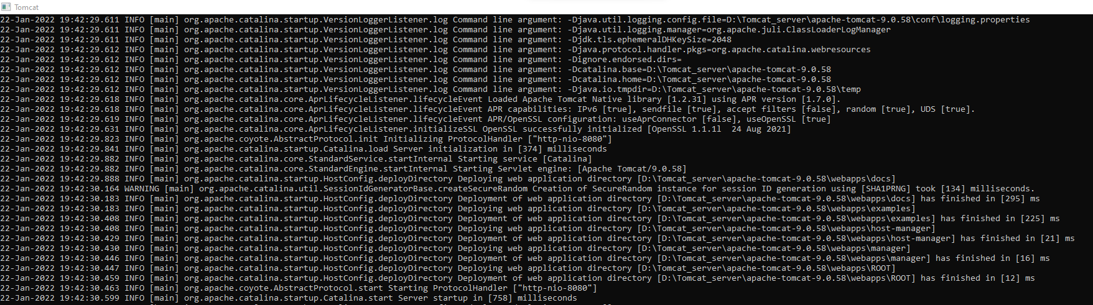

Now we are planning to create a new Jenkins project which will deploy the tomcat web application war into the tomcat container.

Before I had forked the sample tomcat based application on my Github.

Forked the project from the below url.

<https://github.com/anshulc55/jenkins_Upgradev3/tree/master/java-tomcat-sample>

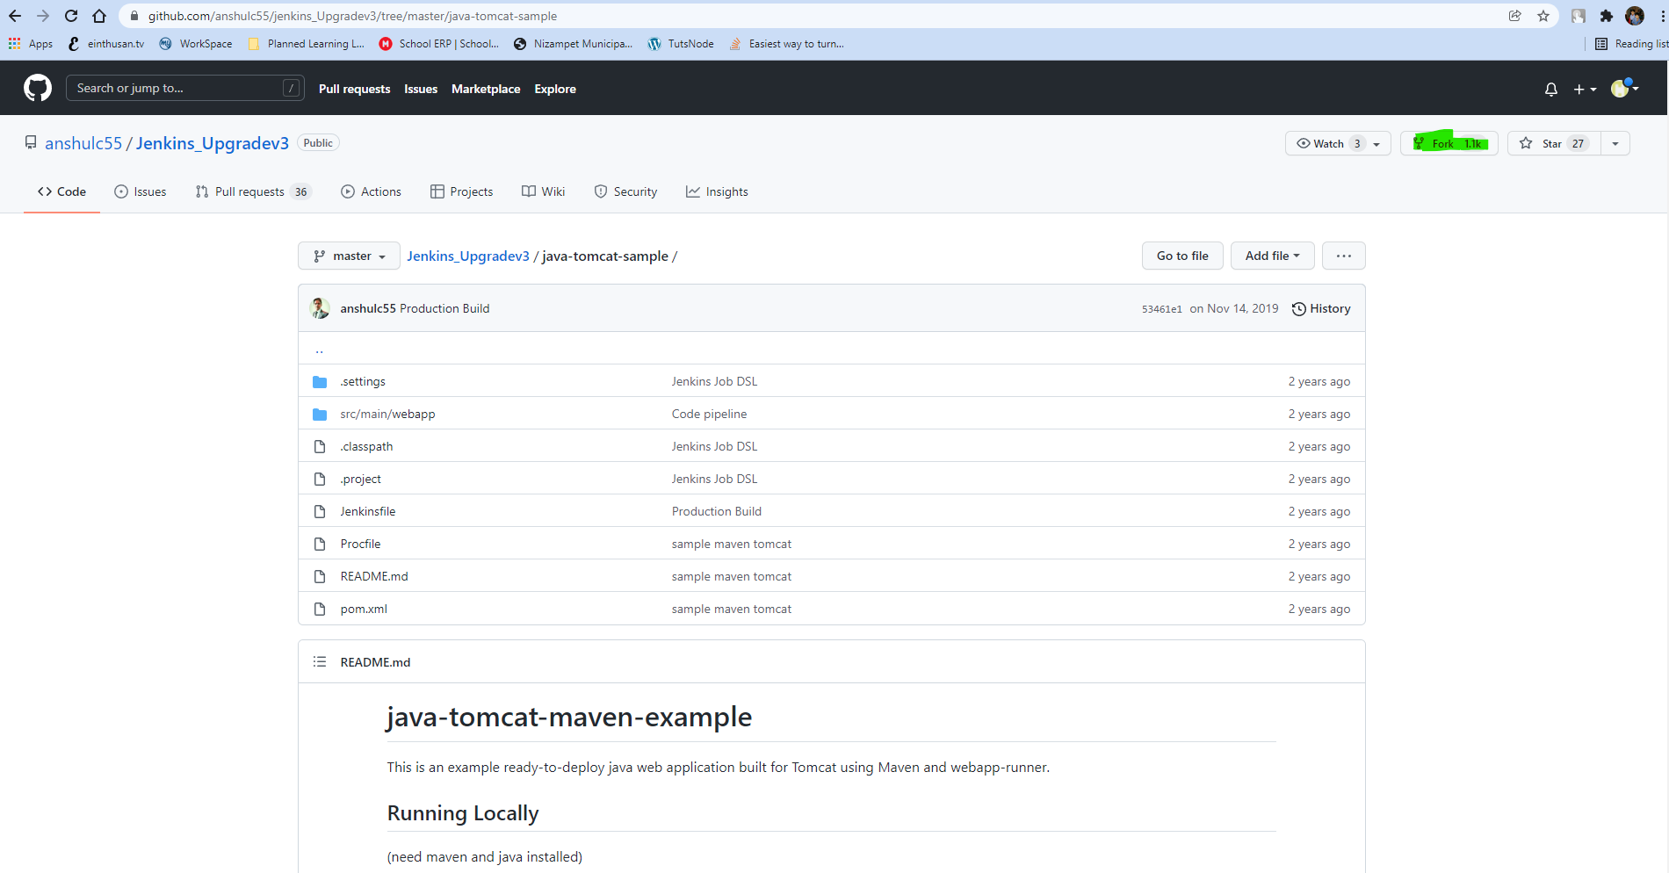

Once you had forked, it had created a project on Github workspace as shown below.

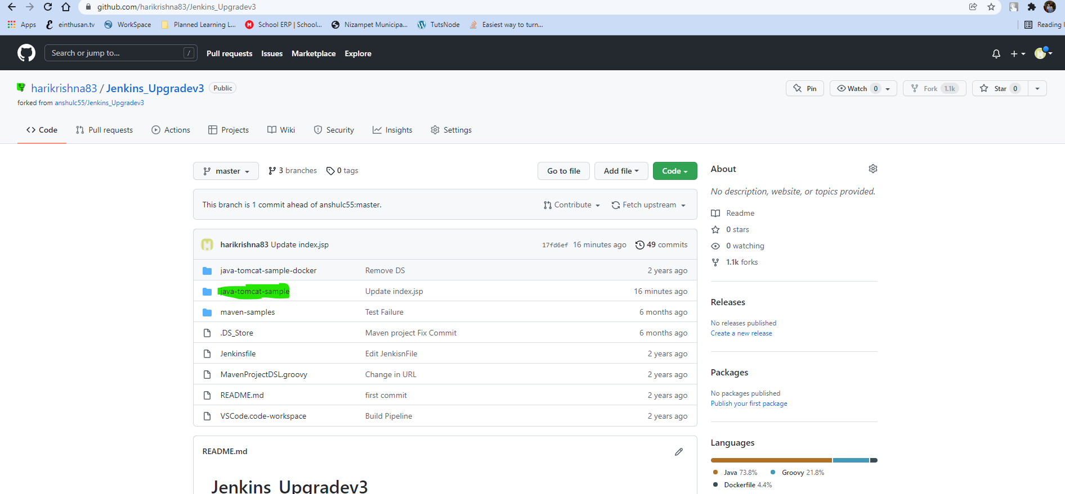

Now login to Jenkins and create a new project. Before creating a new project I had created a new application view by clicking on “+” icon.

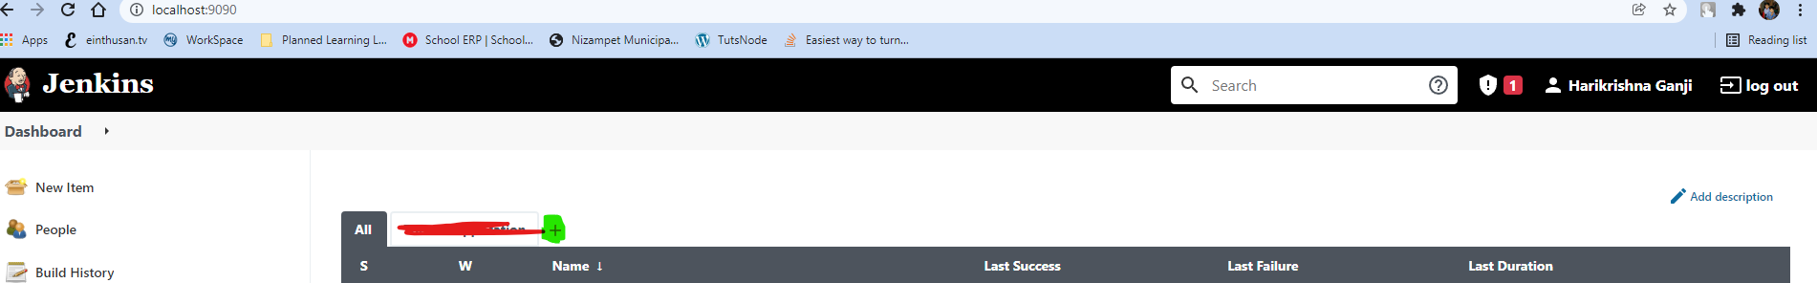

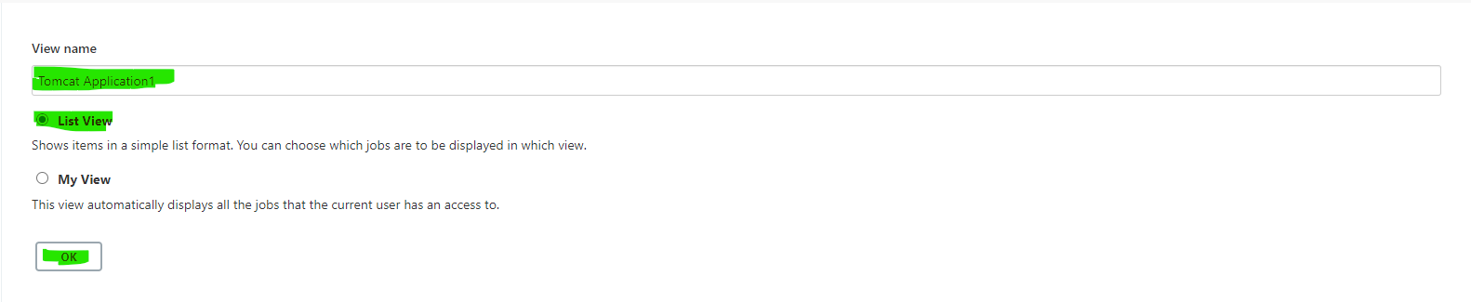

Now new application view had been created, I had a new project from this view only by clicking on New Item.

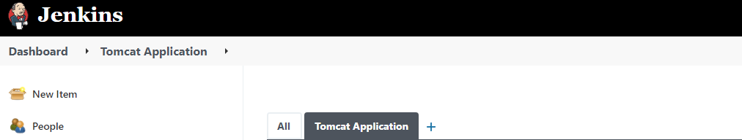

Now I am creating two Jenkin Jobs

1. Package_Application🡪 which will create a war package file
2. Deploy_Application_Staging_Env 🡪 Which will deploy it the war application to stage Env.

Now while configuring the Job Package_Application, I had created dependency that after this build completes successfully, trigger the second Deploy_Application_Staging_Env job.

Before creating these two Job I need to install the few plugins.

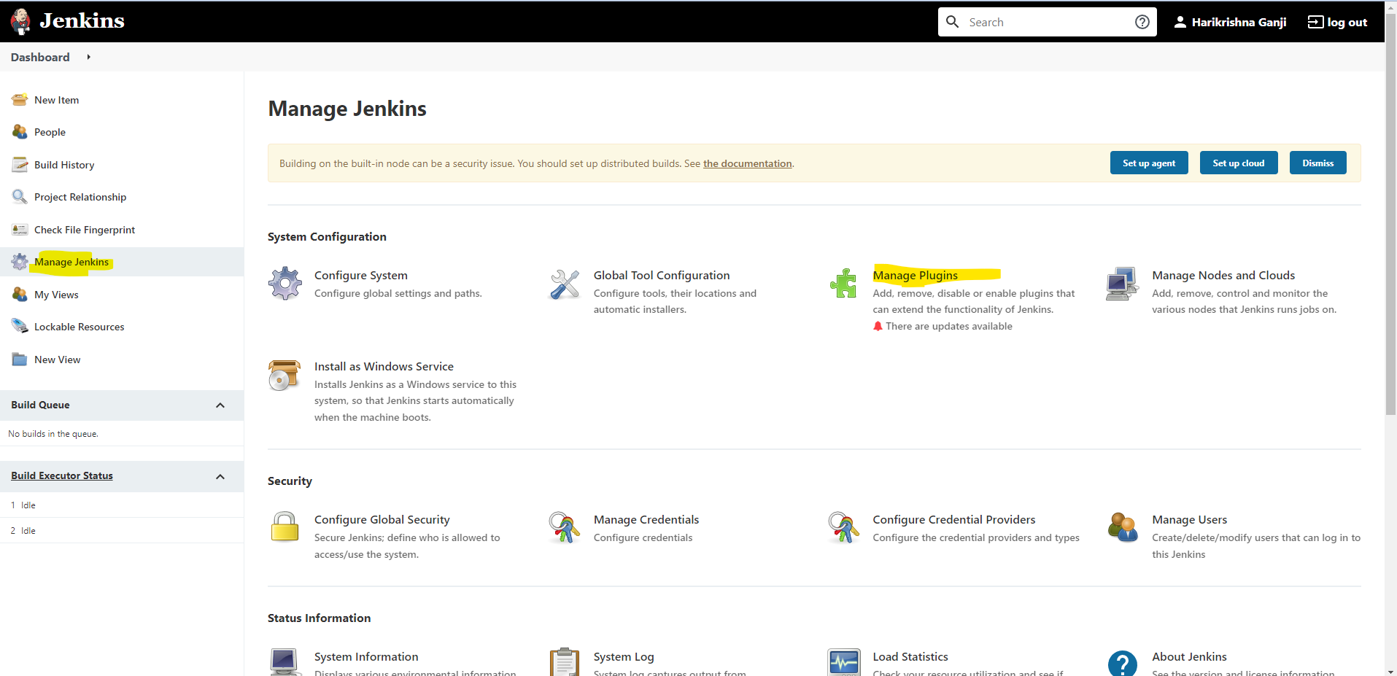

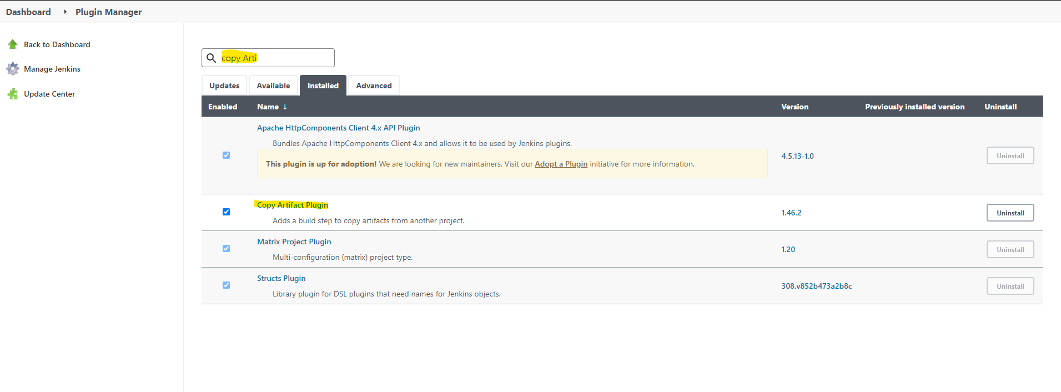

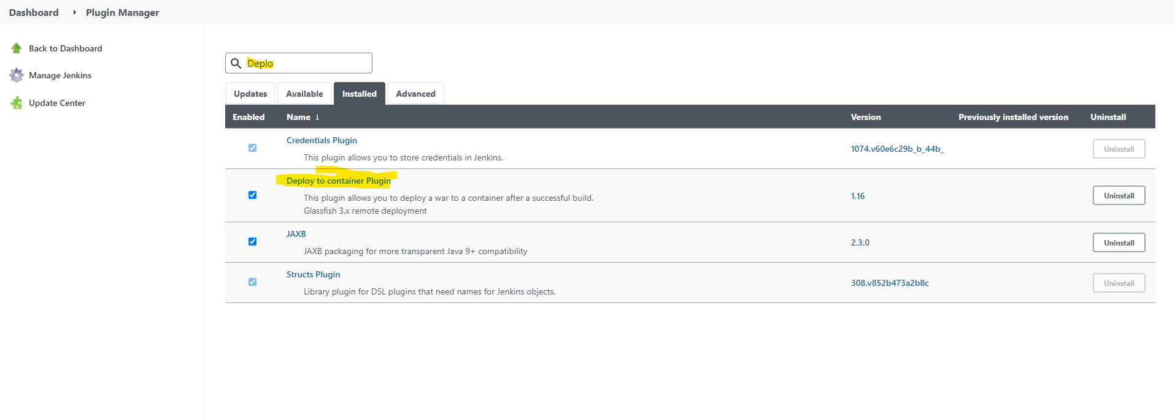

Now create a first Jenkins Job “package_Application”

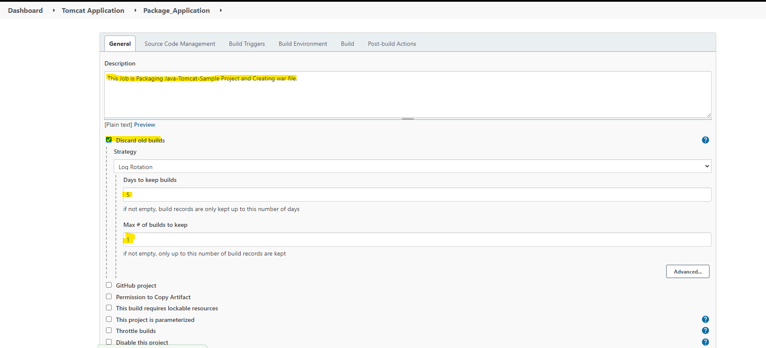

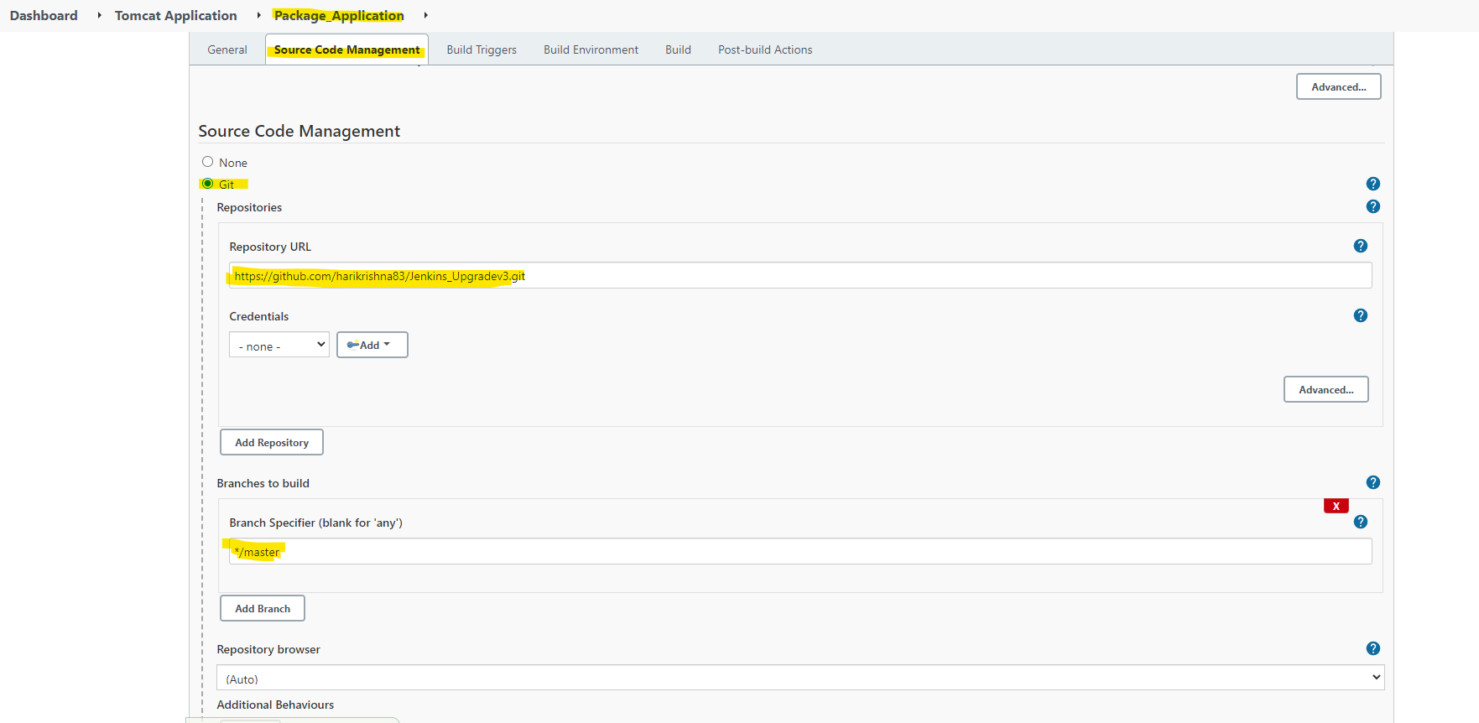

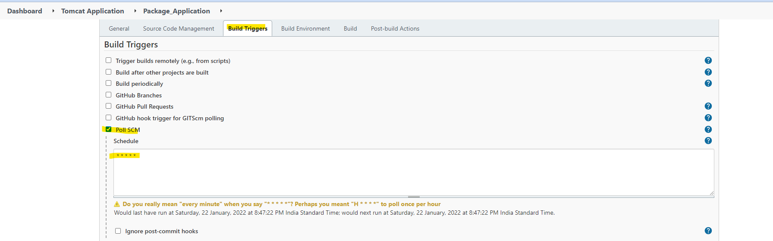

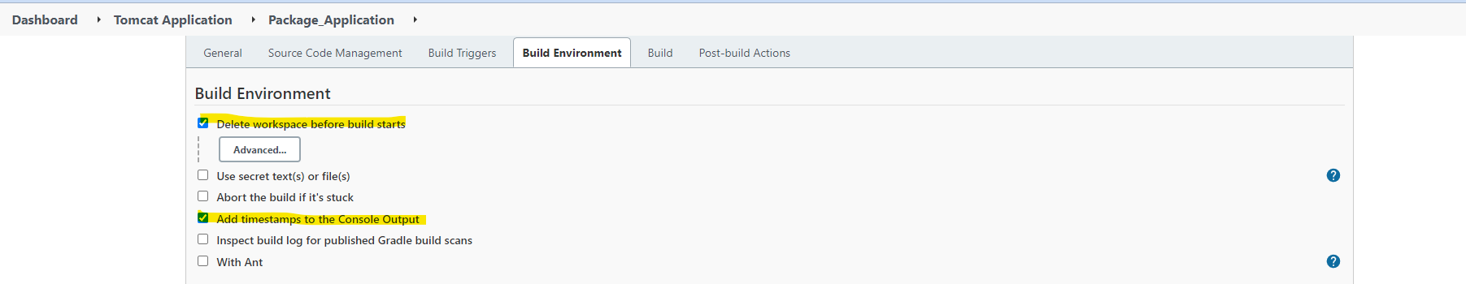

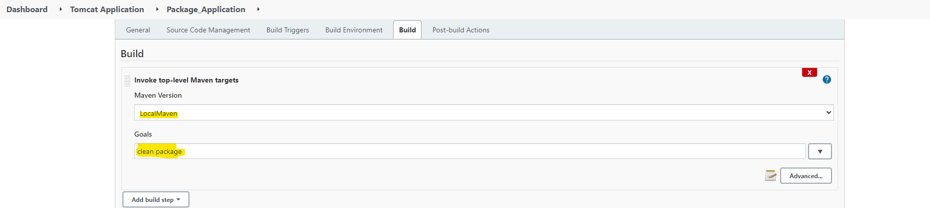

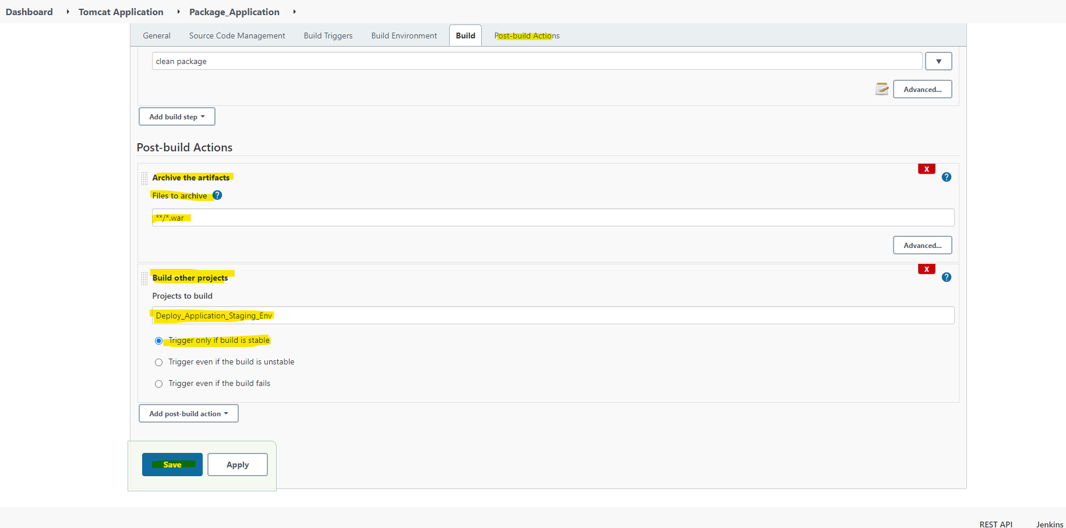

Now create a second Jenkins Job “Deploy_Application_Staging_Env”.

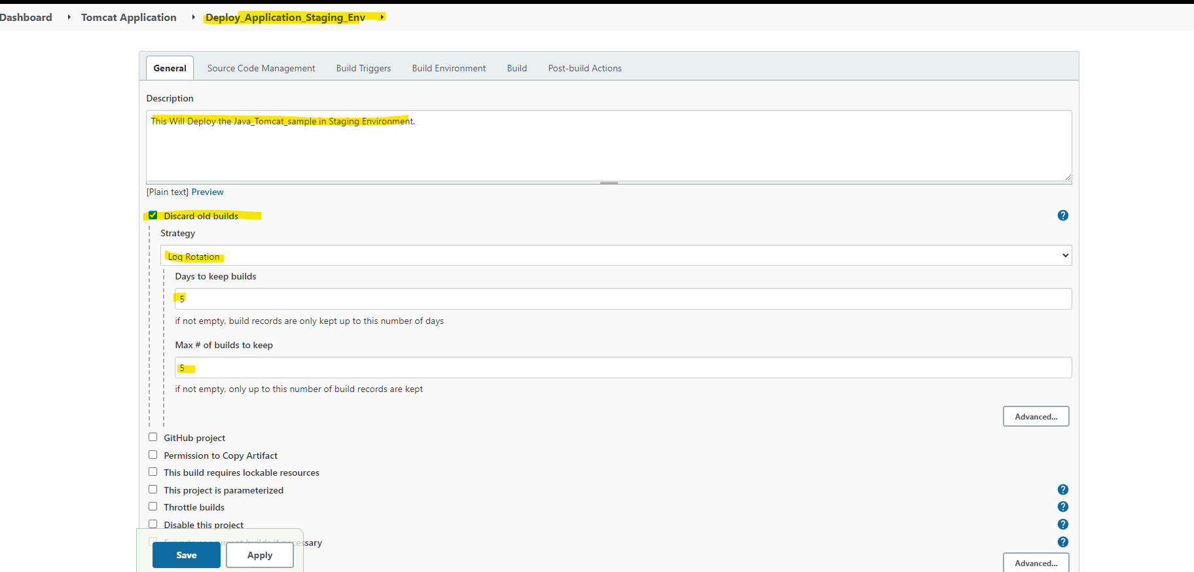

Here we are selecting source code management as None, because this job can’t download any code from SCM it will only deploy the war which is generated by previous Job.

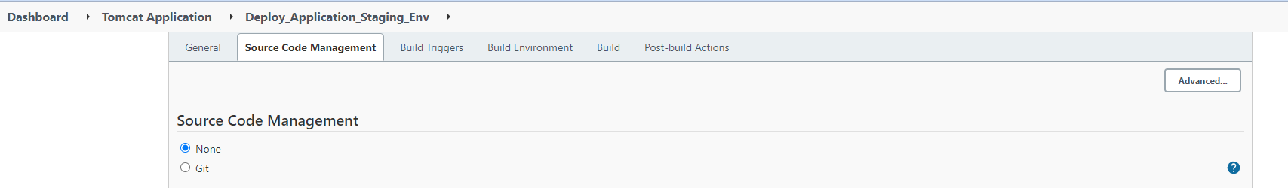

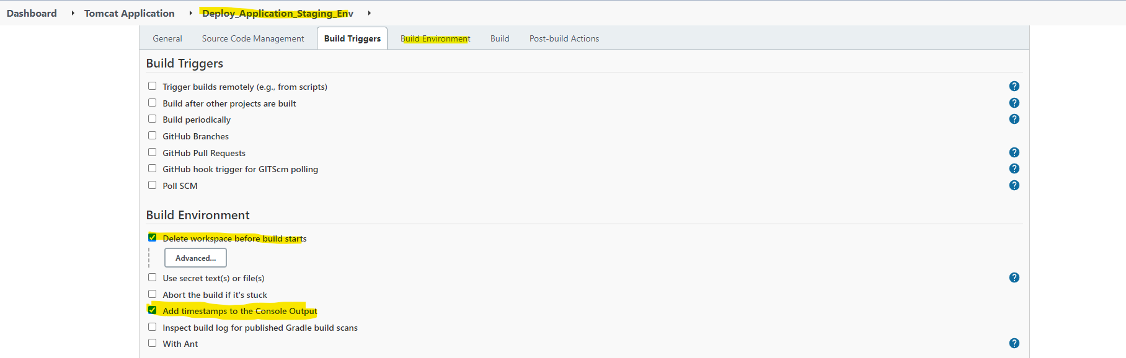

Here on the build, we are copying artifacts from previous project.

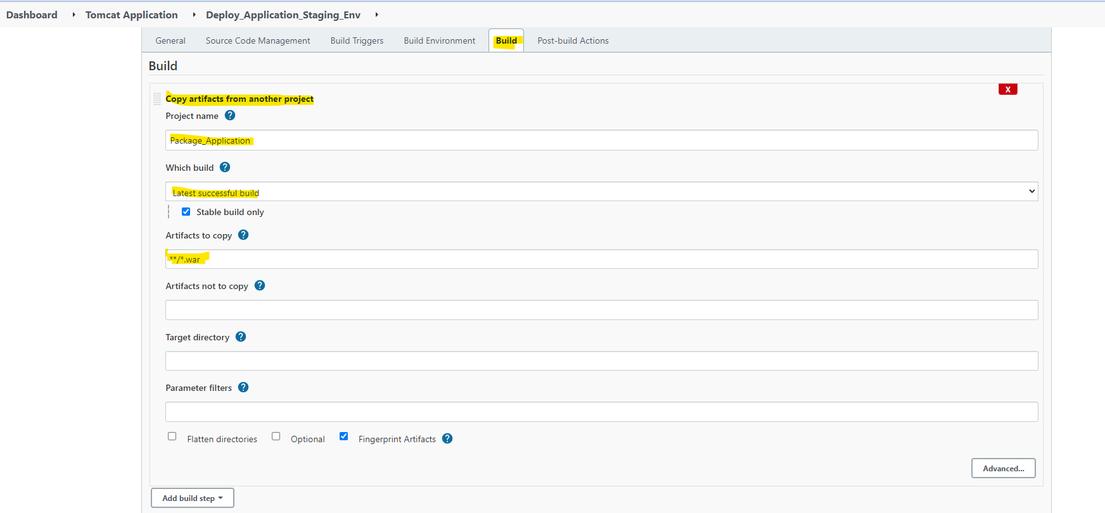

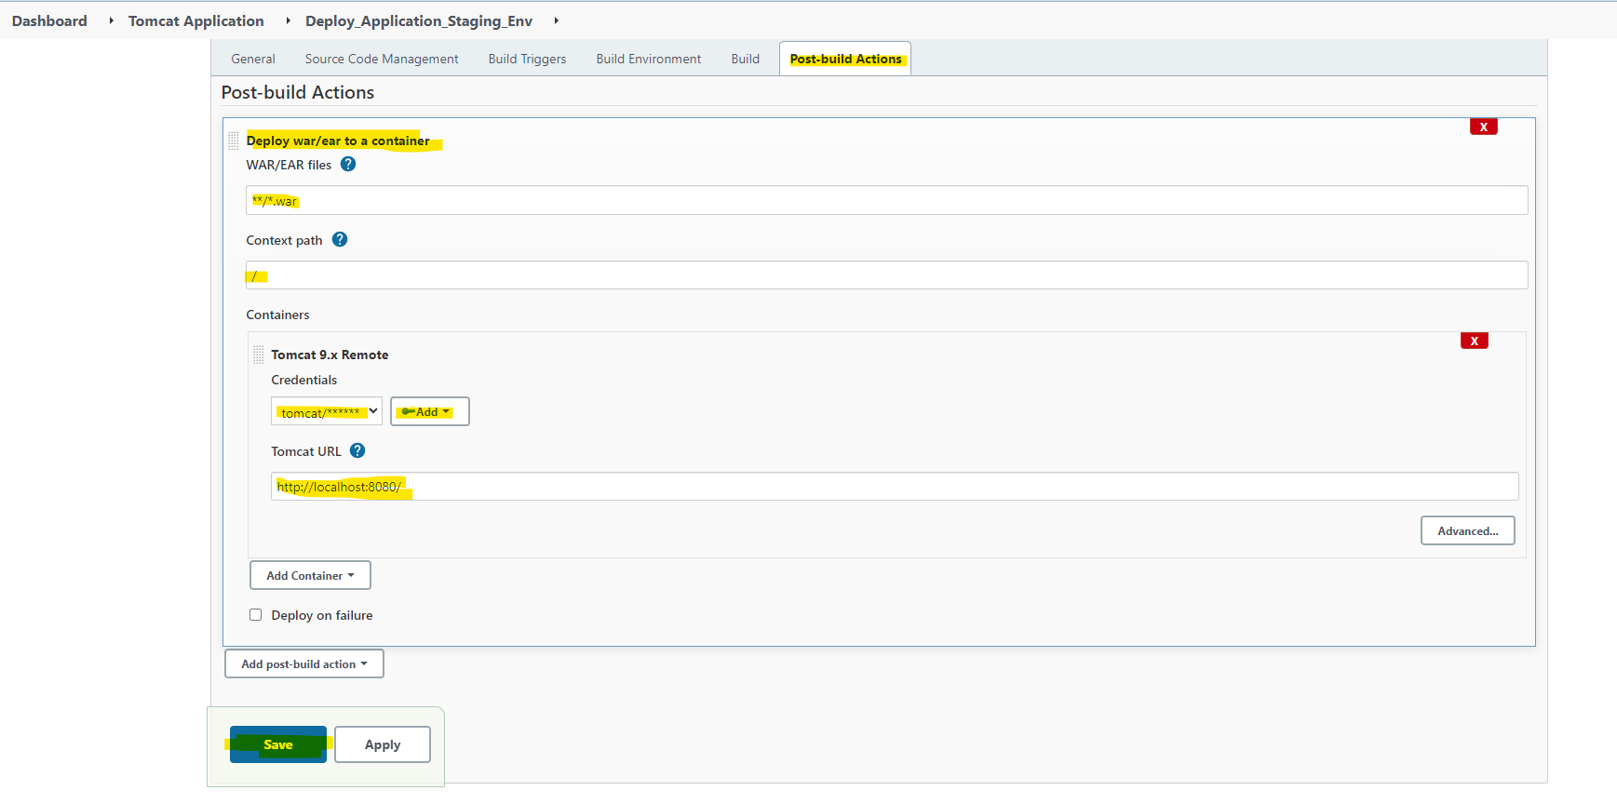

Here on Post build step, I need to add a step Deploy war/ear to a container and also click on Add to add a credentials. Remember while configuring tomcat we had given user and password both as tomcat only.

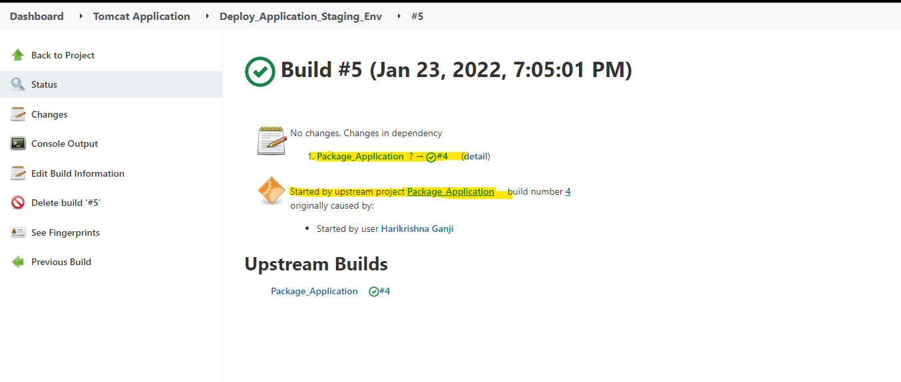

Now I am creating another same production environment and create a pipeline to deploy the application on prod once it is successful on stage (Note: On prod we are deploying manually not automatically.)

Before creating I am going to install the plugin “Build Pipeline plugin”.

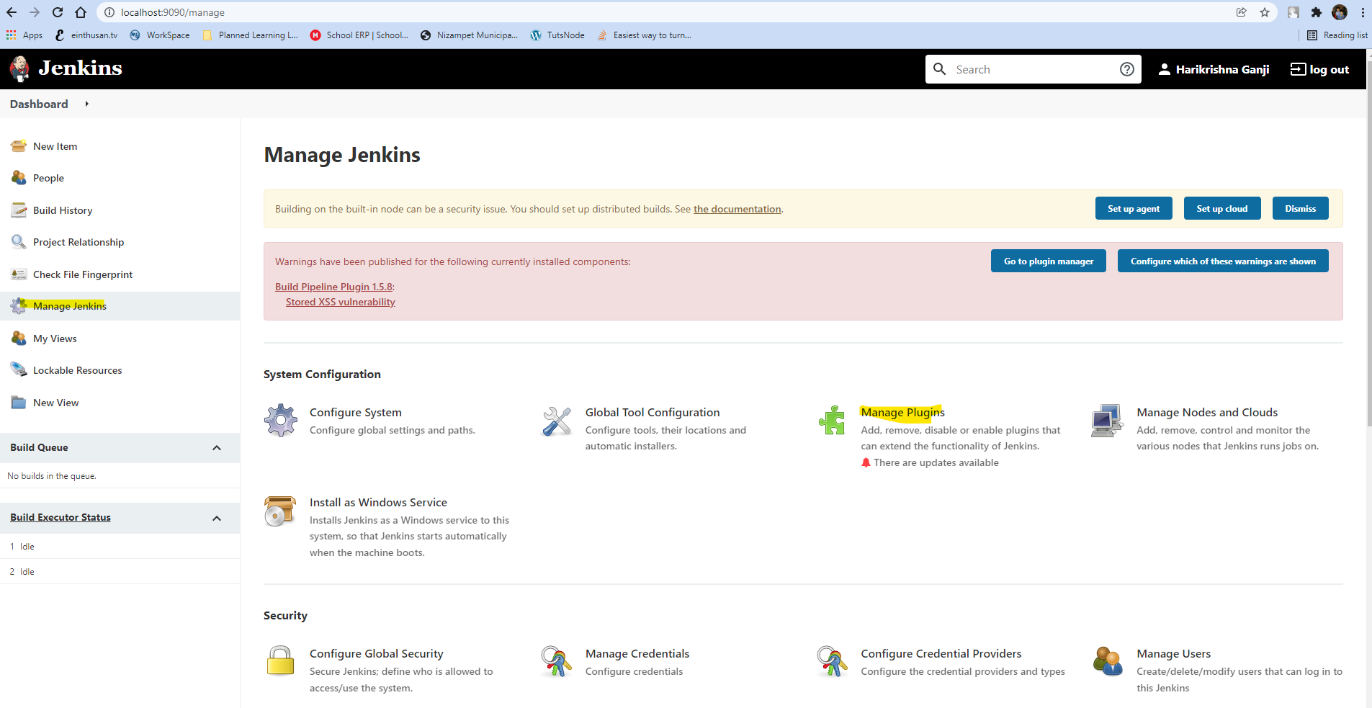

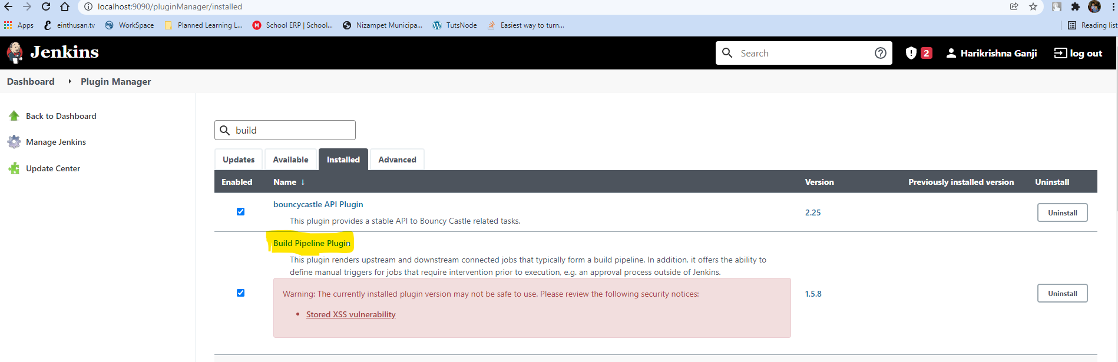

Once you installed that create an application view “Pipeline Tomcat View” by clicking on ‘+’ symbol.

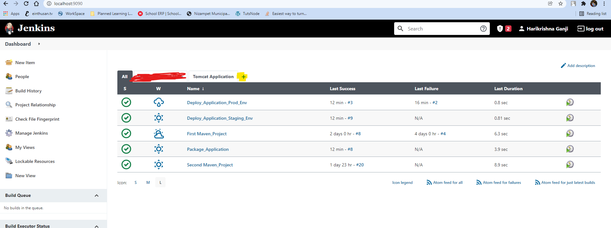

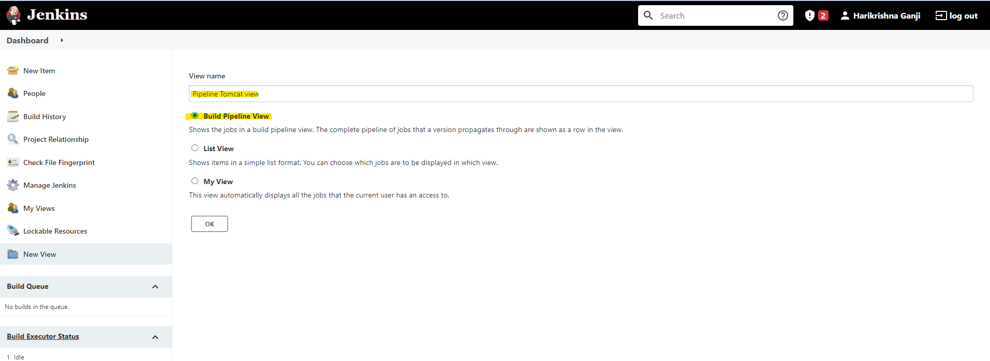

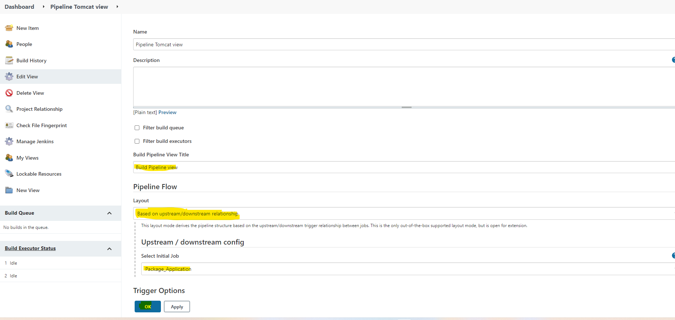

Now select the build pipeline view it will show the complete pipeline which is upstream Job and which are downstream jobs.

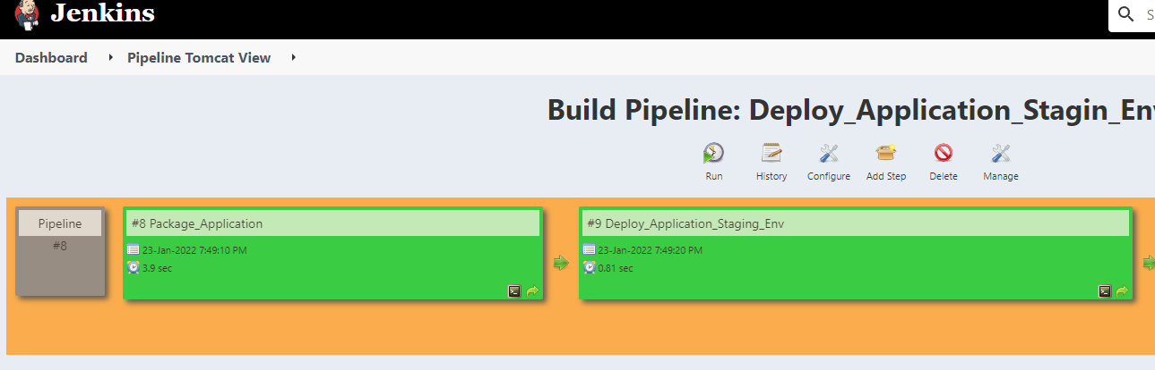

Now we are replicating another tomcat production environment by modifying the port number to 8081. So the production instance of tomcat will run on another port 8081.

For this create another folder “Tomcat_server_prod” and copy the entire tomcat server files to here.

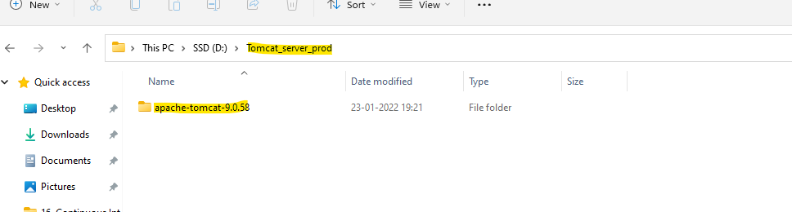

Now modify the port numbers on server.xml which resides on conf directory.

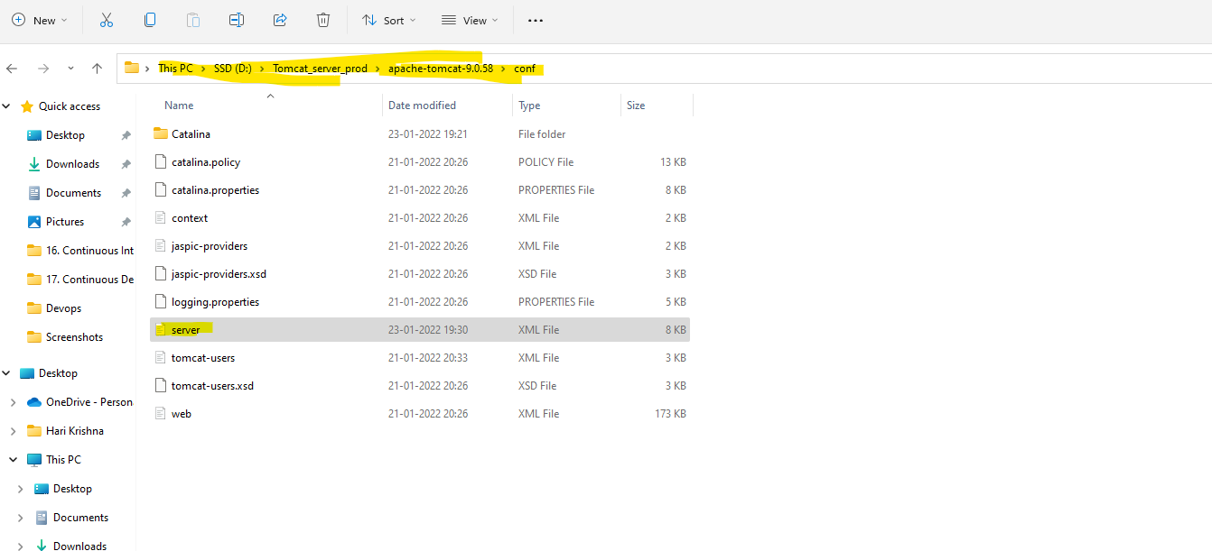

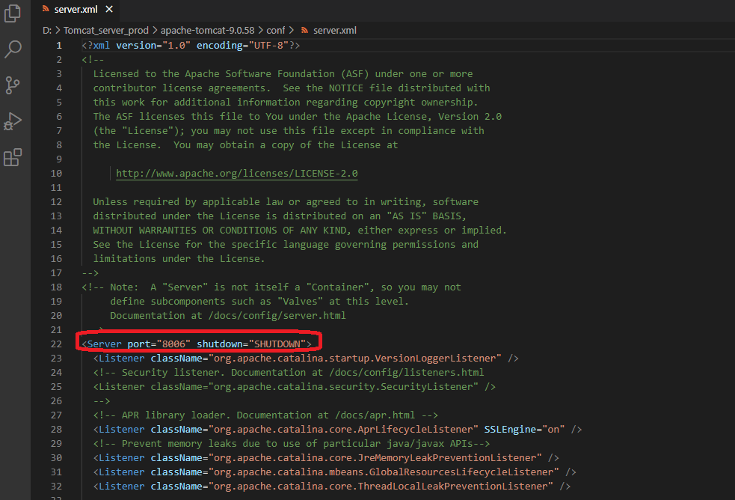

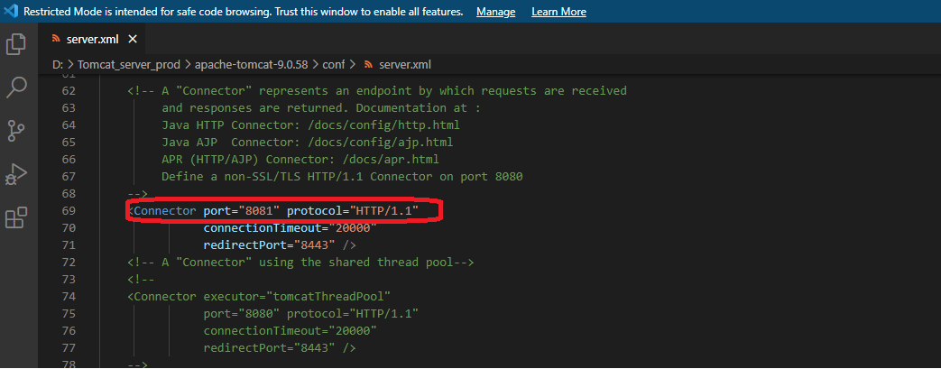

Now save the file and start the tomcat server.

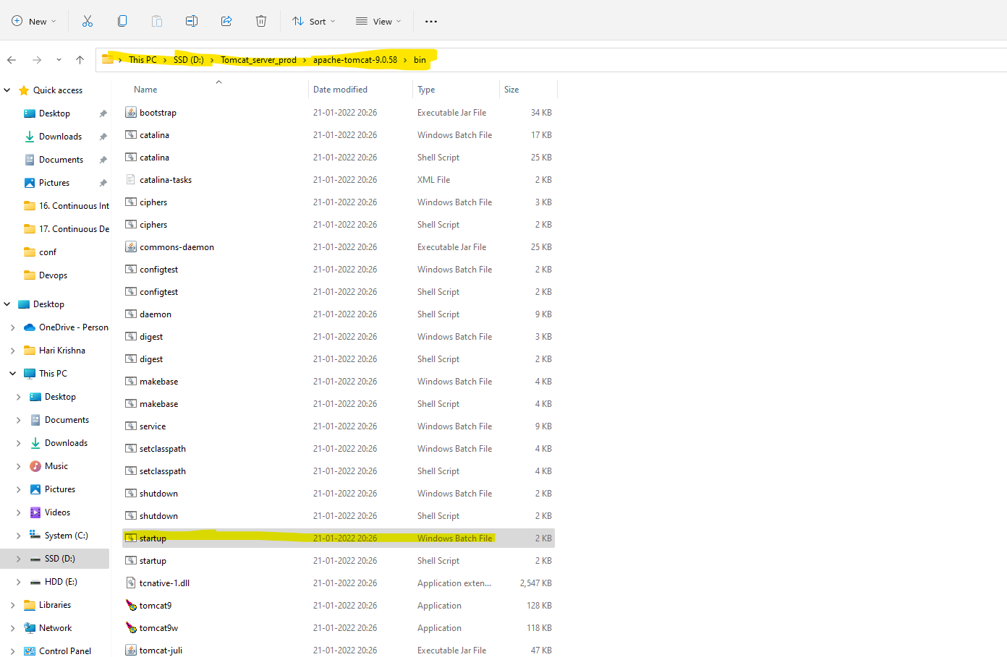

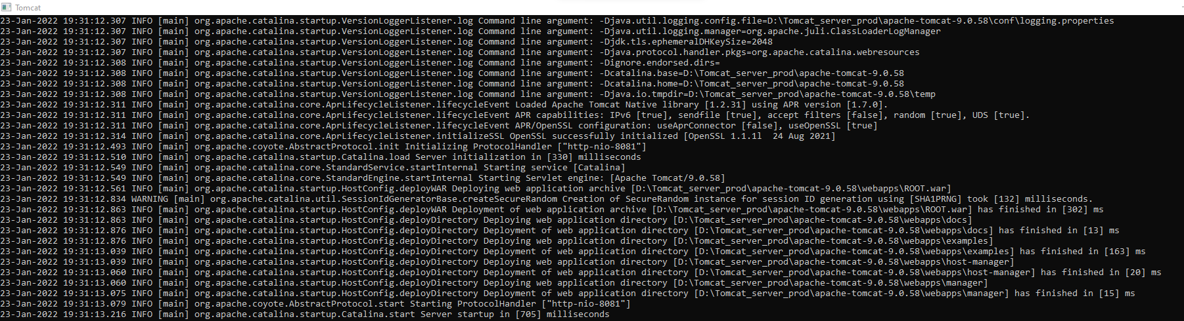

Now my production env is ready, I can access it via <http://localhost:8081>.

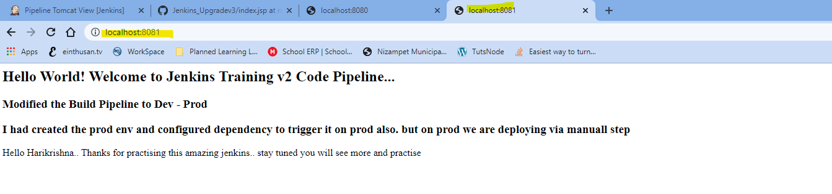

Now we need to configure another Jenkins job with the name “Deploy_Applciation_Prod_env”.

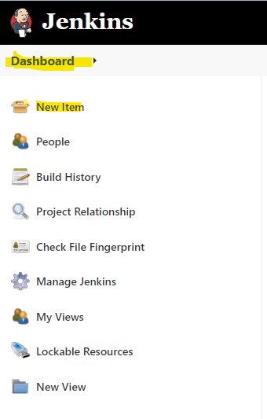

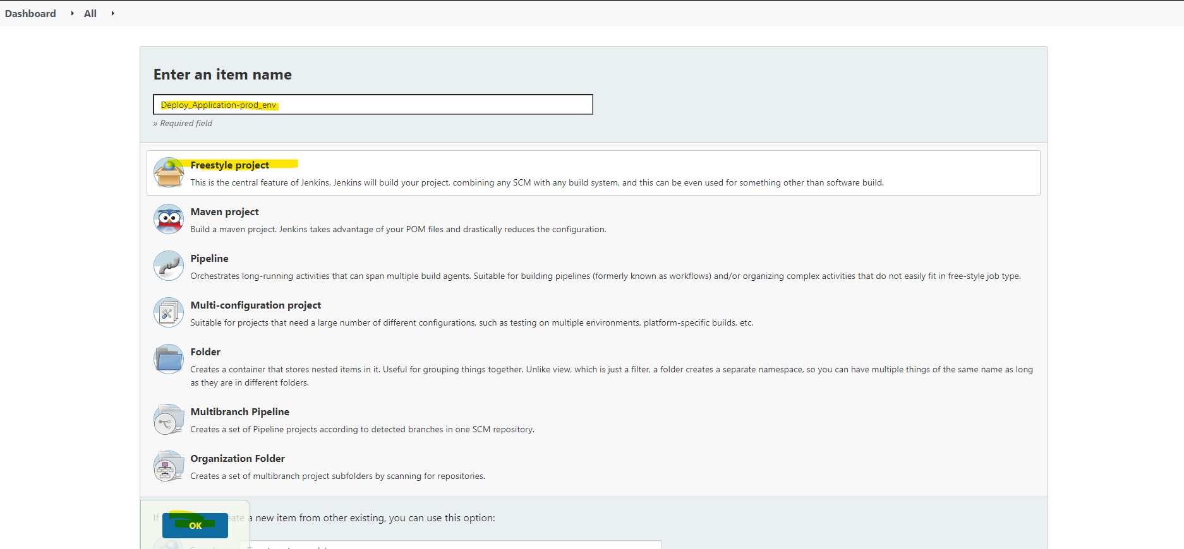

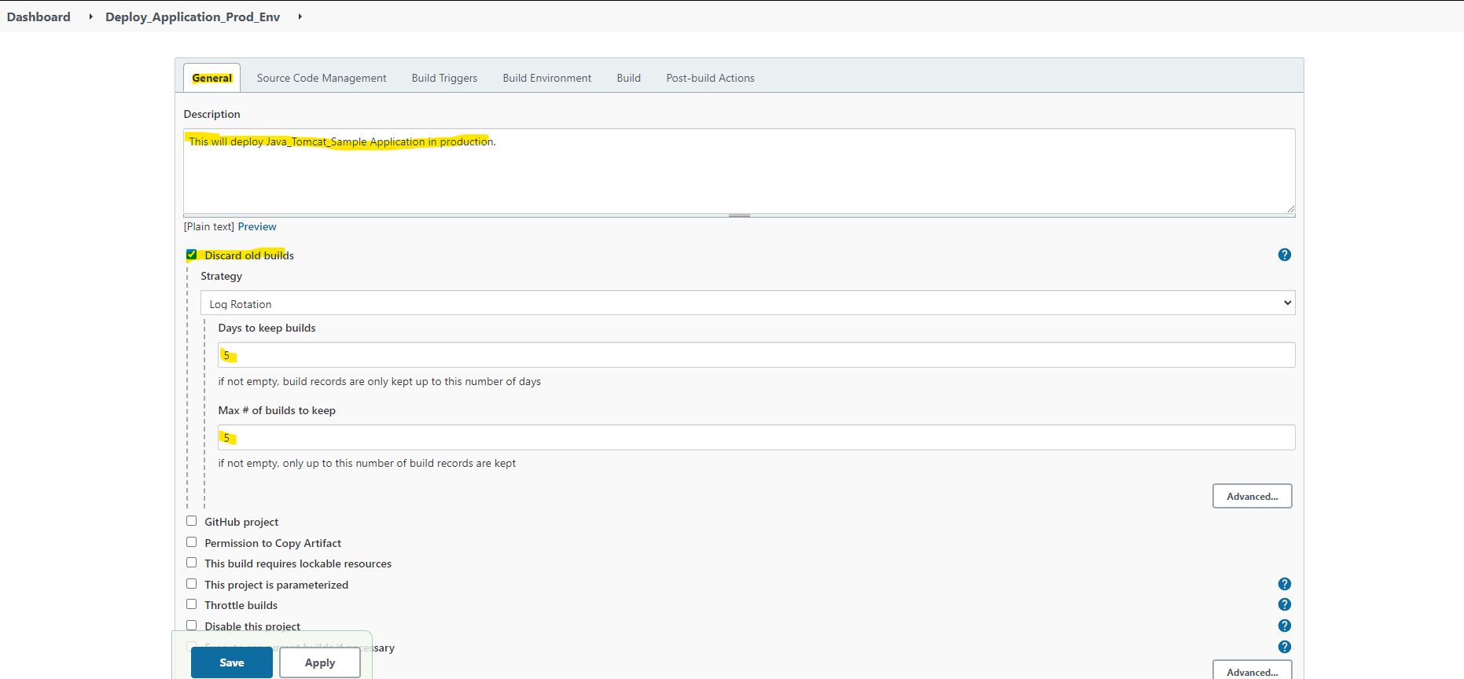

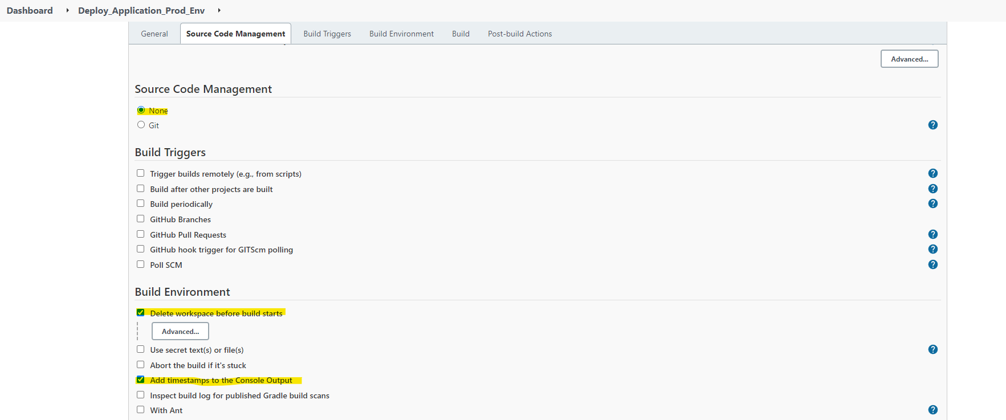

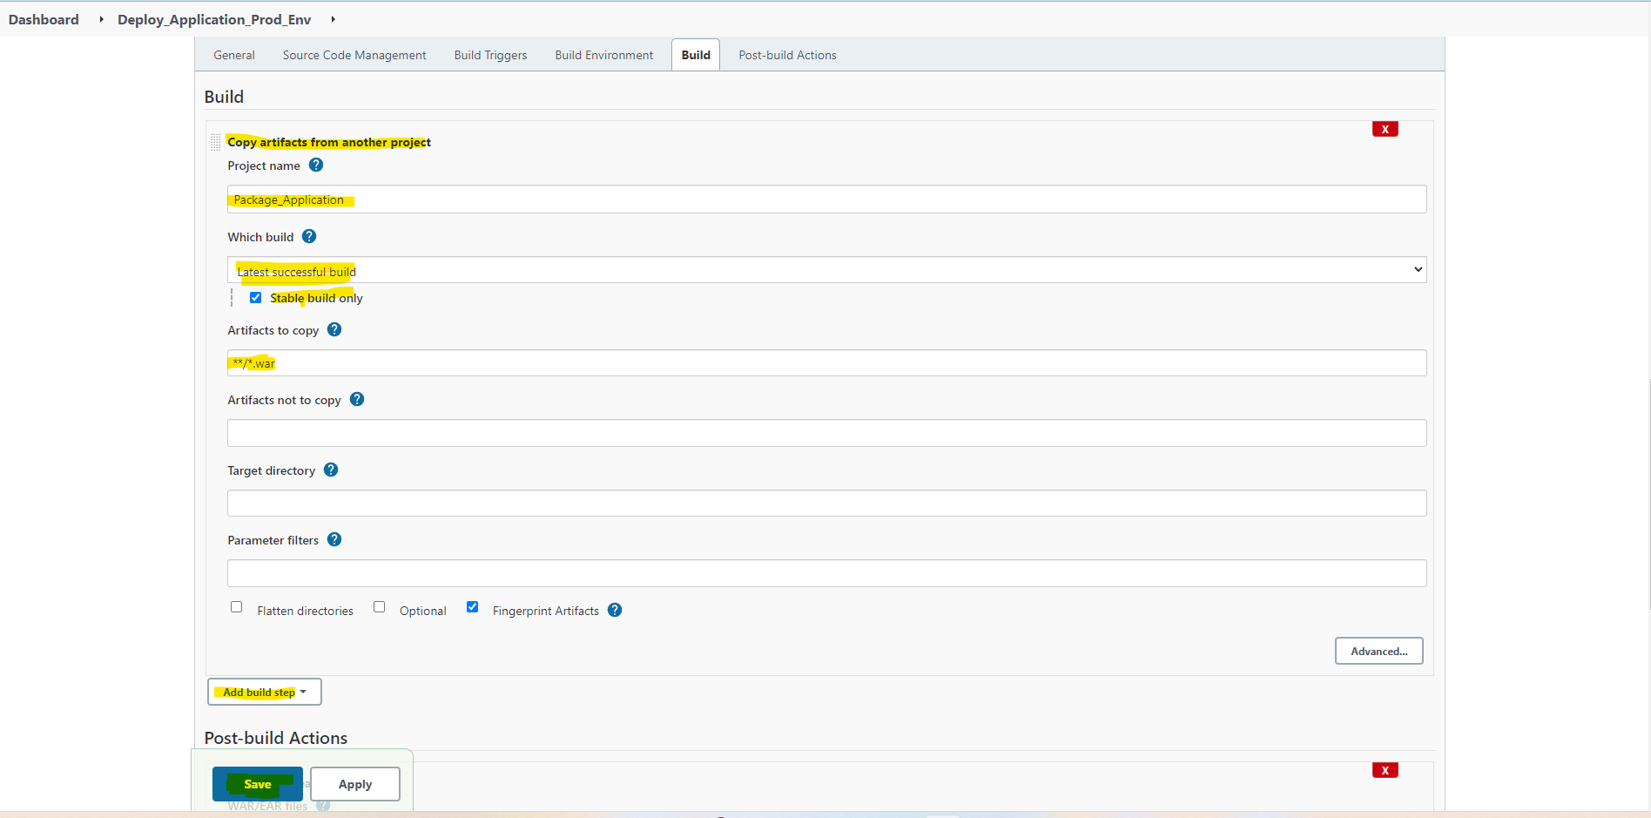

Once you created the Job “Deploy_Application_Prod_Env”, move to the job Deploy_Application_Staging_Env and add the Post-build Action as “Build other projects (manual step) and click on Save

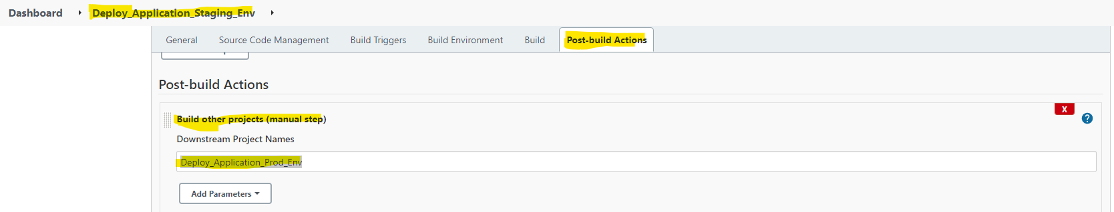

Note: The post “Build other projects (manual step). Doesn’t trigger the build automatically you need to trigger it manually.

Now move to the Jenkins Job “Deploy_Application_Prod_Env”, configure the post action “Deploy war/ear to a container”.

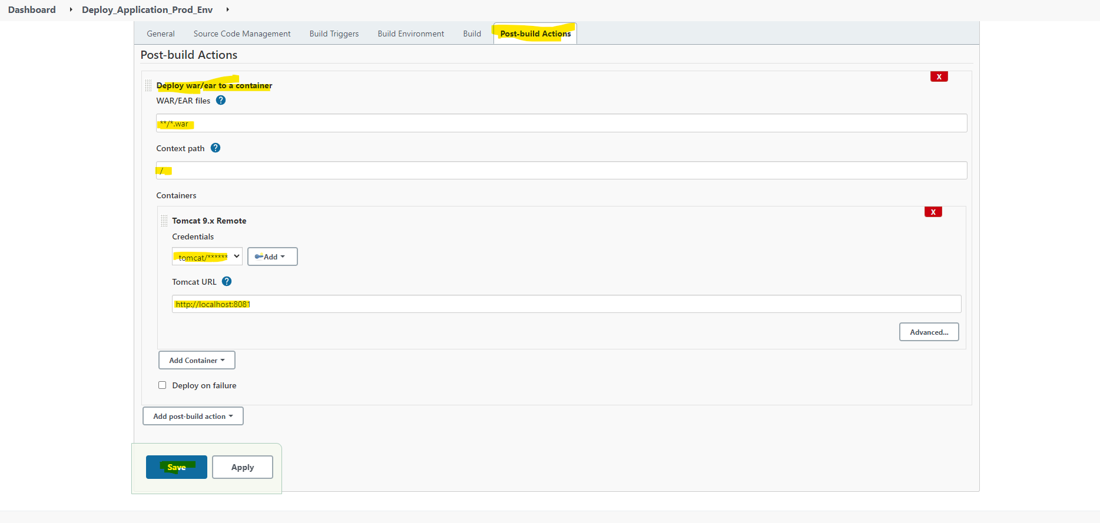

Now modify the github and change the source code and commit it, as the Jenkins job “Package_Application” configured to poll scm for every minute, it will trigger a build automatically after one minute.

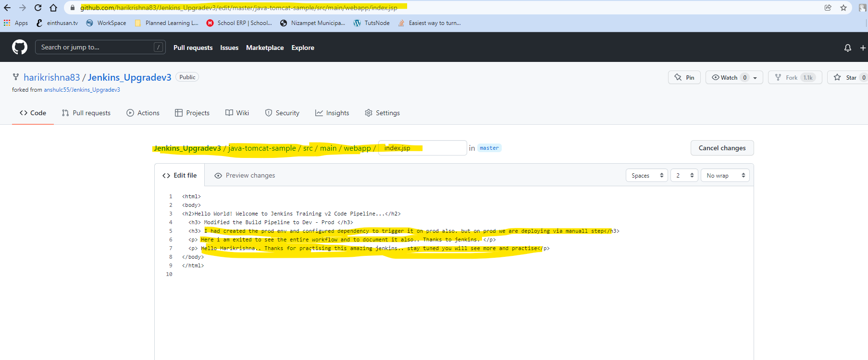

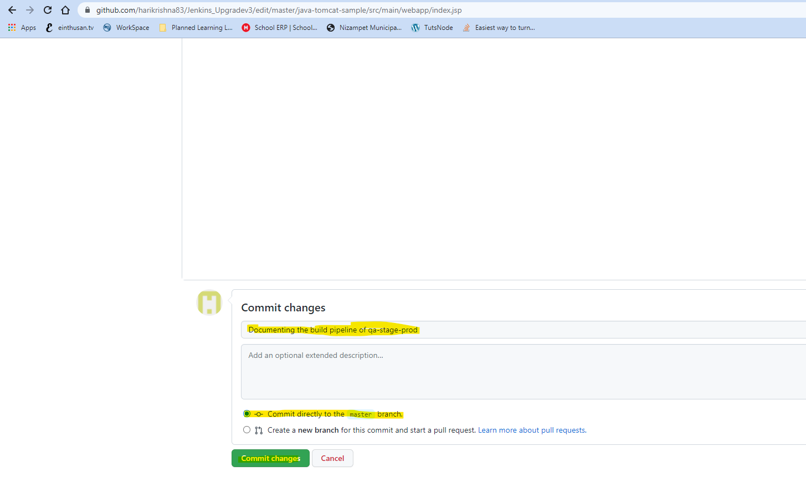

Now after 1 min, you can check on build pipeline view, the job Package_Application got triggered automatically.

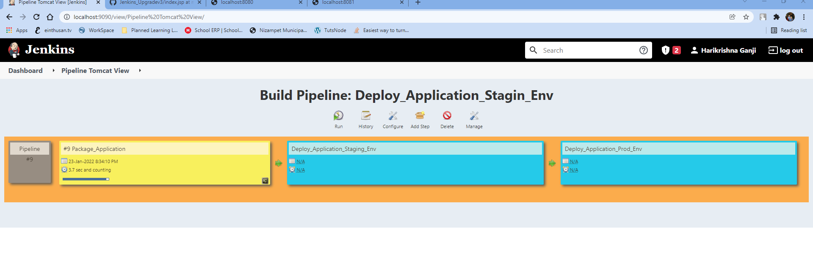

Subsequent job Deploy_Application_Staging_Env also triggered and the last job Deploy_Application_Prod_env won’t execute it automatically as we had configured it to execute manually.

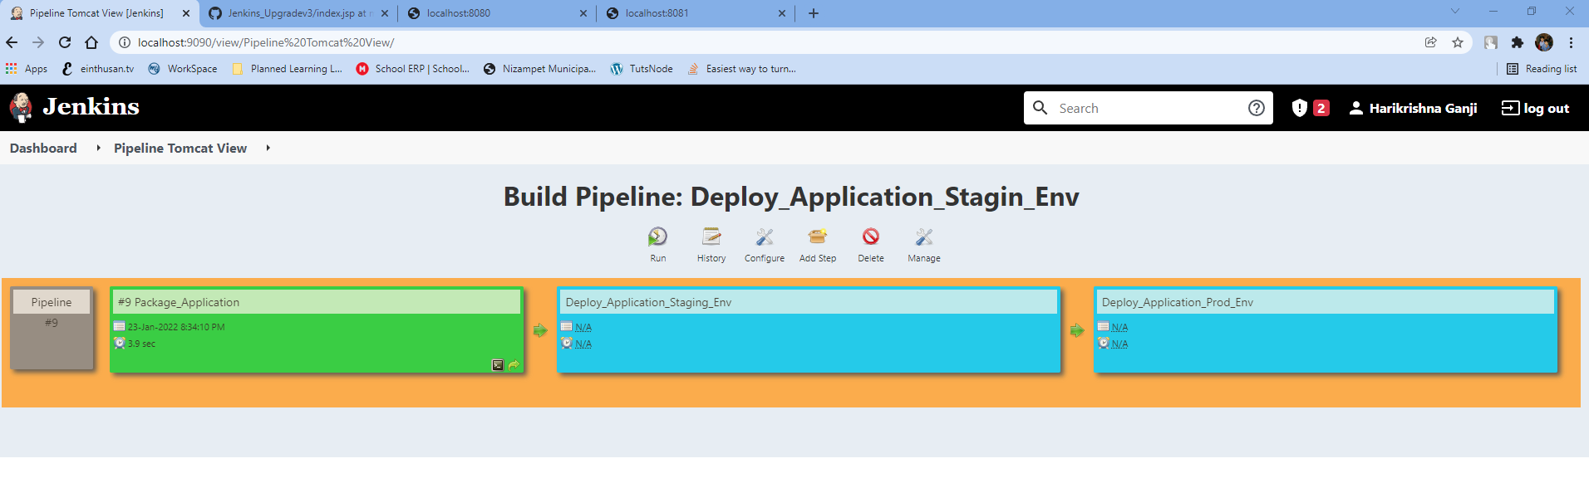

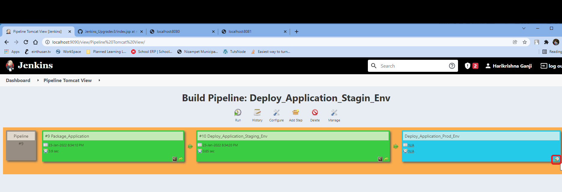

Once I click the above highlighted icon, the job will triggered and completed successfully.

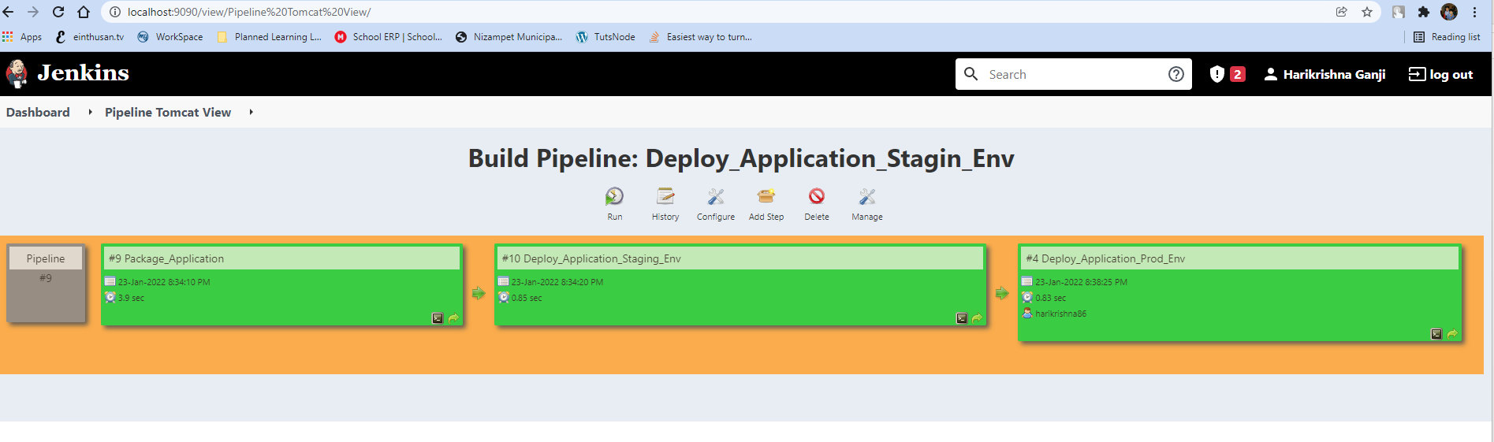

You can view the console output of each individual jobs by clicking the below highlighted icons.

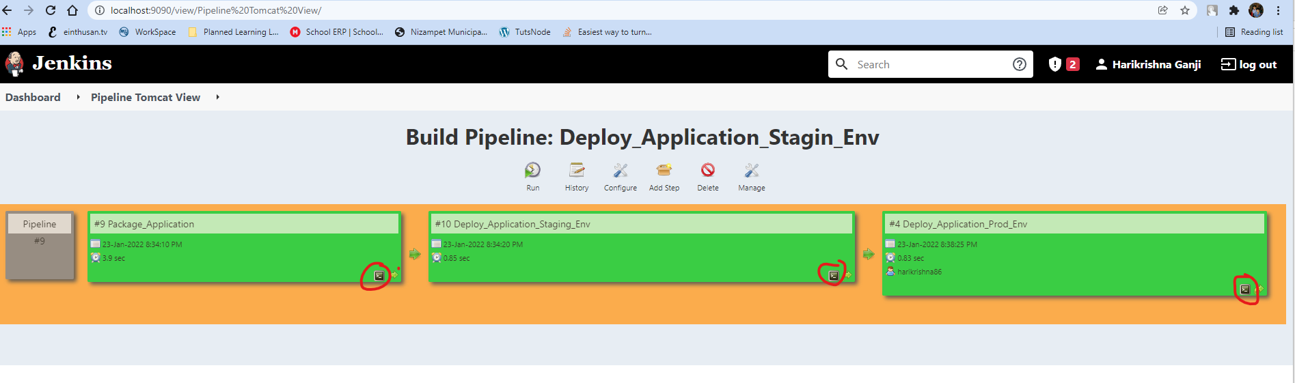

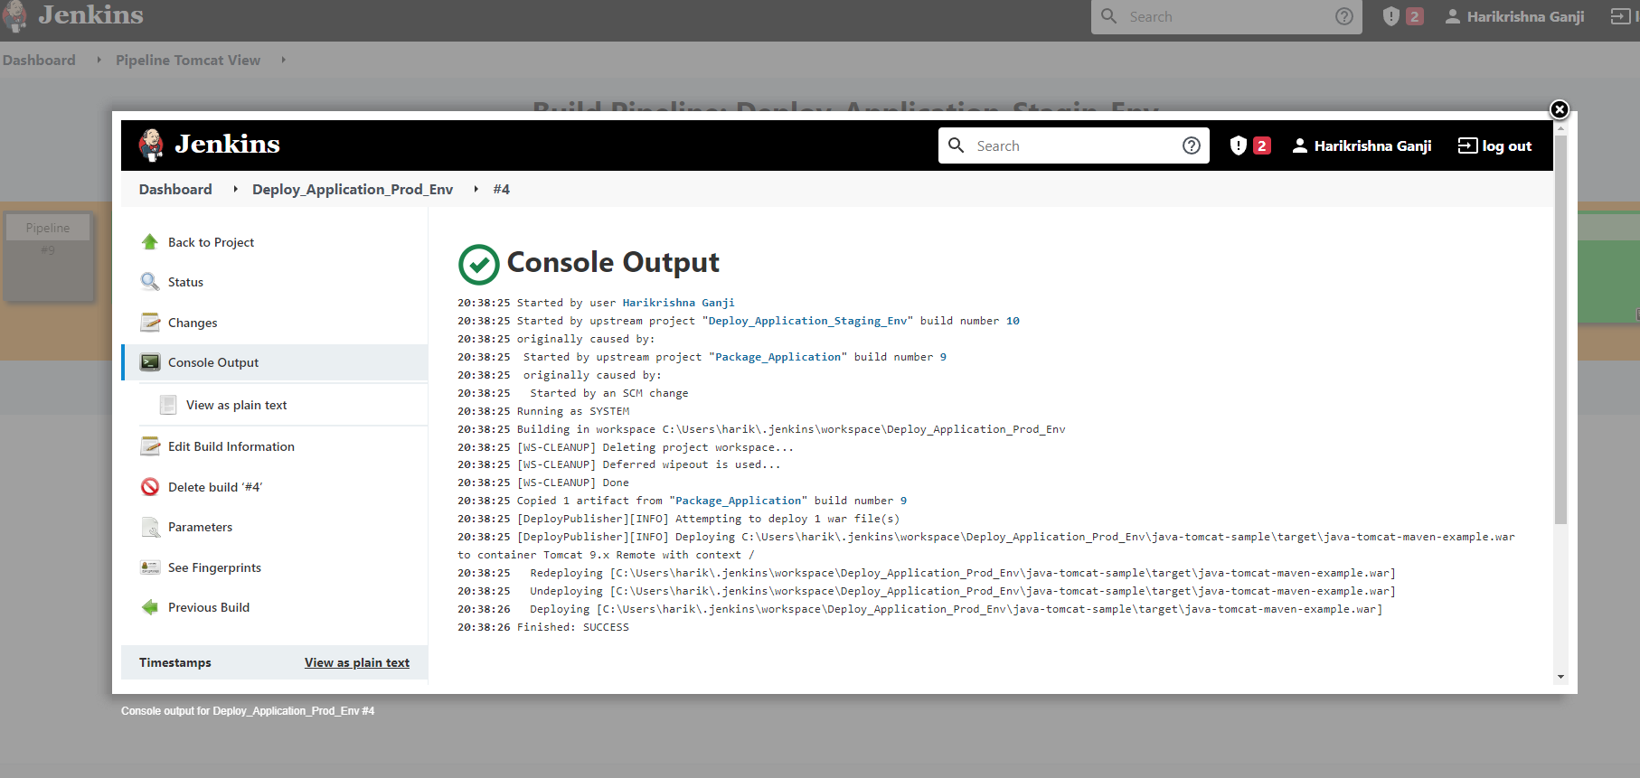



**Creating a Job via DSL (Infrastructure as a code):**

DSL uses groovy language which can create a jobs automatically via code.

So initially we need to create Seed job to fetch the Groovy file and that Groovy file contains the code to create a new Job.

Before proceeding we need to install the plugin.

DSL 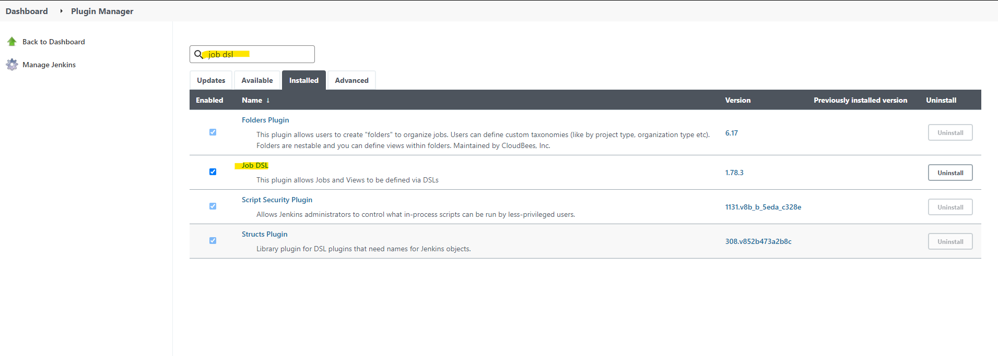

DSL is plugin which will read the code in groovy and the documentation will be available on the following link.

<https://jenkinsci.github.io/job-dsl-plugin/#path/freeStyleJob>

Now create the file with the name “MavenProjectDSL.groovy” and commit the code on source repository “[**maven-samples**](https://github.com/harikrishna83/maven-samples)” as shown below.

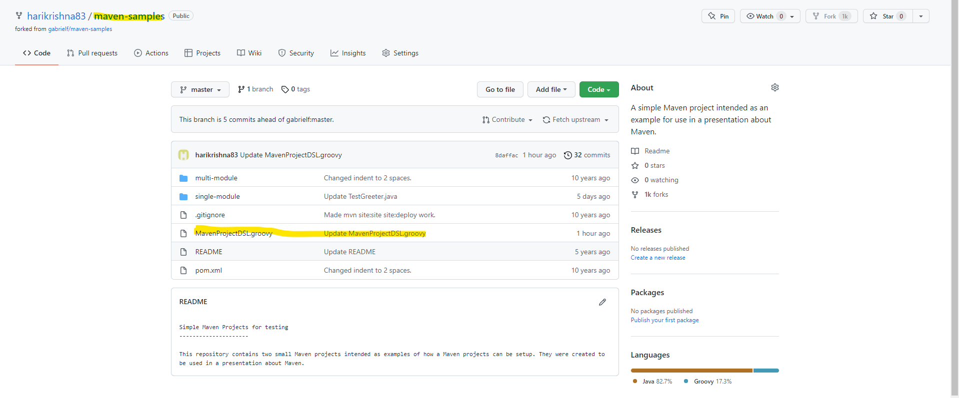

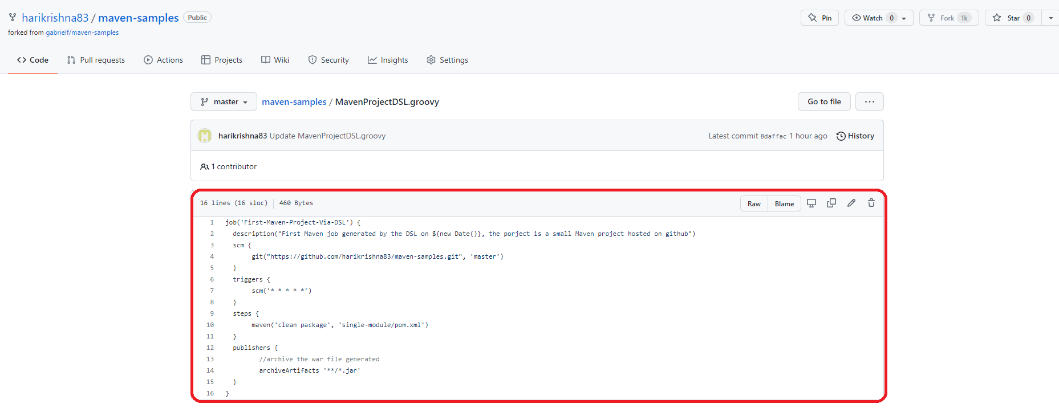

Now from the code, it will create the following things

1. It will create a job First-Maven-Project-Via-DSL with the following description mentioned.

description("First Maven job generated by the DSL on ${new Date()}, the porject is a small Maven project hosted on github")

1. It will look for the source code repository mentioned above to the master branch.
2. It will poll the source code management for every minute.
3. It will execute the Maven goals and create a war file.
4. It will clean the generated artifacts.

Now we need to create a Seed Job on Jenkins which this job will pull the groovy file and build the job mentioned.

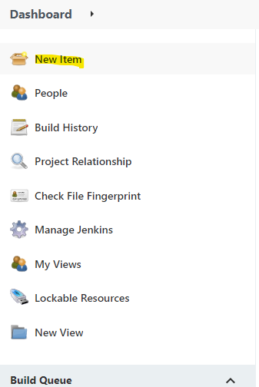

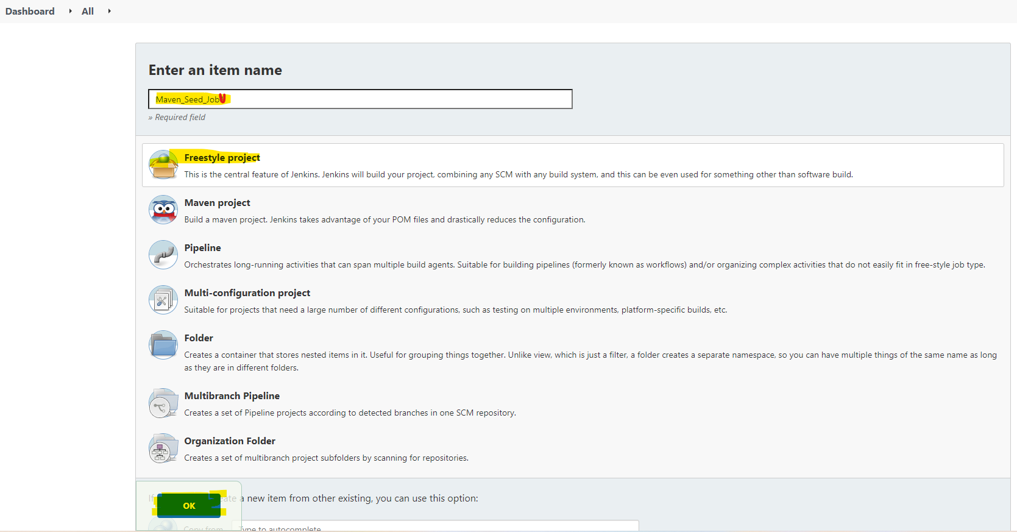

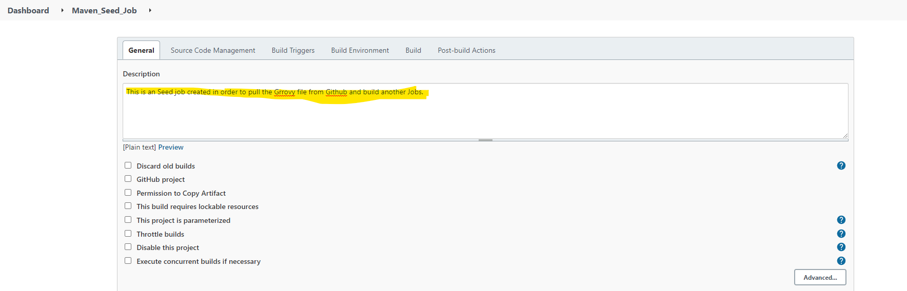

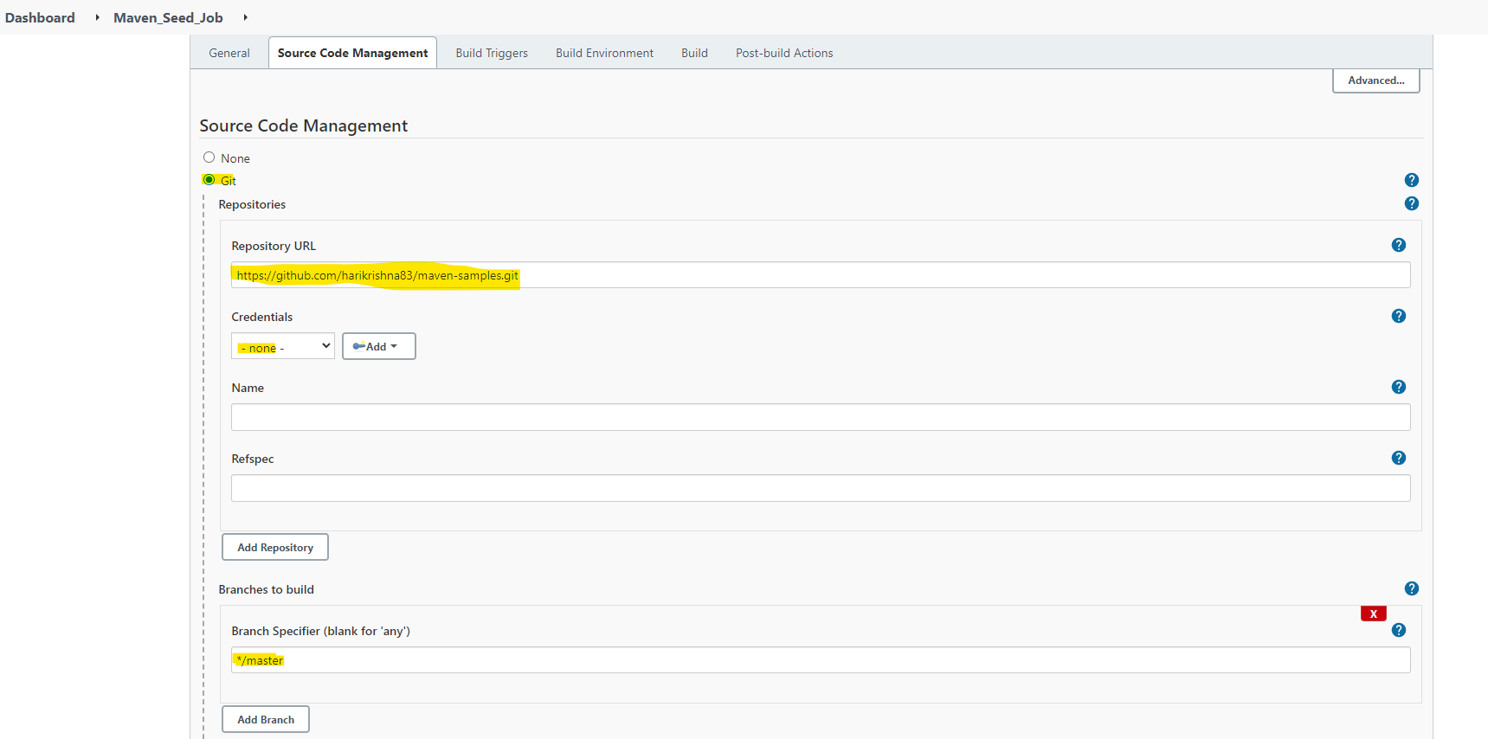

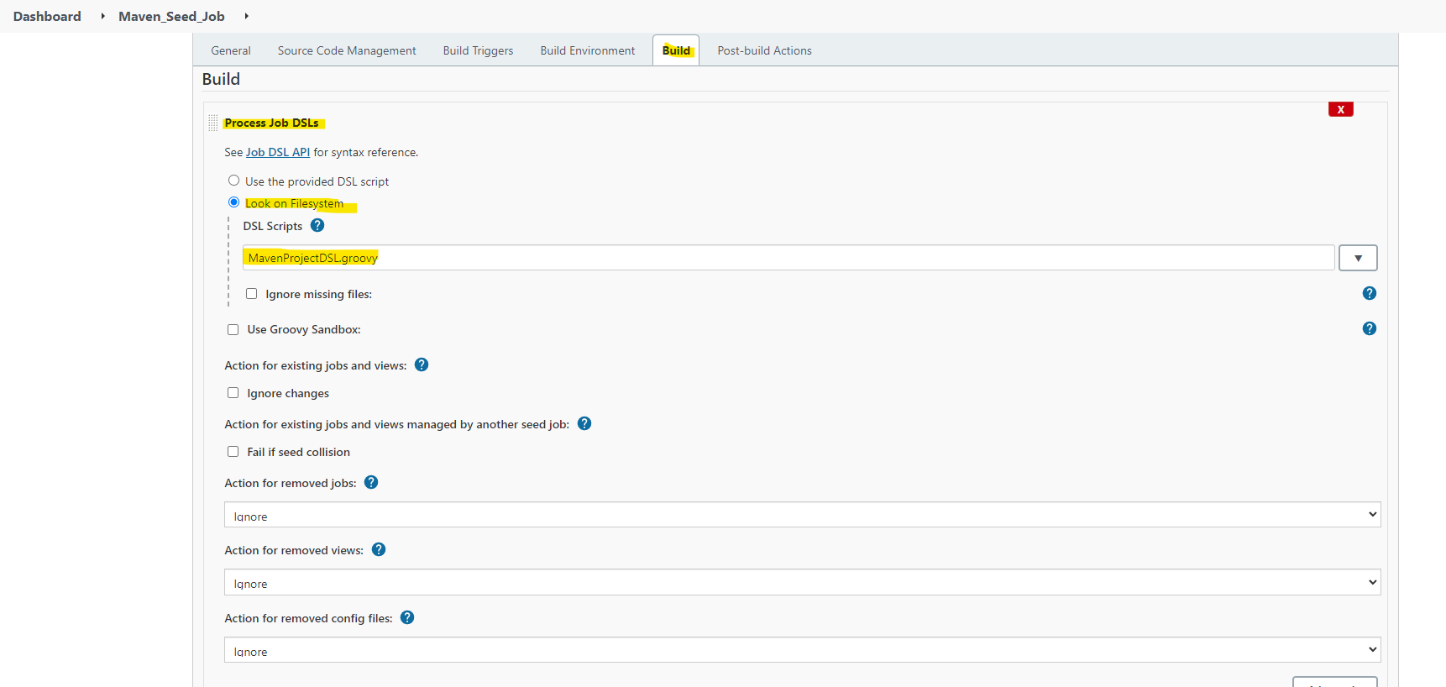

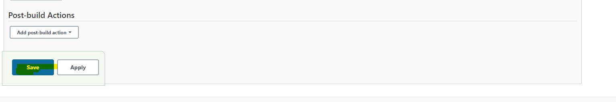

Once you build the seed job execute the job, it will throw an error. Because for every modifications of the Groovy script you need approve it.

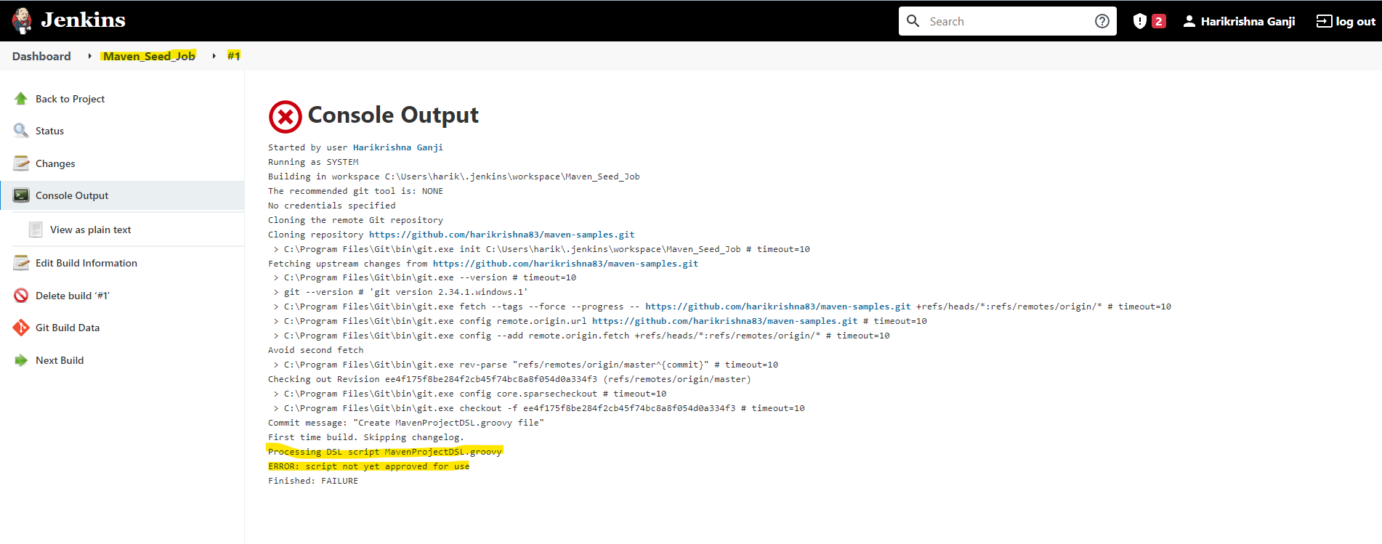

In order to approve the script, click on “Manage Jenkins” and click on “In-process Script Approval”.

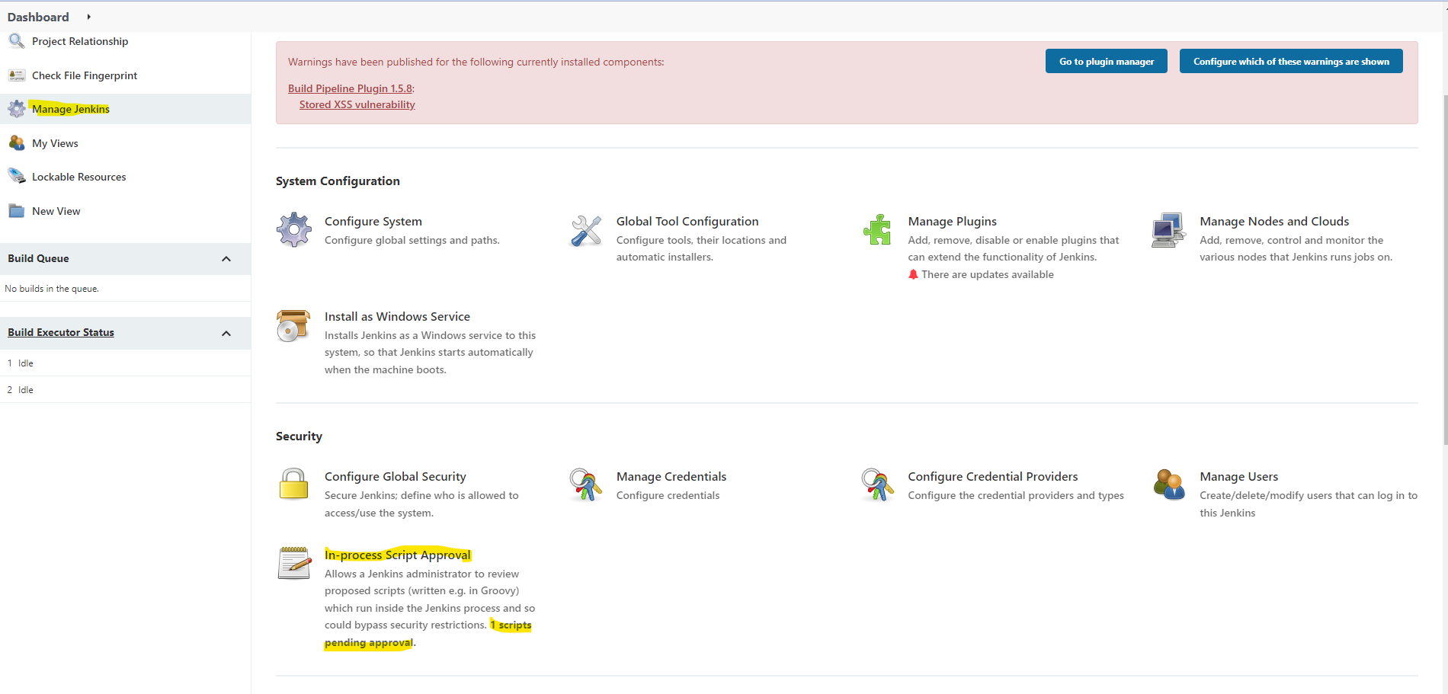

Now verify the script and click on Approve as shown if everything looks good.

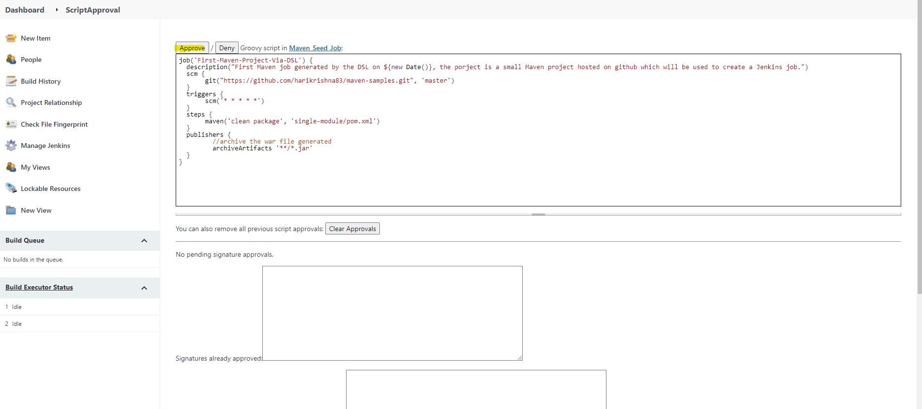

Now go to Jenkins seed job and build it again

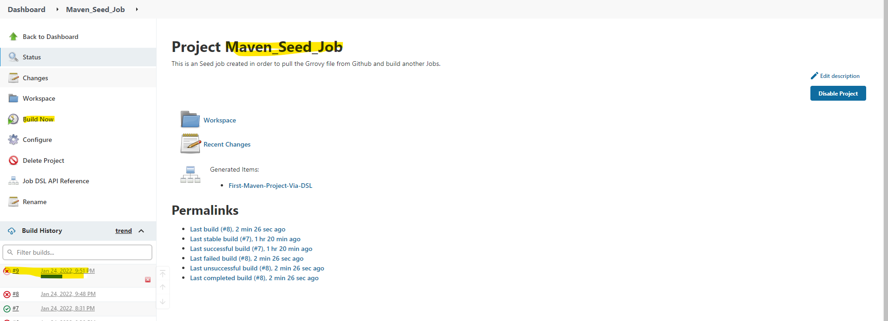

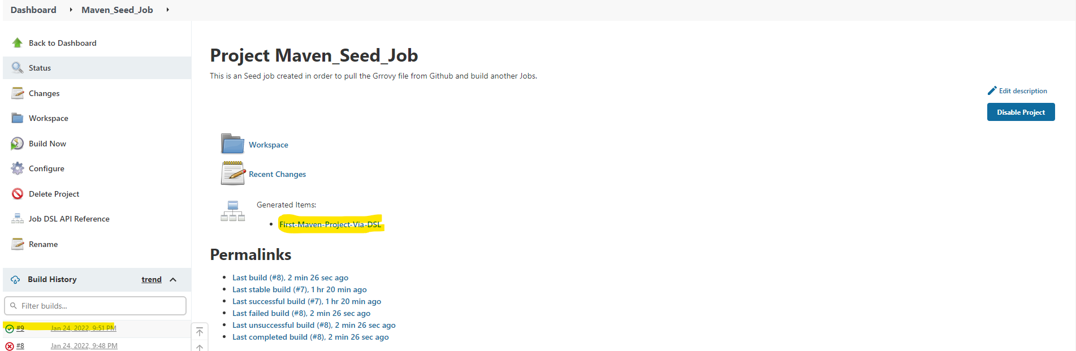

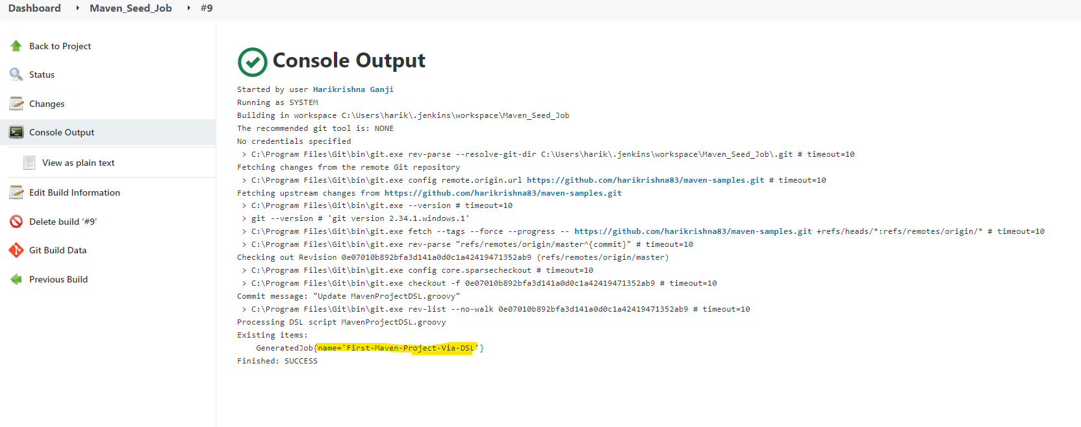

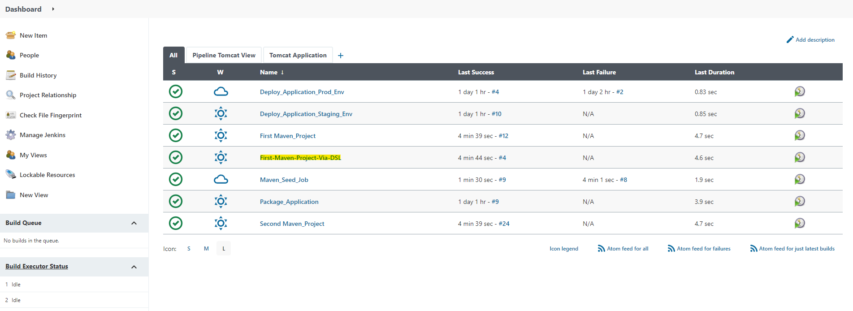

Now you can go and build your created Jenkins project “First-Maven-Project-Via-DSL”.

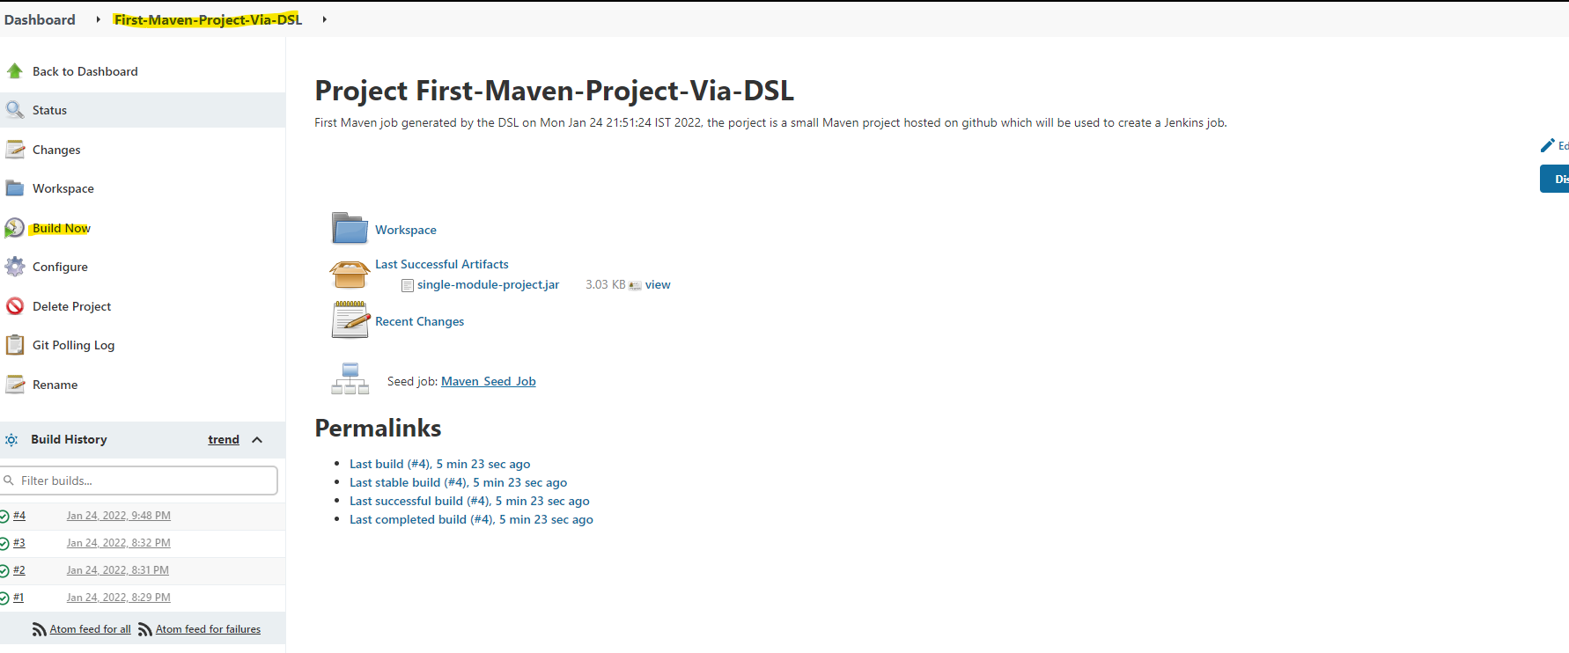

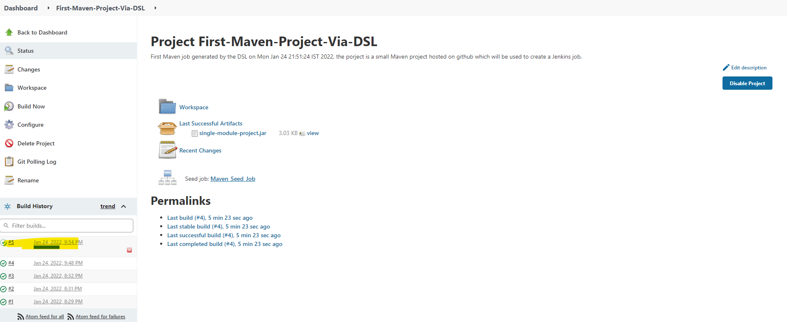

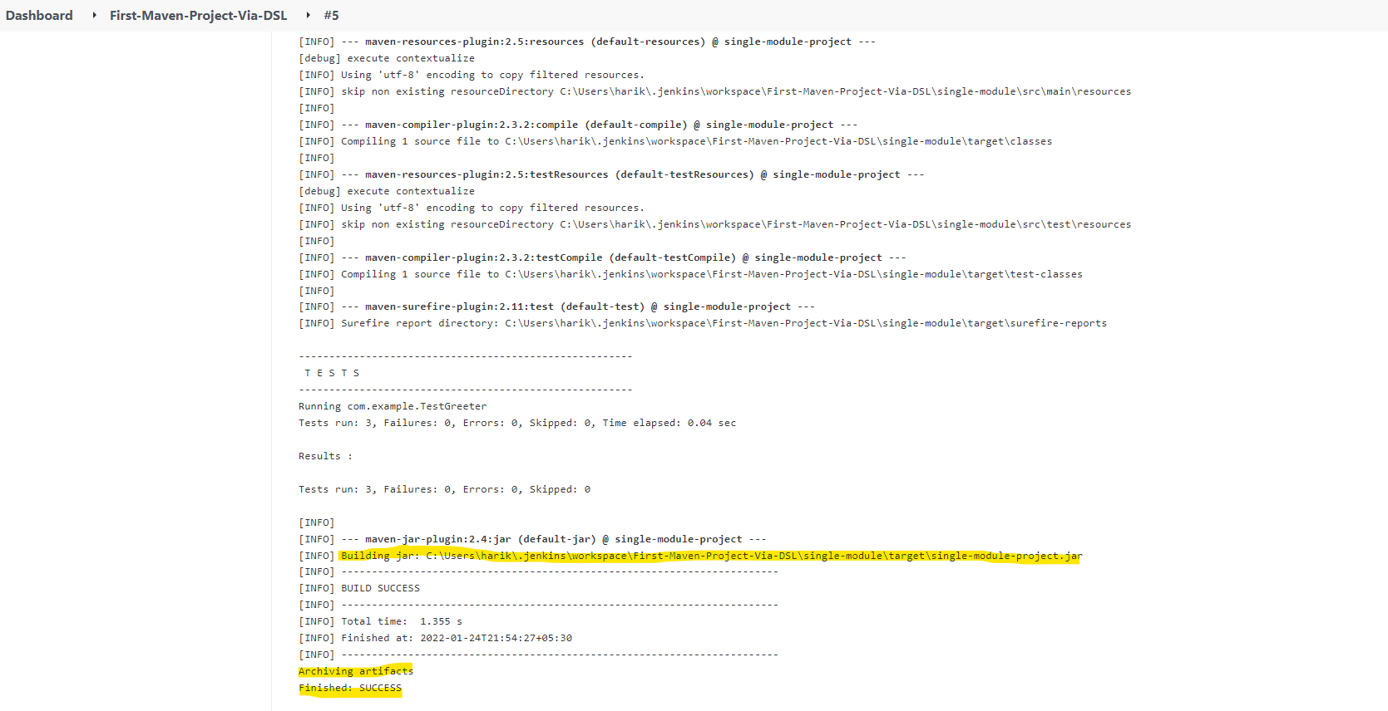

**Building Code pipeline Using DSL (IaaC):**

Previously by using the DSL Groovy language, we had built a single Jenkins Job, now we are going to create a Jenkins code pipeline itself by using the DSL language.

For more information Jenkins pipeline documentation, please follow the below link.

<https://www.jenkins.io/doc/book/pipeline/syntax/>

We also need to plugin “Build Pipeline Plugin” to be installed before proceeding, I had already installed and copied the screenshots above.

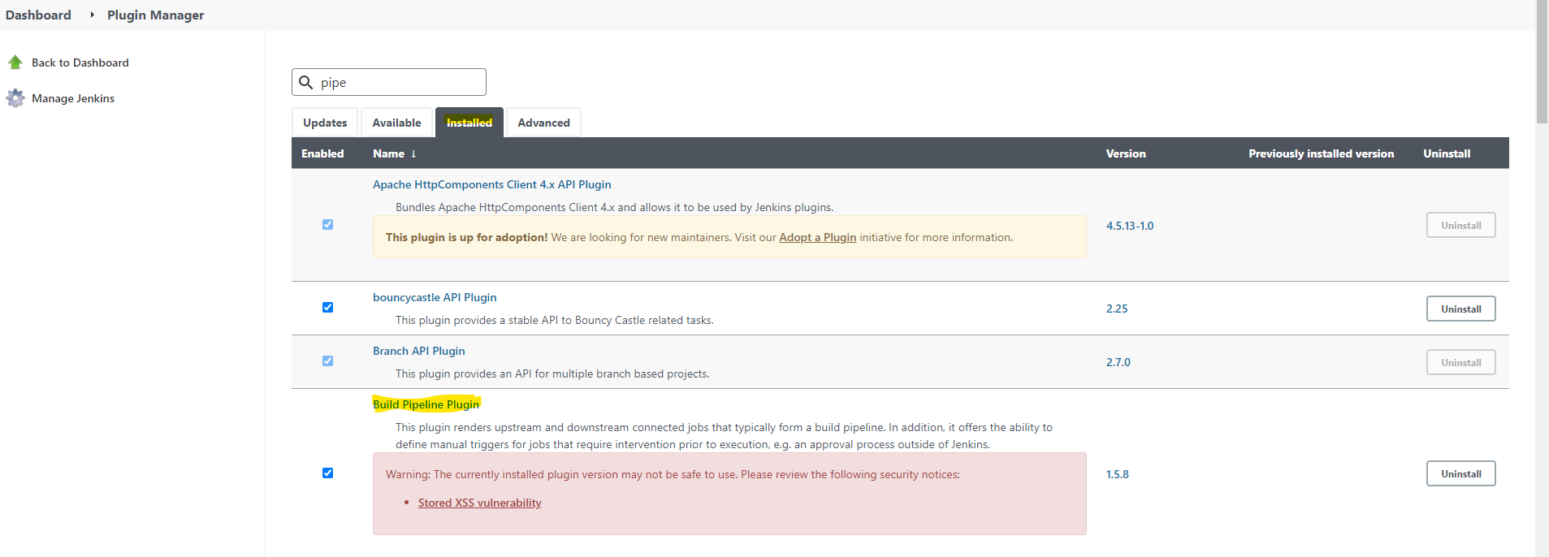

Now we are ready to configure the build pipeline, before we are creating a file “Jenkinsfile” at my and checked in Github maven-samples directory as shown below.

<https://github.com/harikrishna83/maven-samples/blob/master/Jenkinsfile>

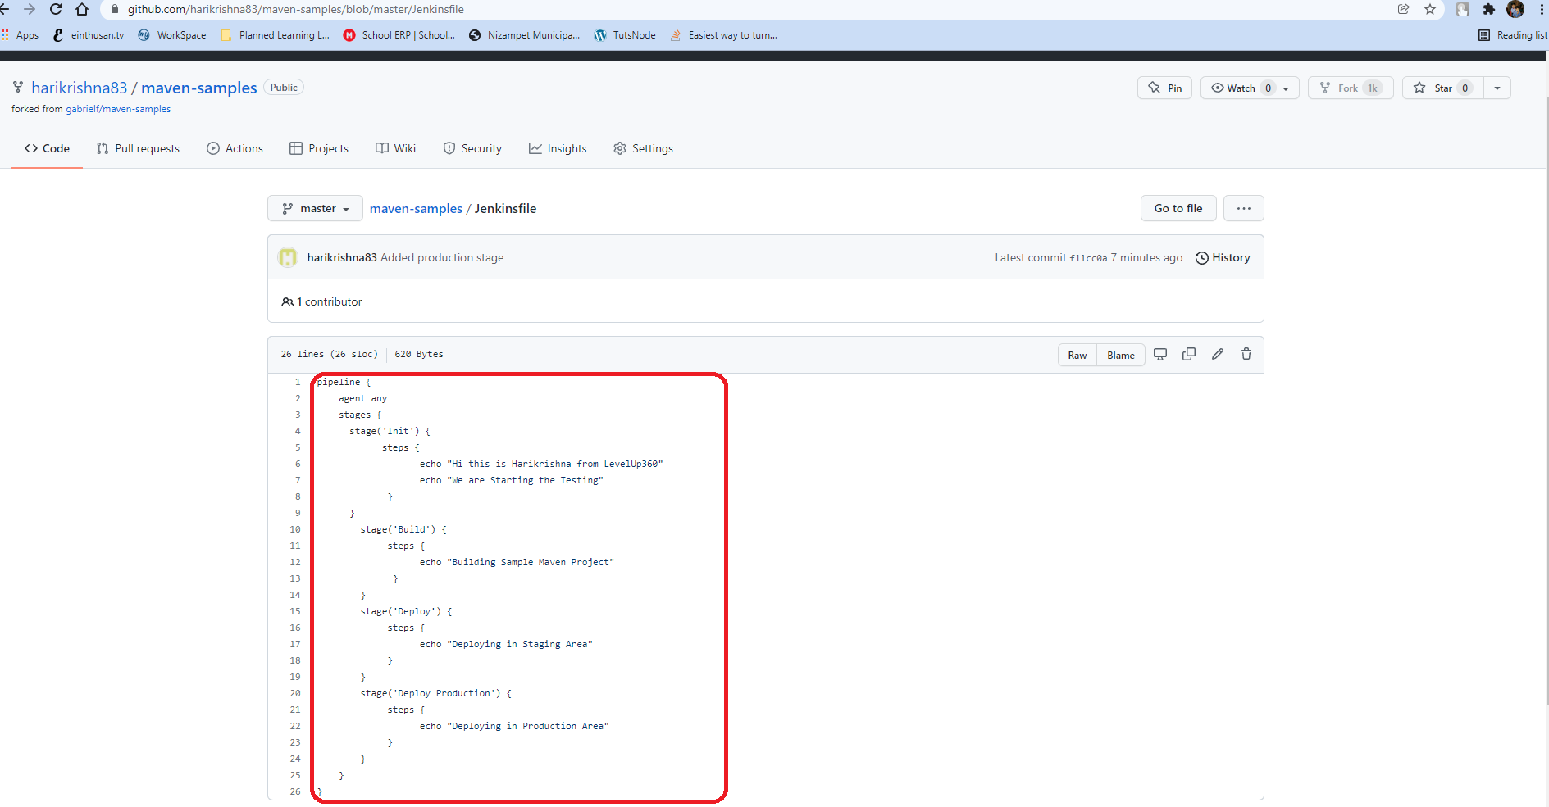

Now create a new project with the name “SampleCodePipeline” and select the project type as Pipeline.

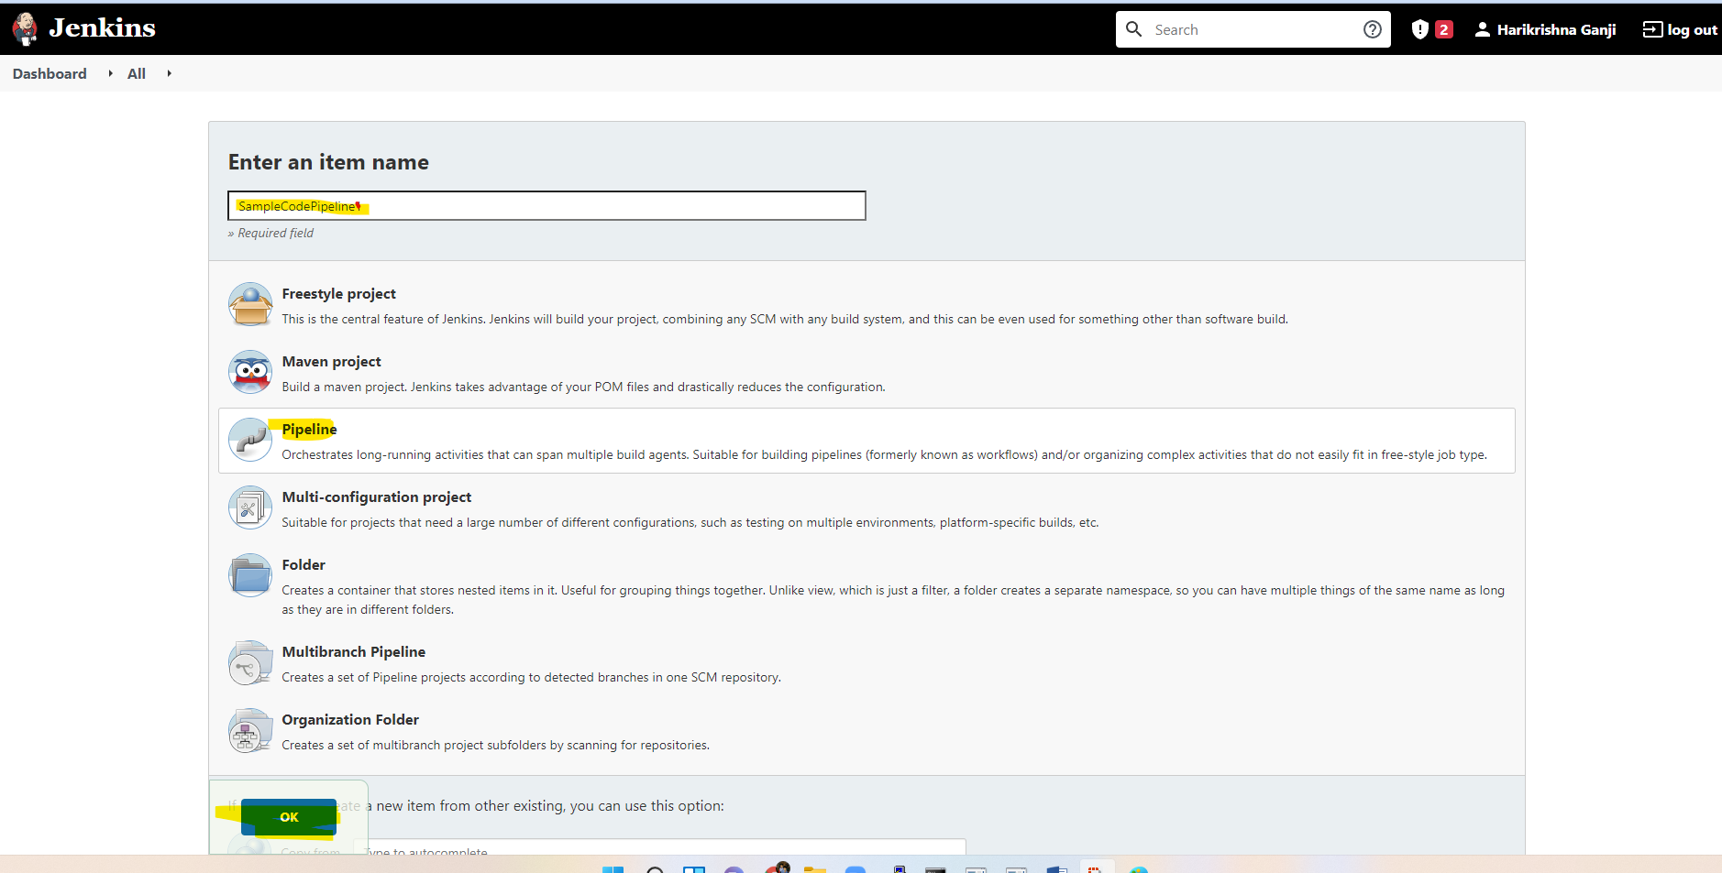

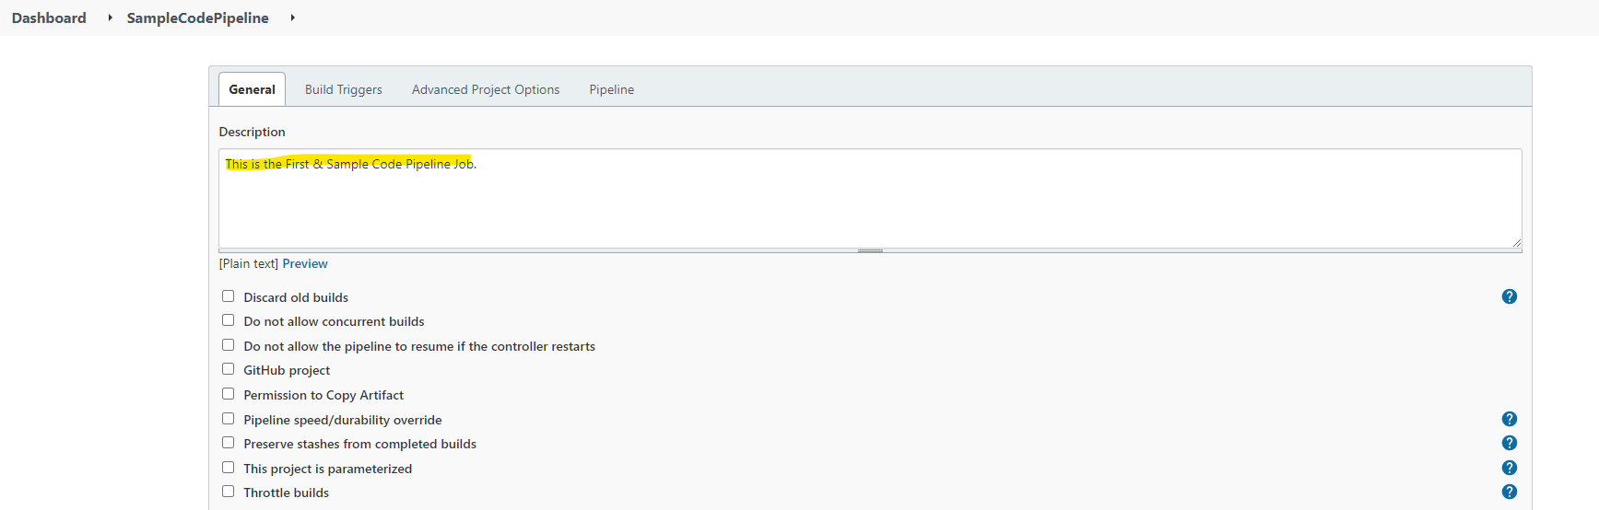

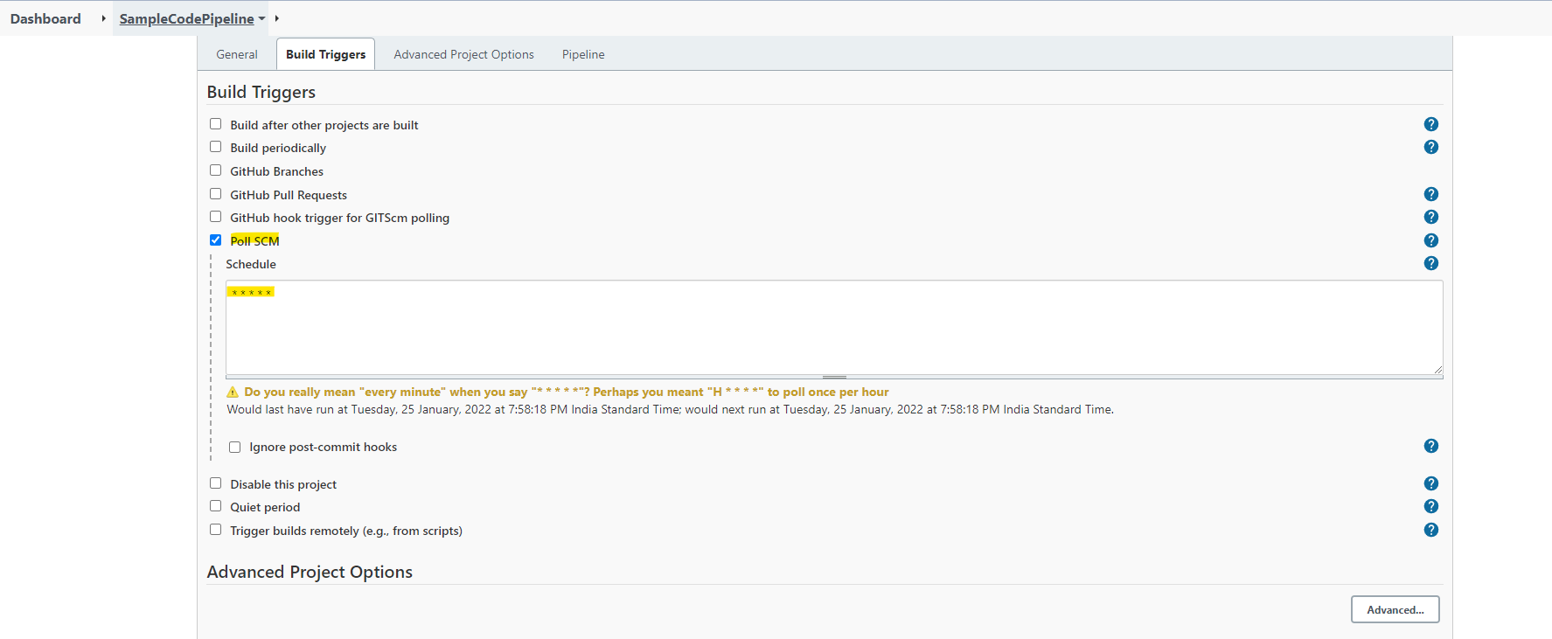

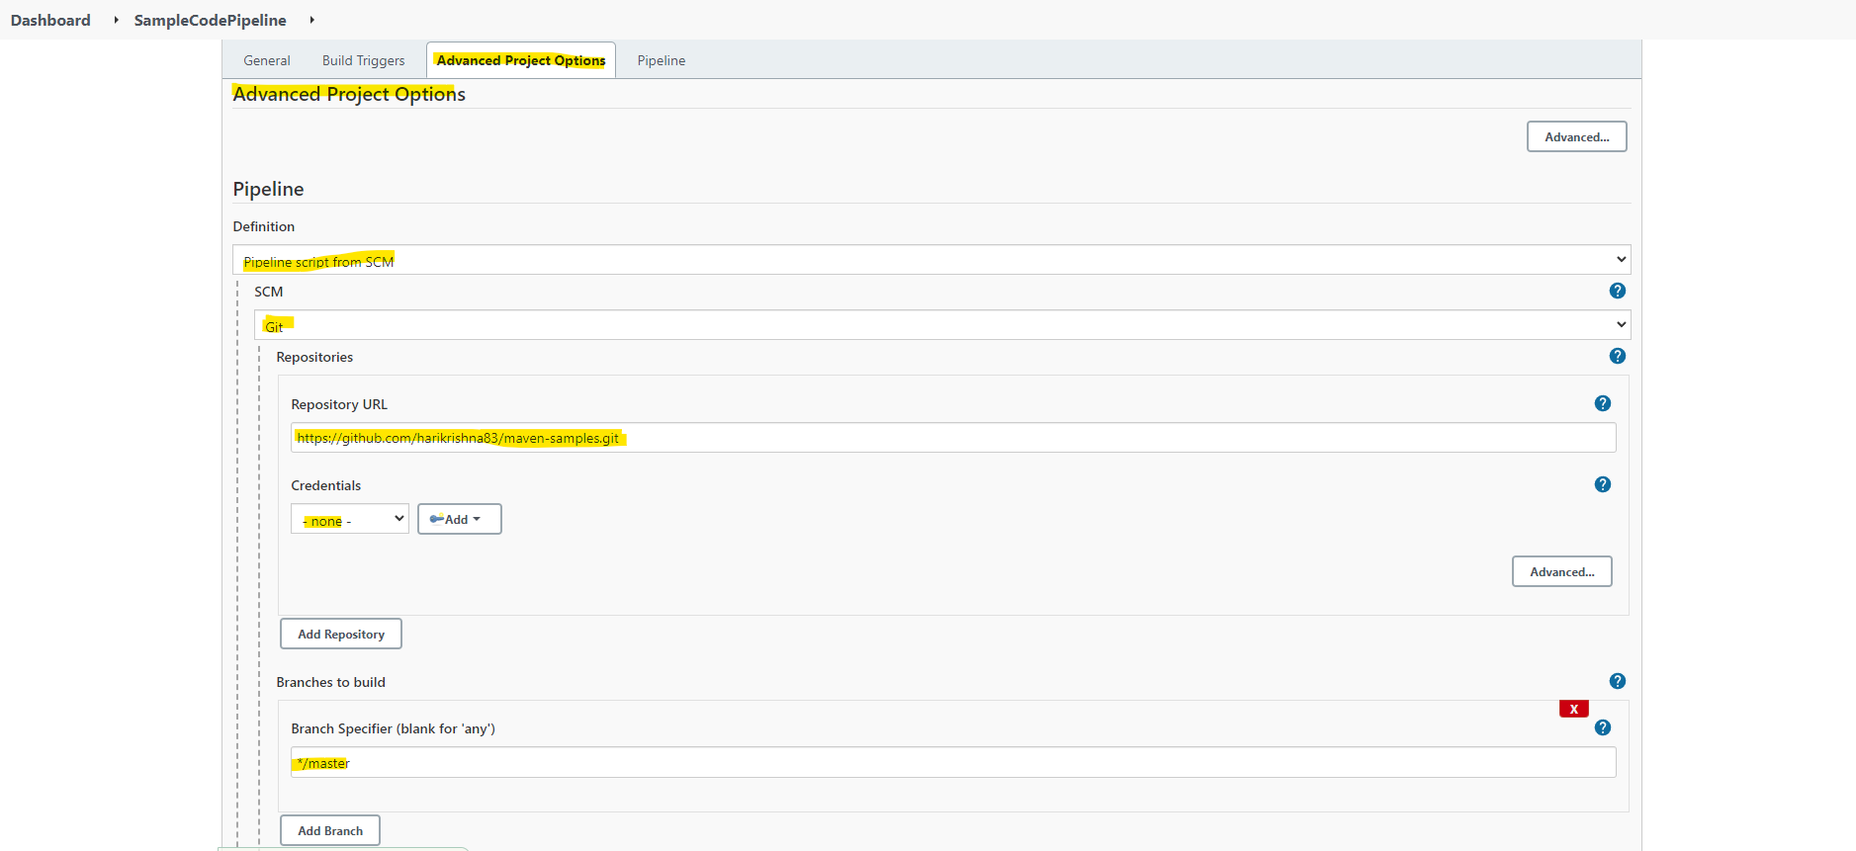

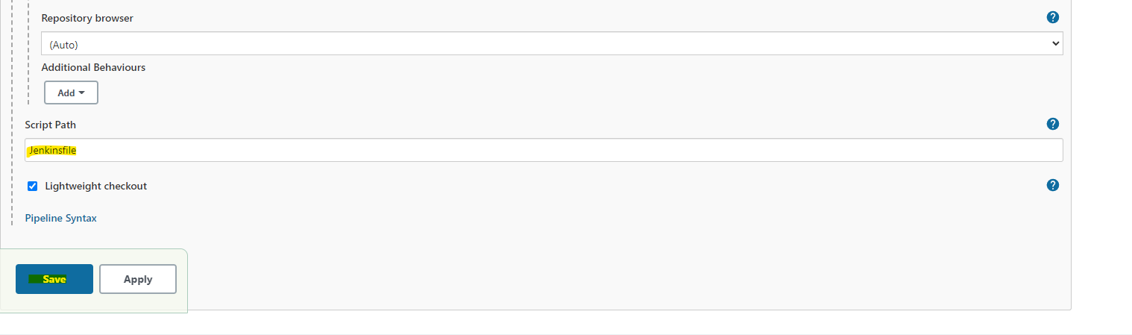

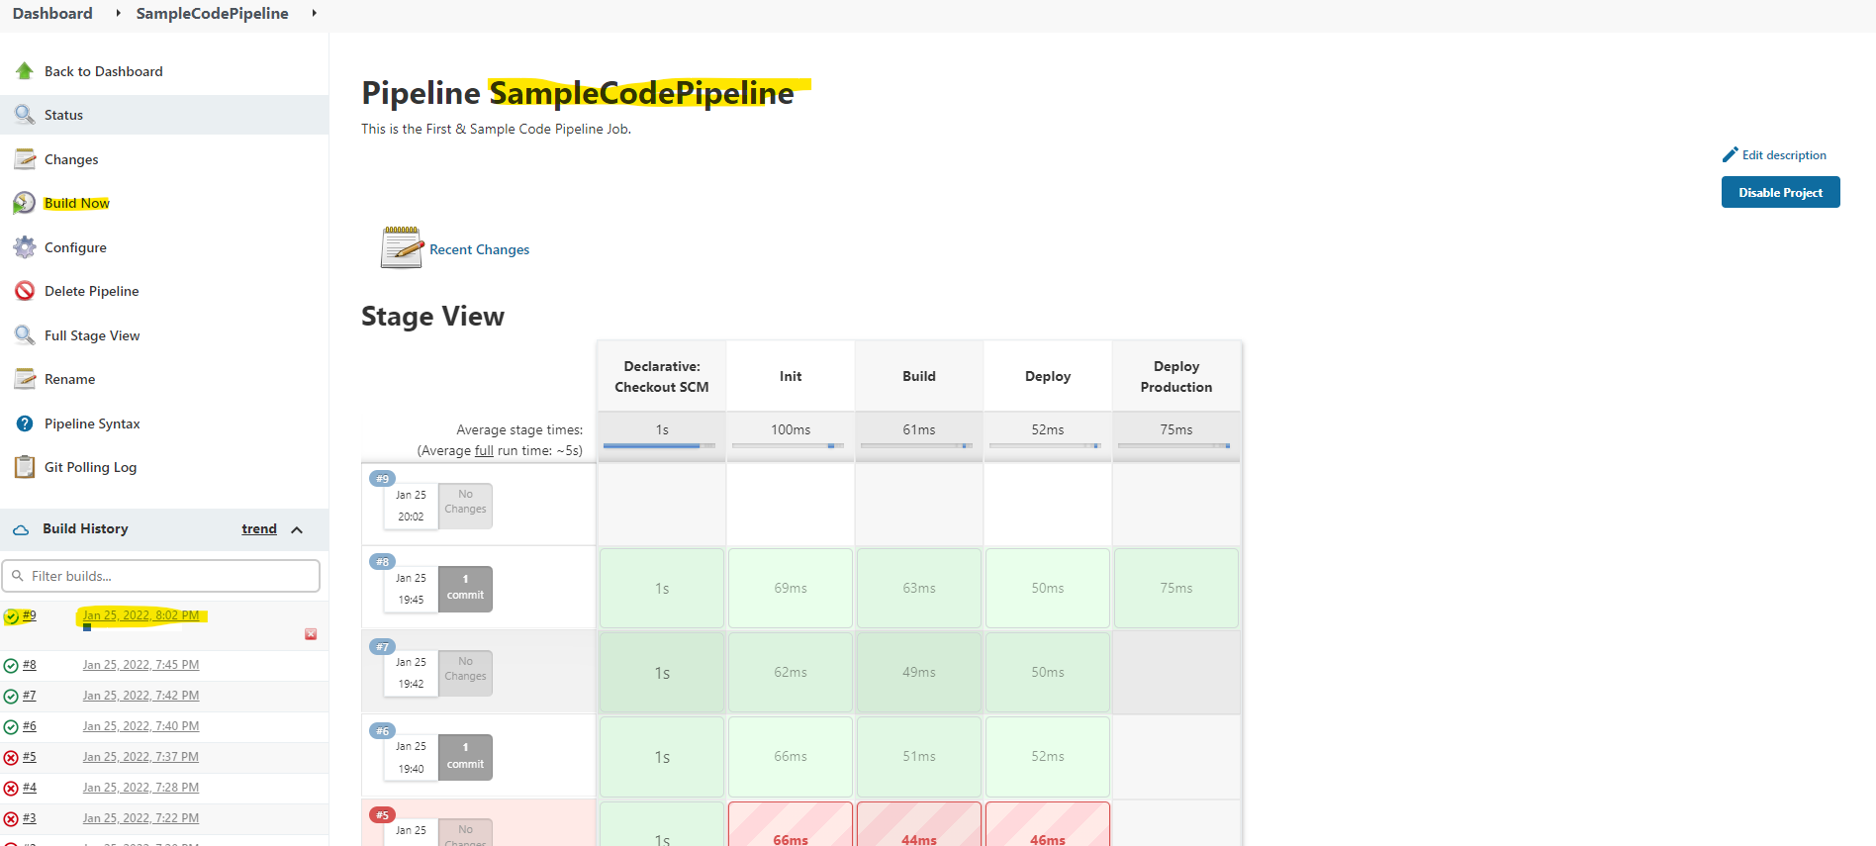

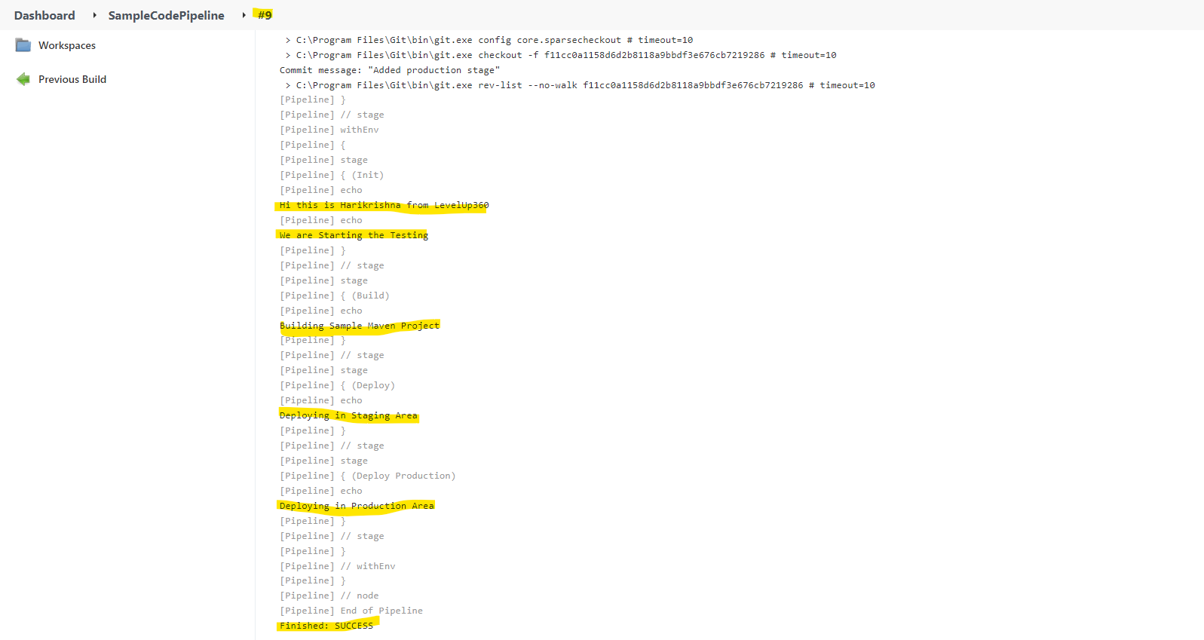

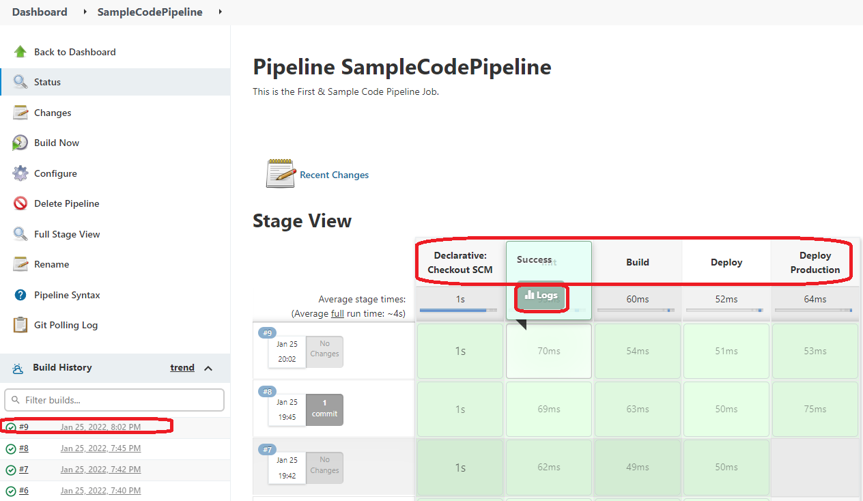

**Jenkins Build whole pipeline (Deploying the application to stage and production using DSL)**

Now we are going to build a complete pipeline to deploying the application to stage and production through a Jenkins by using DSL language.

We are going to build a Jenkins Job with the name “Package Application Code Pipeline” which will pull the code pipeline Groovy file. Through this file we will call the Jenkins job “Deploy_Application_Staging_Env” and deploy the application to stage Environment, also by using another job “Deploy_Application_Prod_Env”, we will deploy the application on production environment. But before deploying the application on production we will ask for an approval, once it approved only it will deploy the application on production instance.

Jenkins Groovy files can be downloaded from the GitHub location

<https://github.com/harikrishna83/Jenkins_Upgradev3/blob/master/java-tomcat-sample/Jenkinsfile>

Now we will build the Jenkins Job “Package Application Code Pipeline” as shown below, this job will package a tomcat war file as artifact.

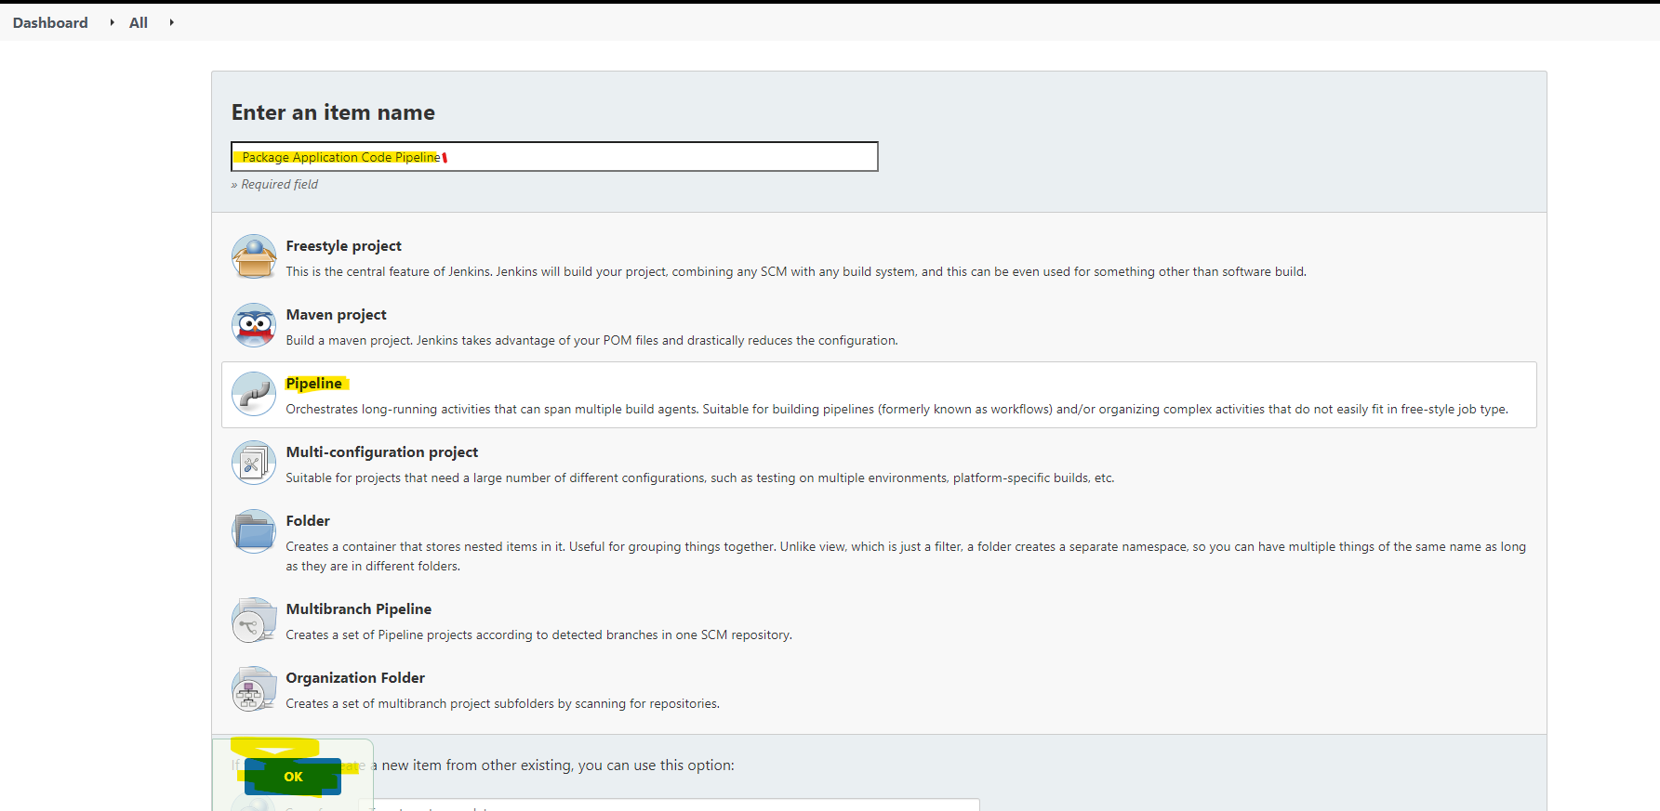

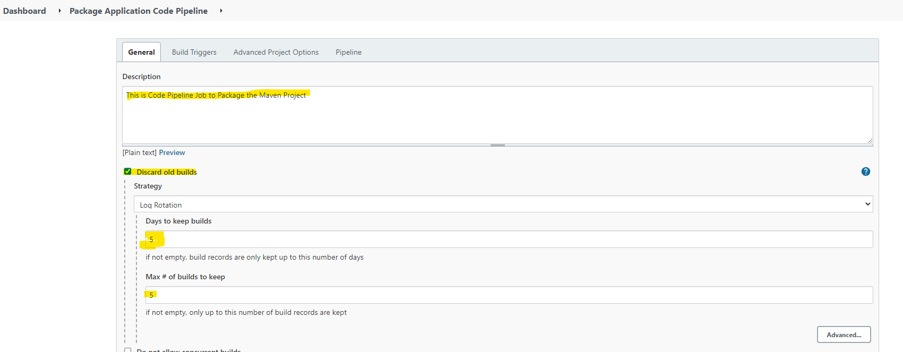

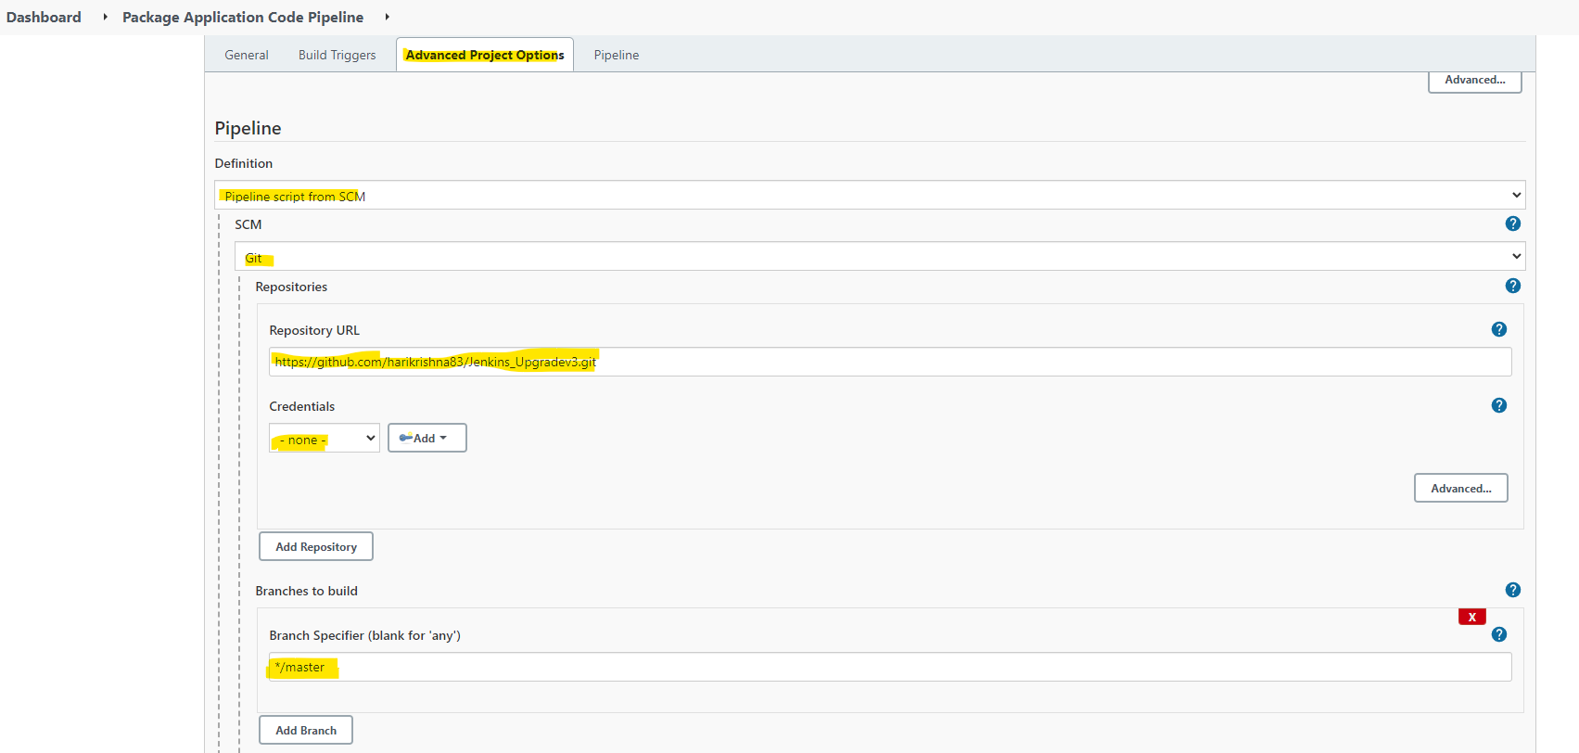

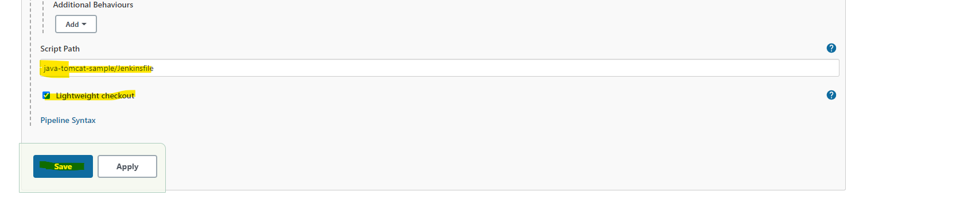

On the above Jenkins we had placed the script file at the location “java-tomcat-sample/Jenkinsfile”

The following is the script it is going to download from GitHub.

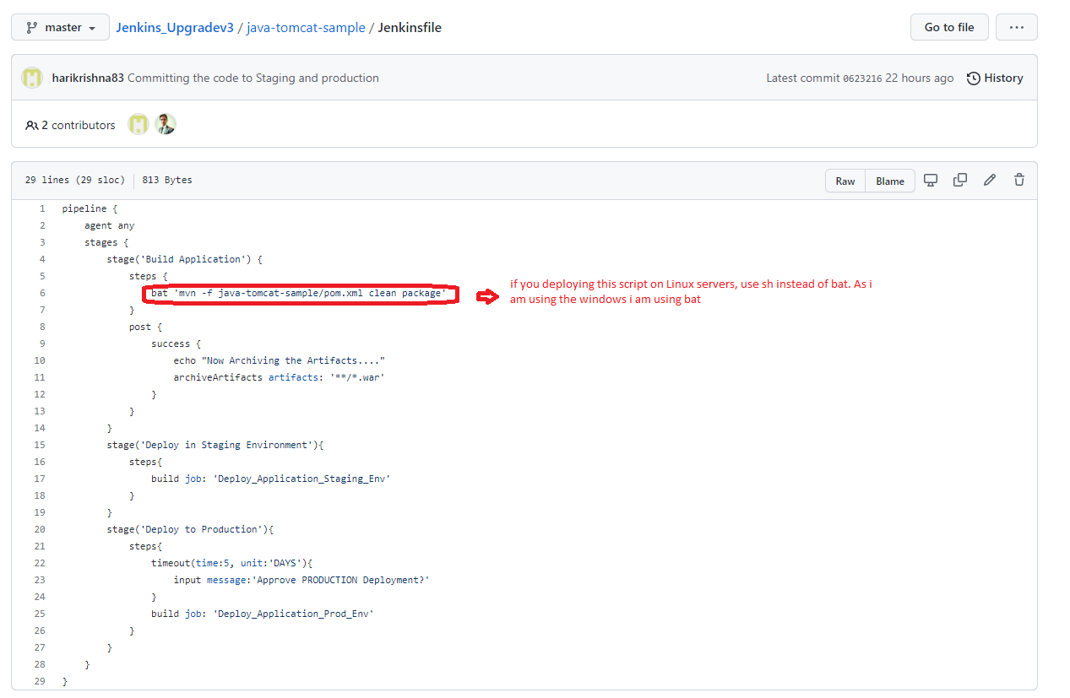

As we had used the below jobs on the script to deploy the application on their respected tomcat containers, modify those jobs to uses the artifacts generated by the code pipeline and deploy it.

Jobs:

1. Deploy_Application_Staging_Env 🡪 to deploy the app on stage Env
2. Deploy_Application_Prod_Env 🡪 to deploy the app on production Env

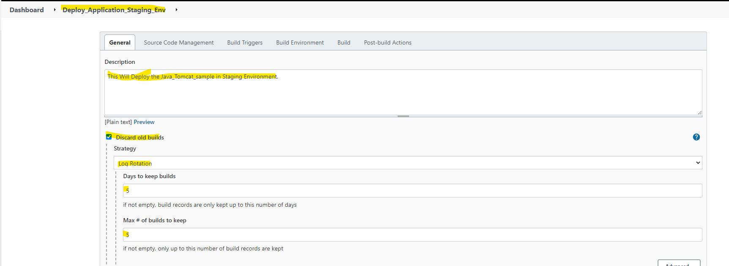

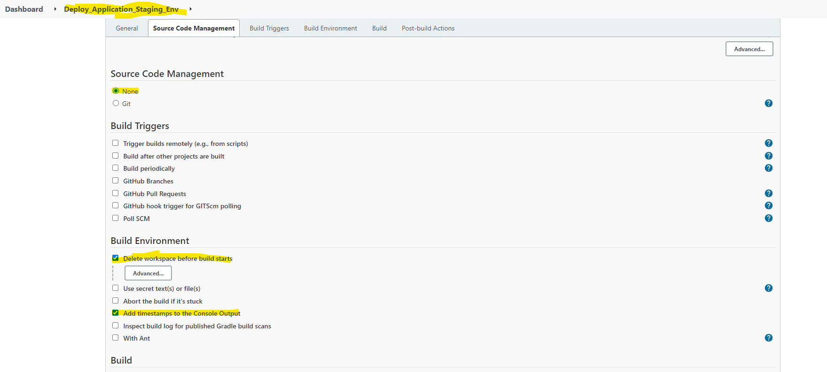

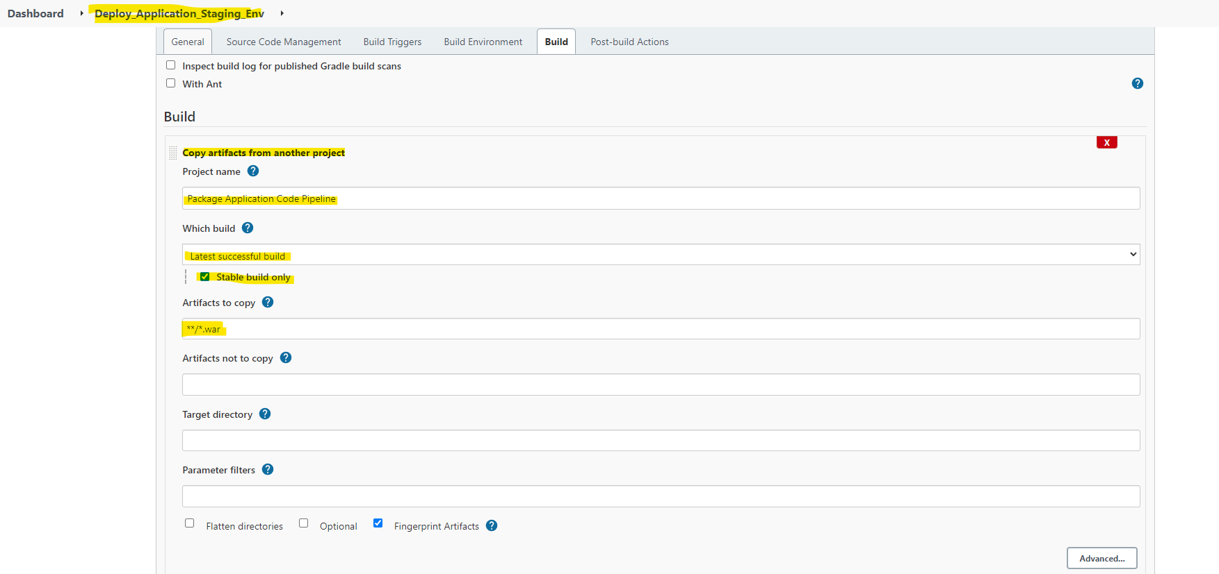

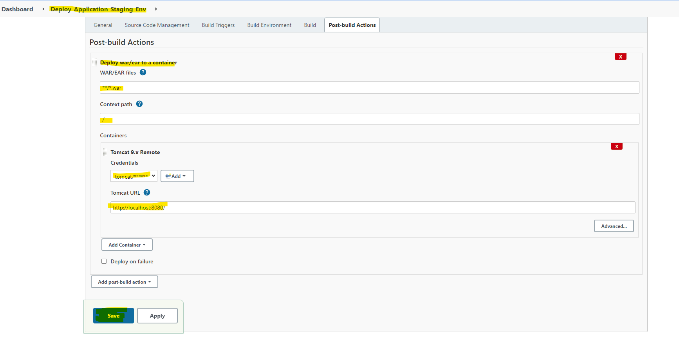

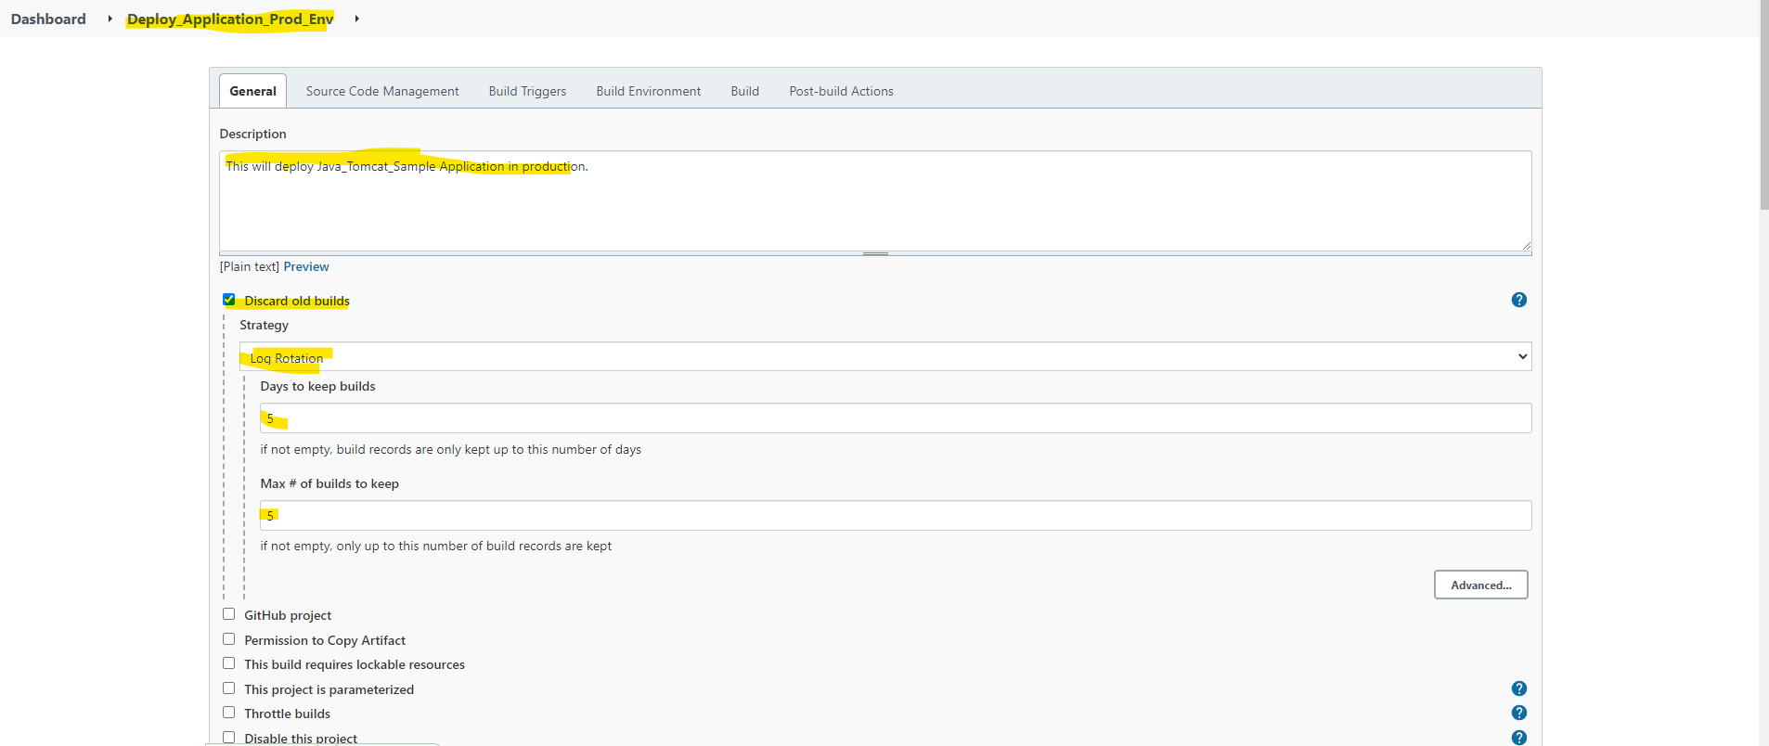

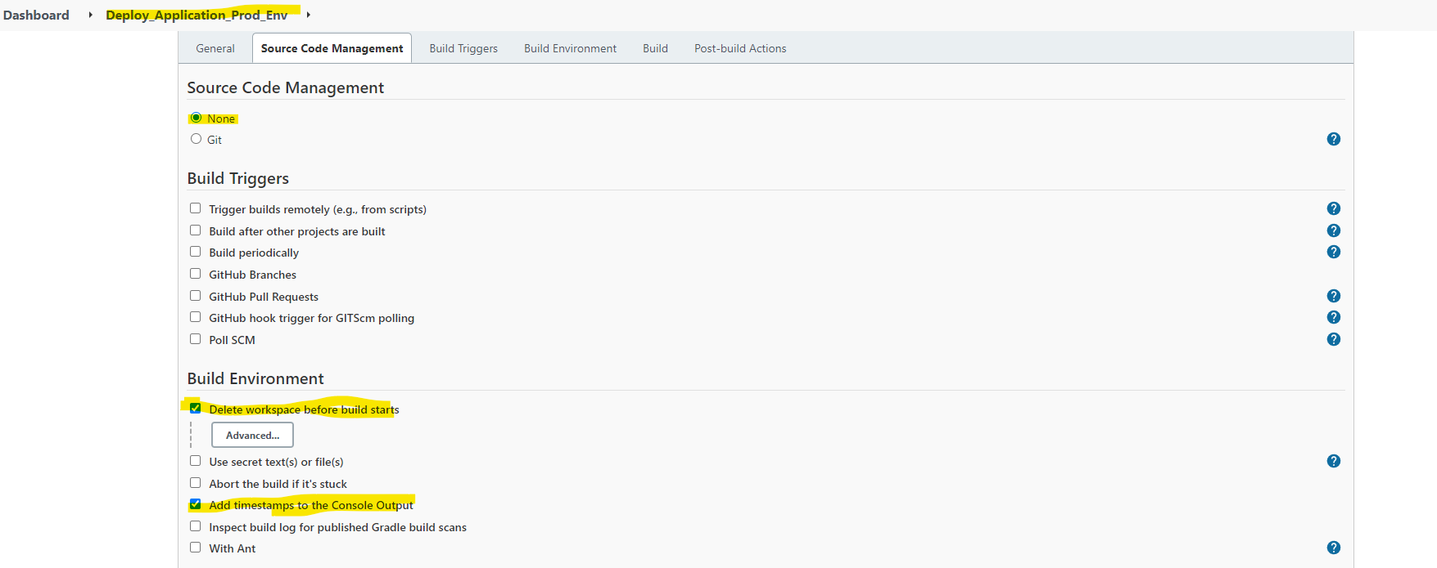

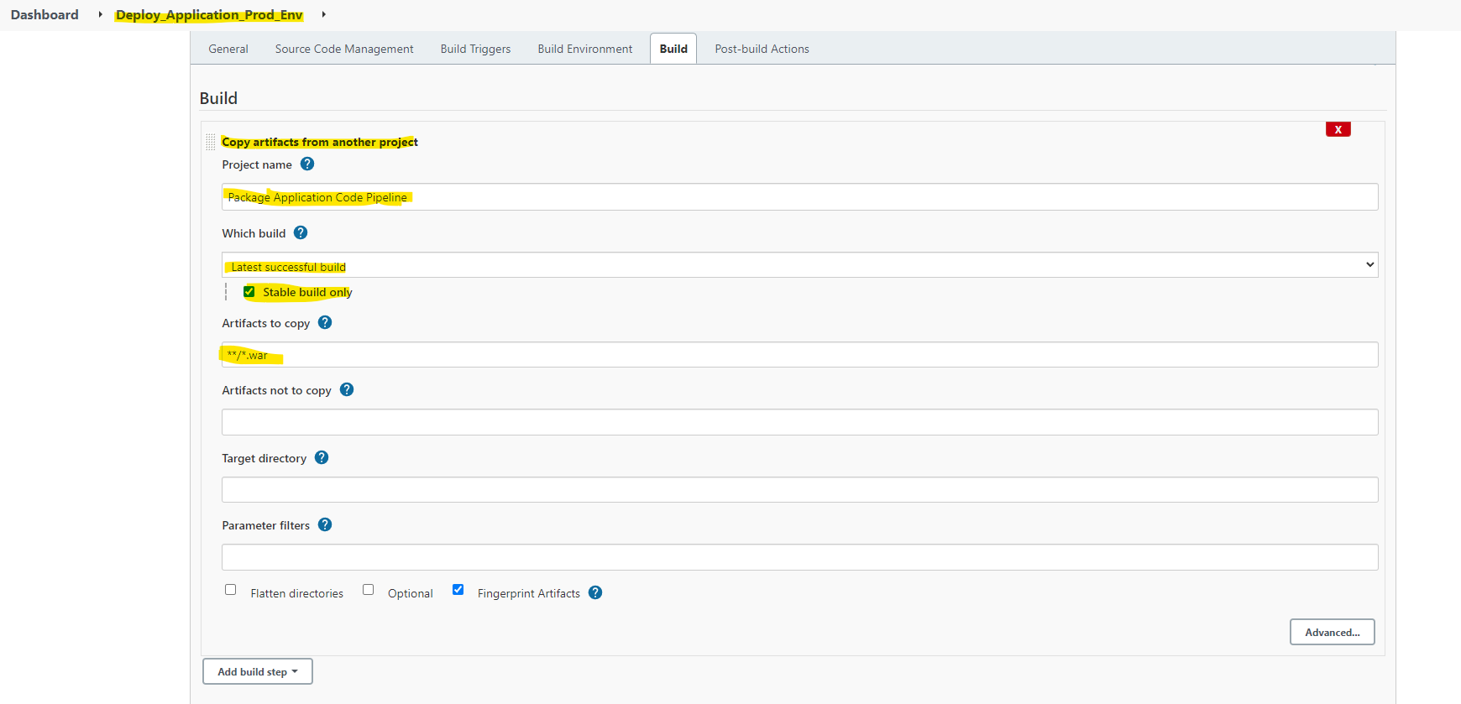

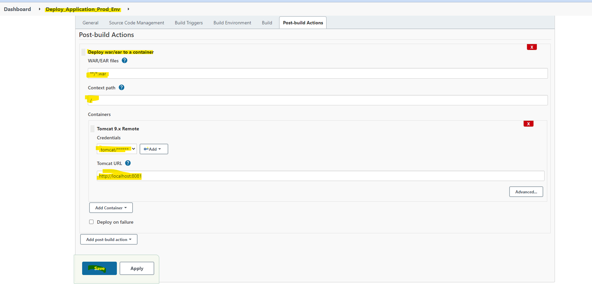

Now we had configured both build to use the pipeline, copy the artifacts and deploy the application to stage and prod.

Now go the Jenkins Job “Package Application Code Pipeline”, build it and see how it goes.

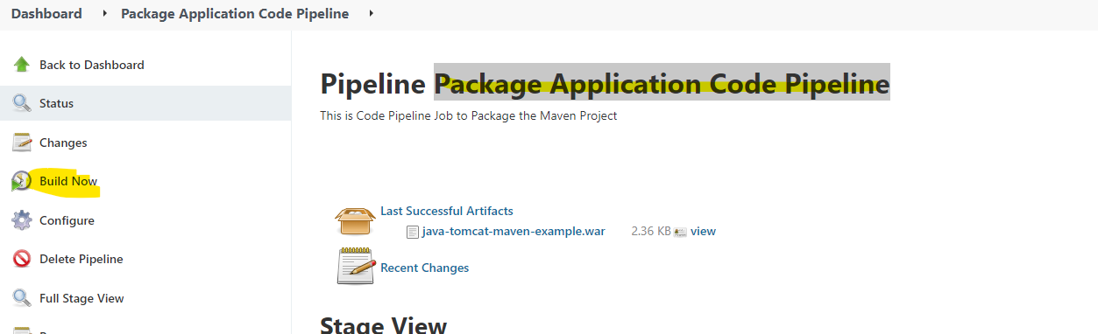

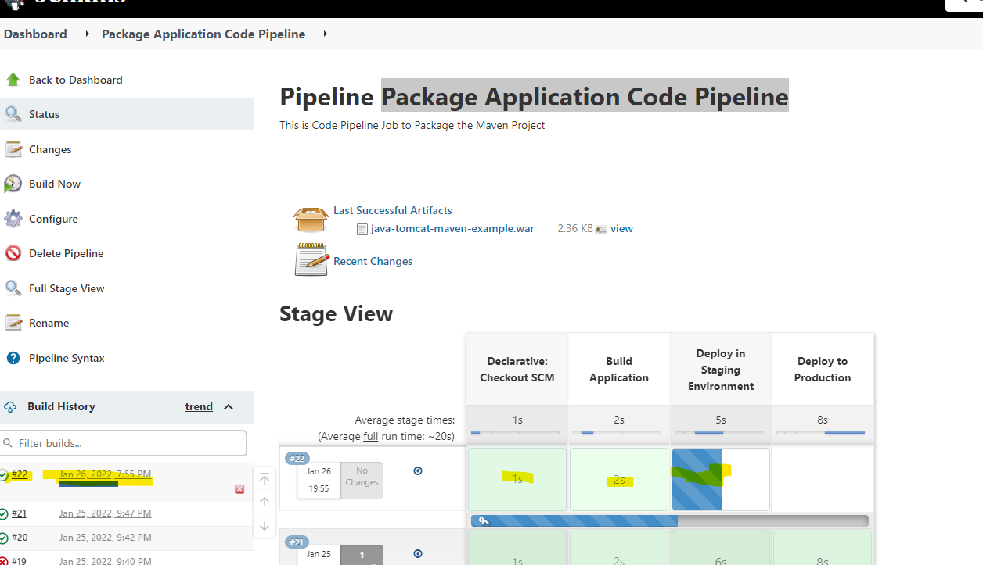

Once after completion of deploying on stage, it’s asking for approval to implement it on production.

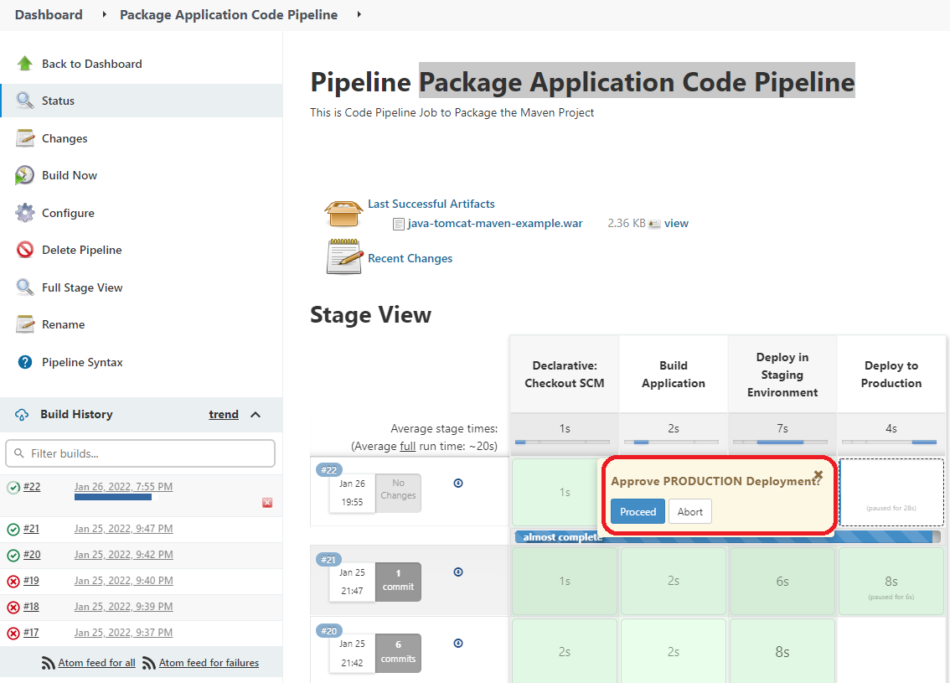

Once approved, it will proceed to deploy it on production.

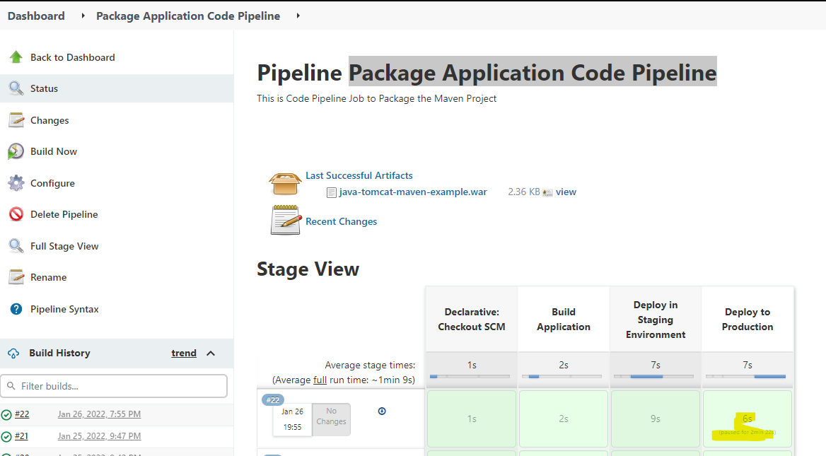

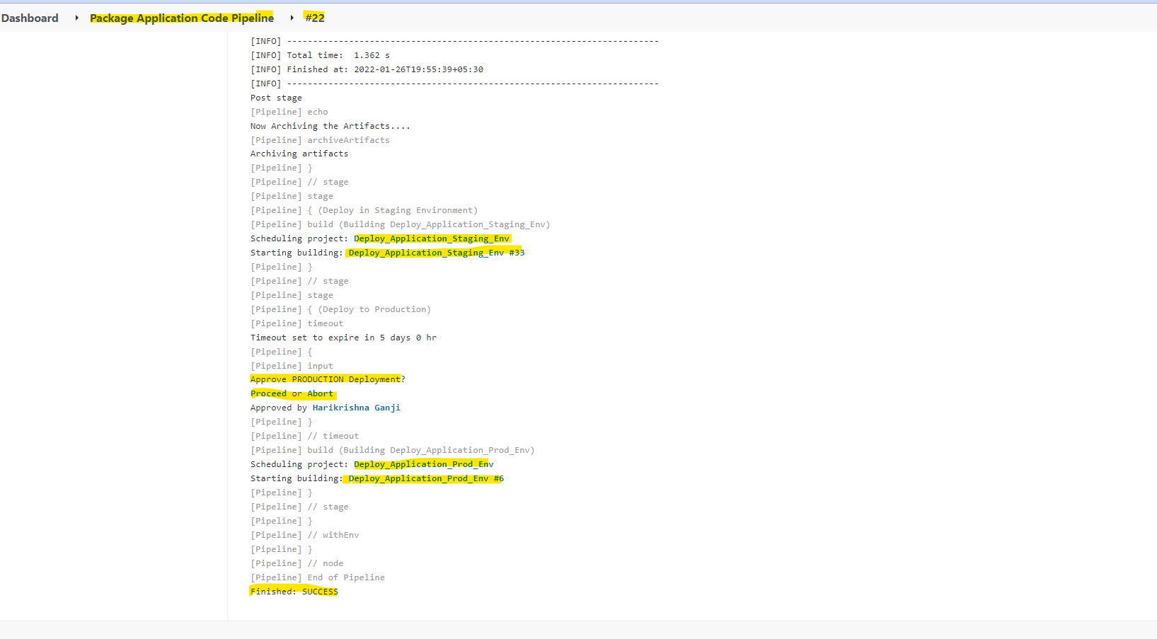

**Configuring Distributed build (Master-Slave) Builds on Jenkins:**

Up to now we have only the master node which I installed and configured the Jenkins on windows platform, whatever the builds we had configured it will be execute on master node. But if the environment grows longer this master node itself won’t suffice we need to build a slave nodes which had Jenkins slave java executors, which will be run the jobs on behalf of master. The master will collect all the reports and show it to user.

For I had built a Ubuntu machine (192.168.29.143) which acts as slave.

Master Node IP: 192.168.29.78 🡪 Windows box

Slave Node IP: 192.168.29.143 🡪 unix Ubuntu machine.

In order to make this Ubuntu machine, first we need to configure the password less SSH from master server to slave.

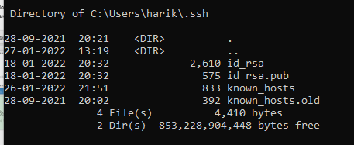

On slave machine:

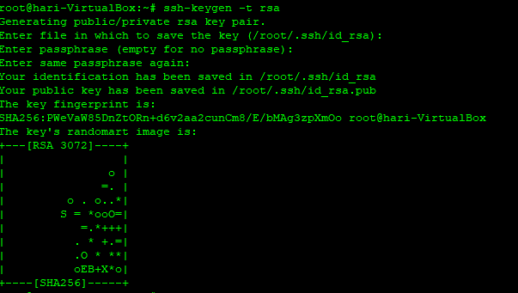

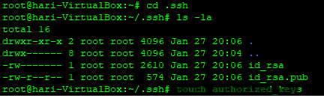

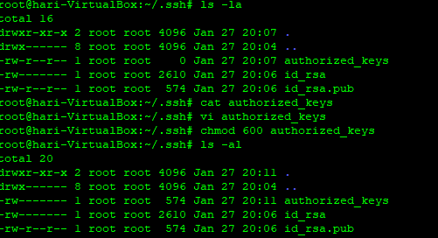

Now copy the public key of windows machine to authorized_keys file.



Now make sure you are able to login to unix slave without any password from master server.

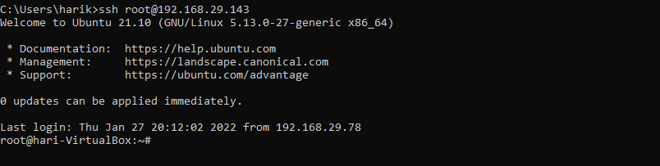

On the slave machine create a bin directory on /root folder and download slave jar file from master node.

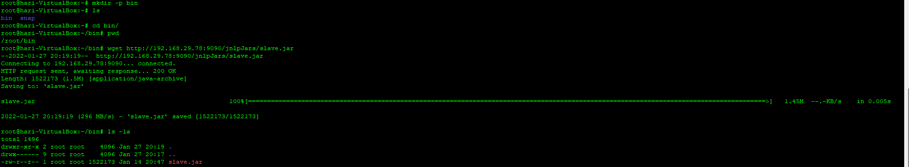

We need to make Java 8 needs to installed on slave machine. For my machine it’s not installed and we will be installing now.

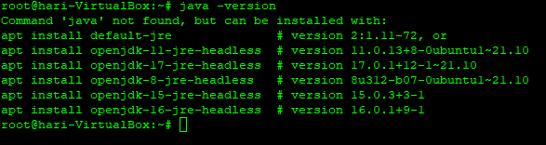

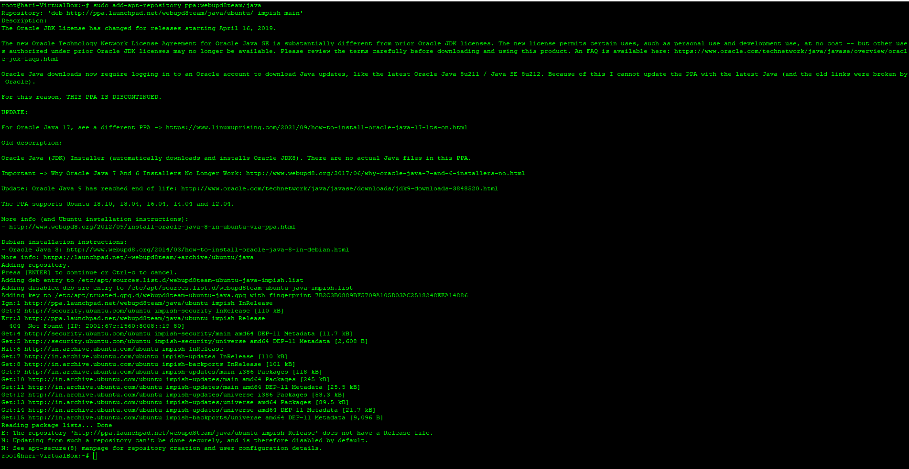

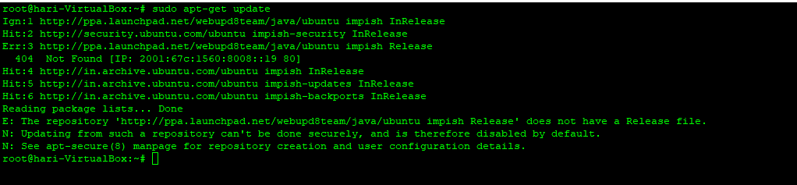

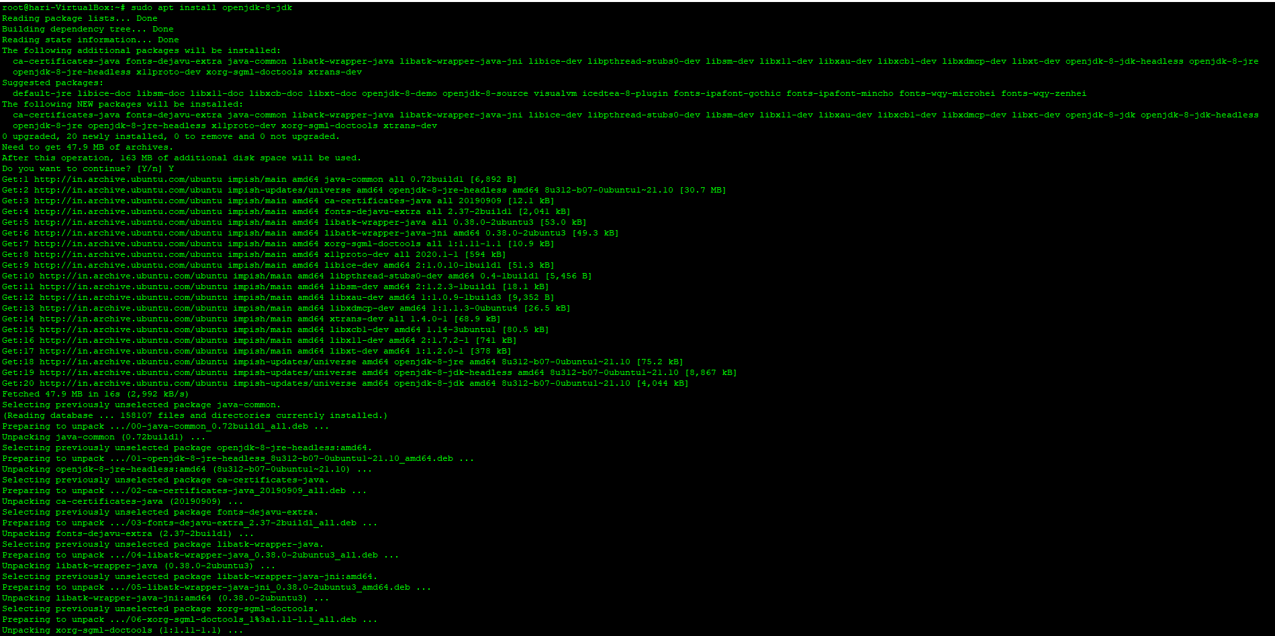

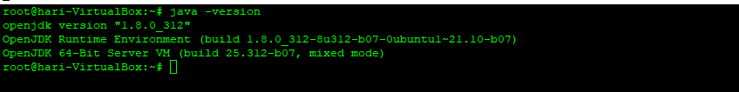

Now login to Jenkins master and click on “Manage Jenkins”.

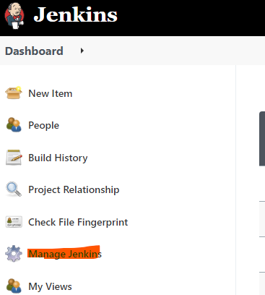

Now click on “Manage Nodes and Clouds”.

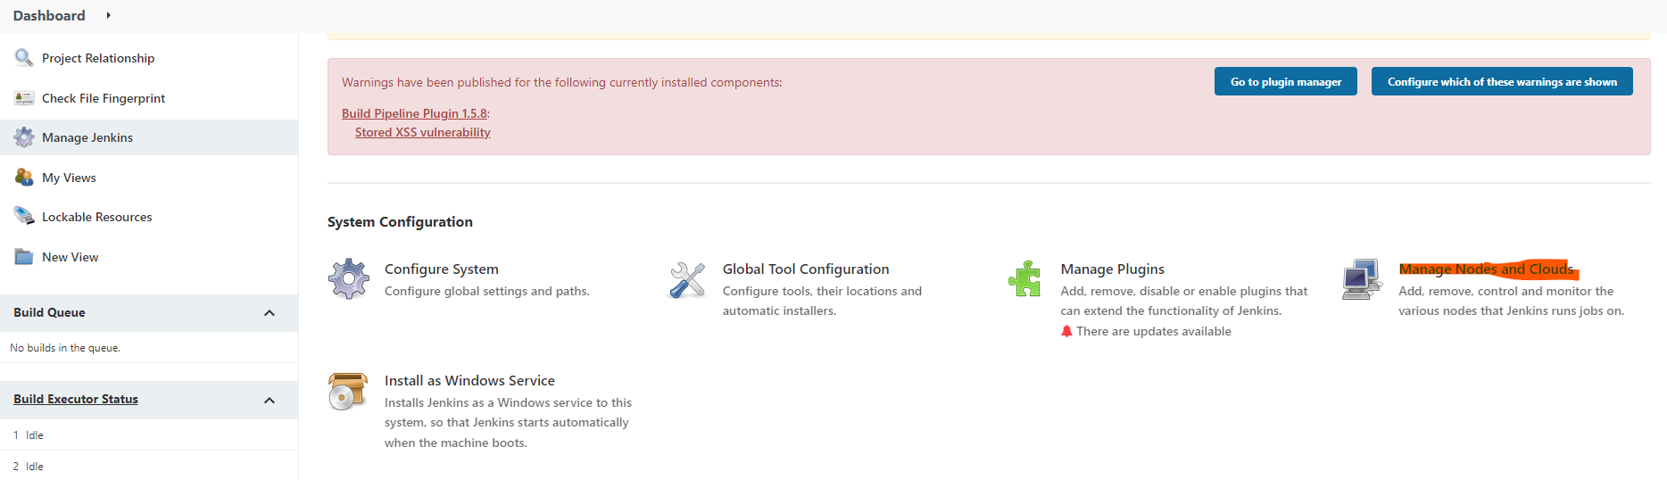

As of now we will the master server a Built-In Node. We need to add the slave node by clicking on New Node.

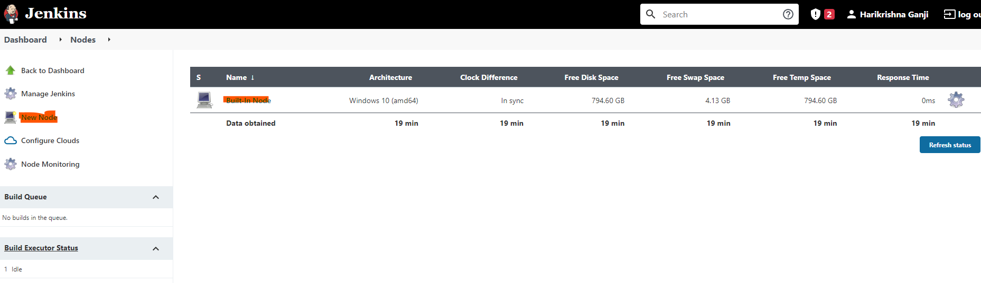

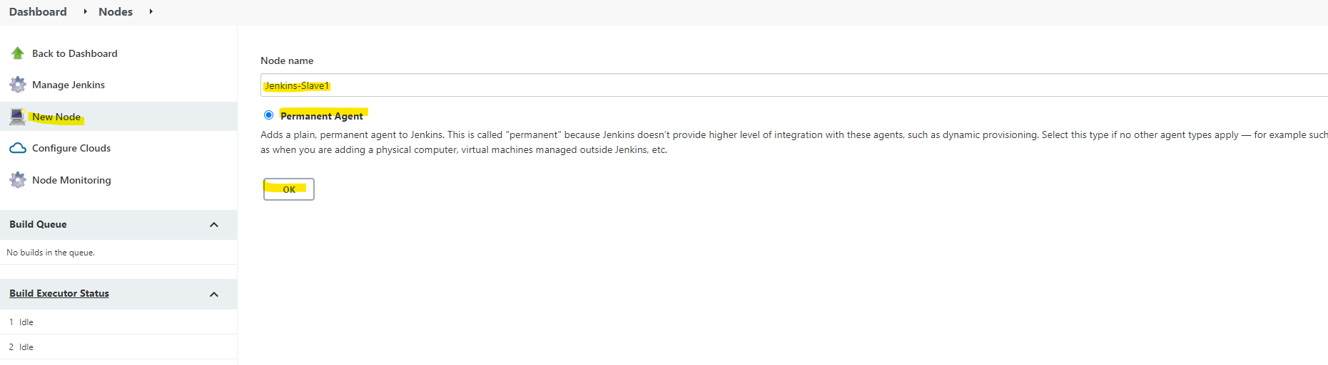

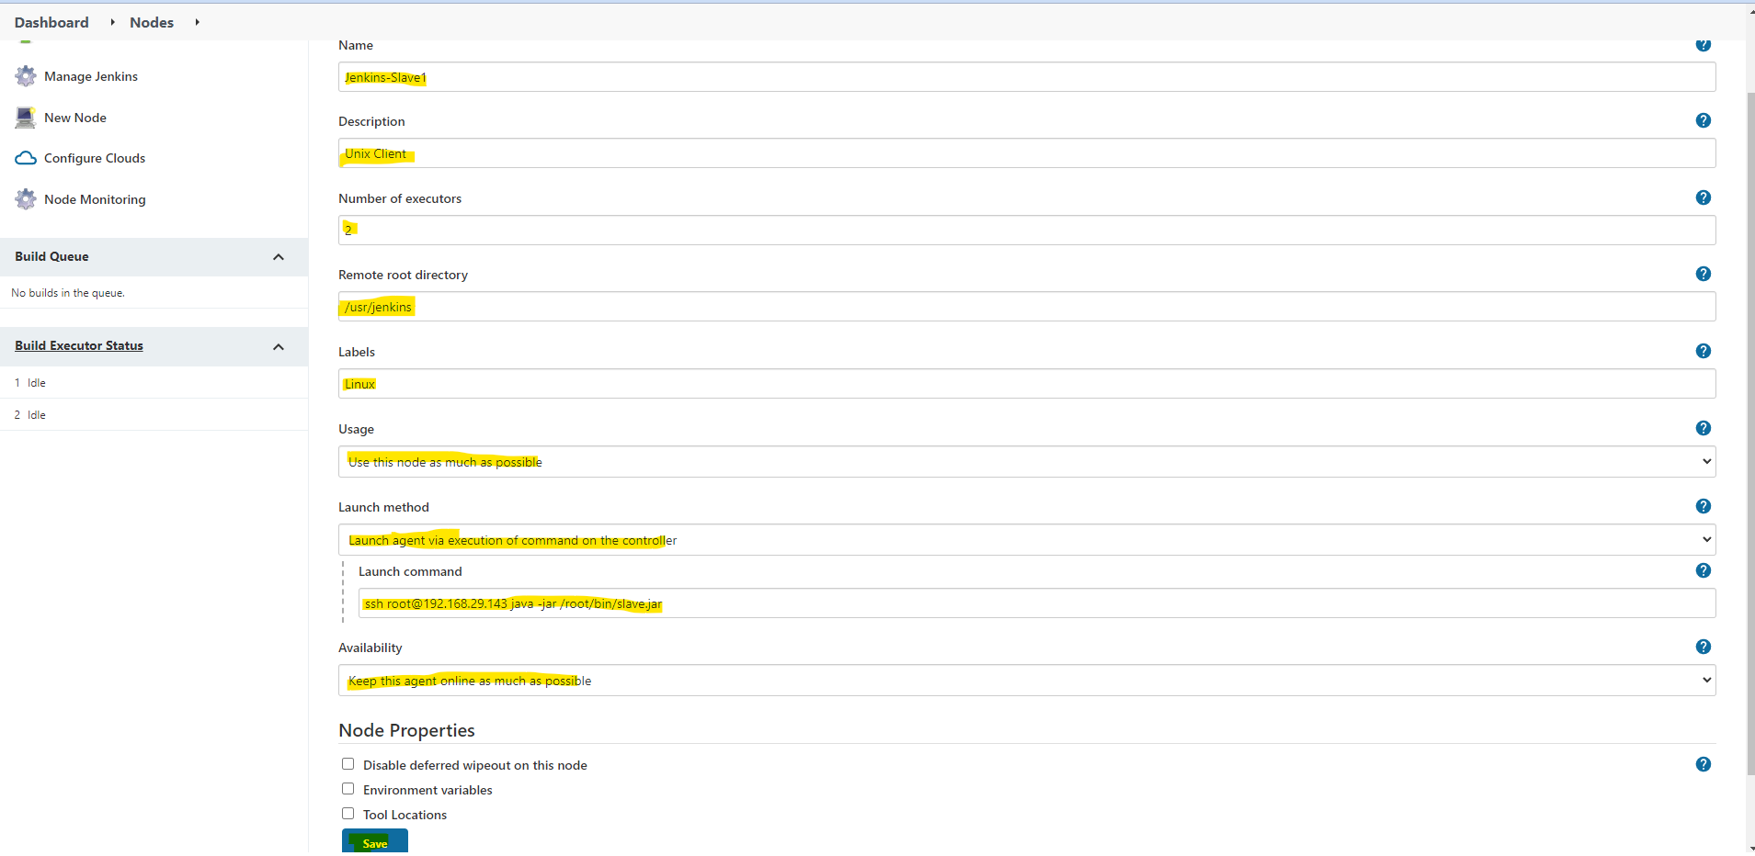

From the above configuration No of Executors depends on cores of your machine, suppose if your machine have 16 cores you can configure 32 executors (which means it will execute 32 parallel Jenkins Jobs on slave node).

Remote directory 🡪 you can mention any directory.

Once you click on refresh status, you find the status of both nodes as shown below.

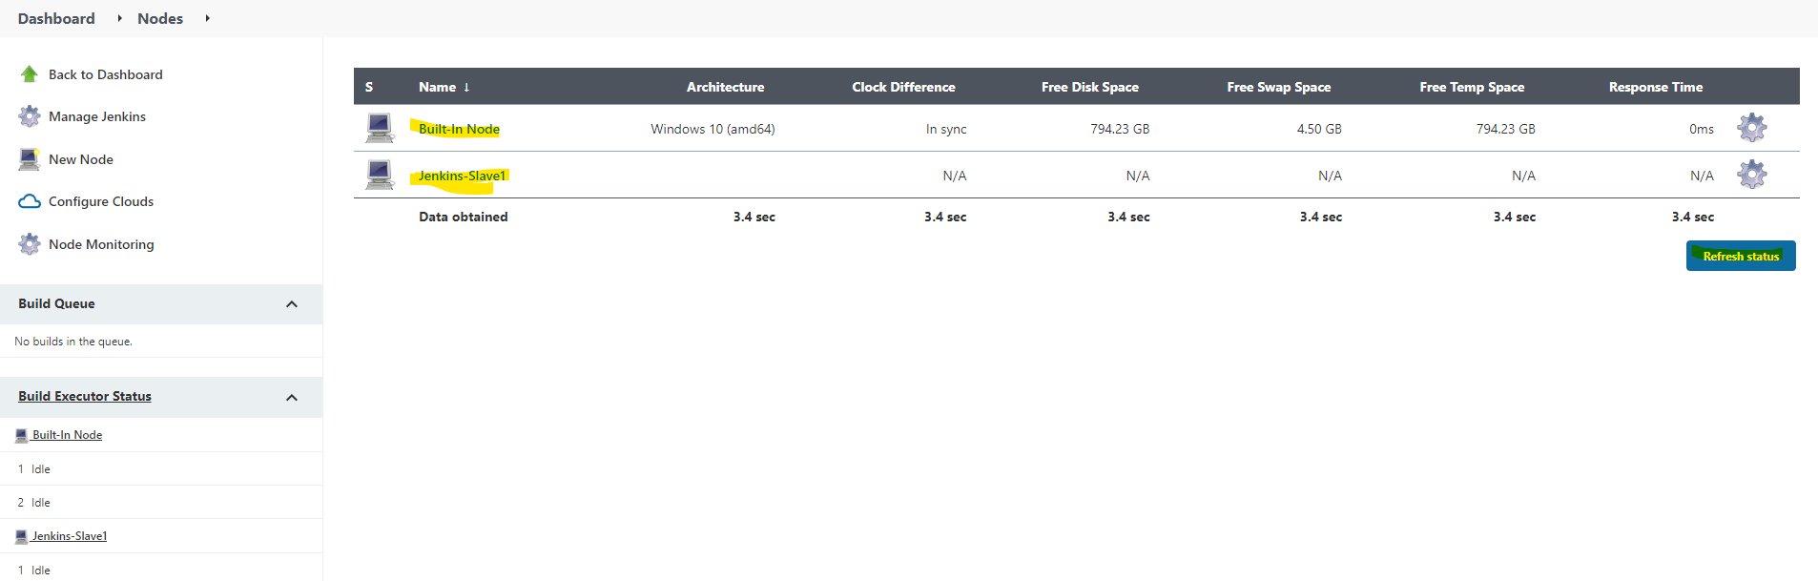

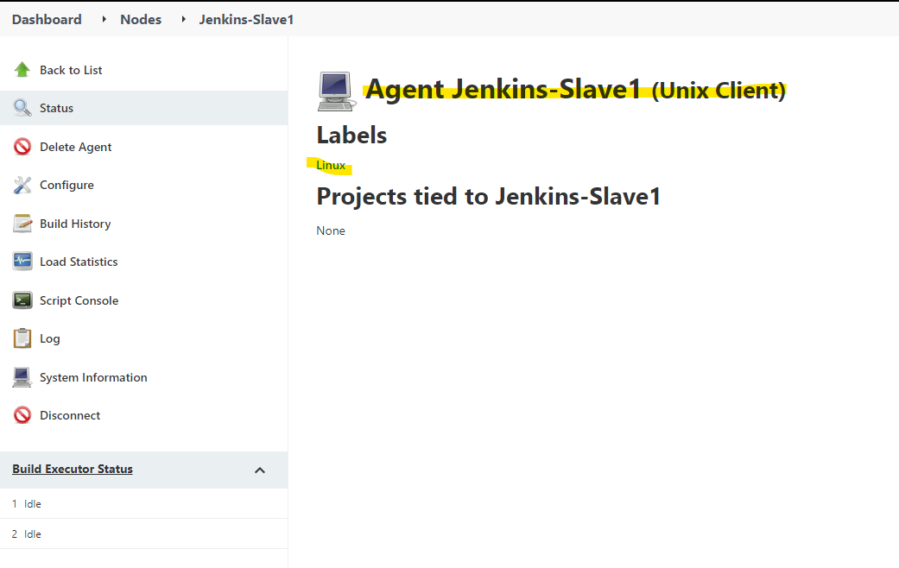

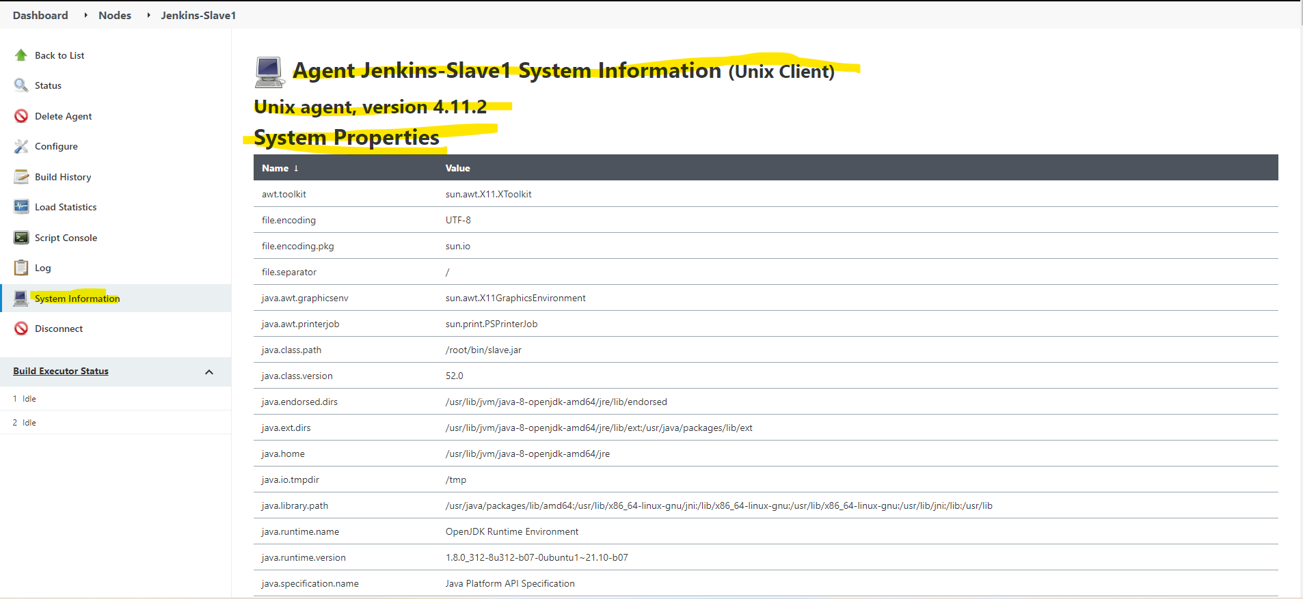

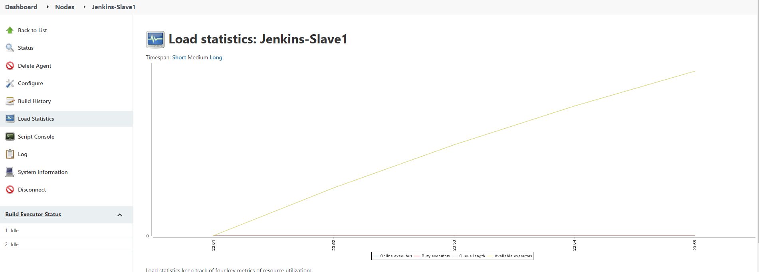

Up to now we had configured Jenkins slave and attached to master node. Now we will create concurrent jobs and see how it will execute on master and slave machine.

Now create a new view with the name Concurrent Jobs and select that view as List view.

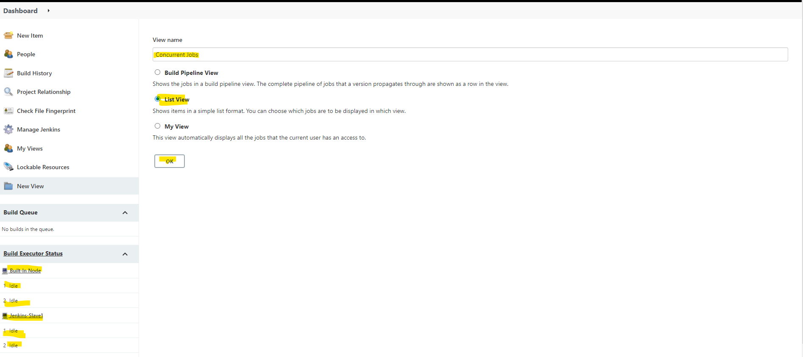

Create a new Jenkins job on this view

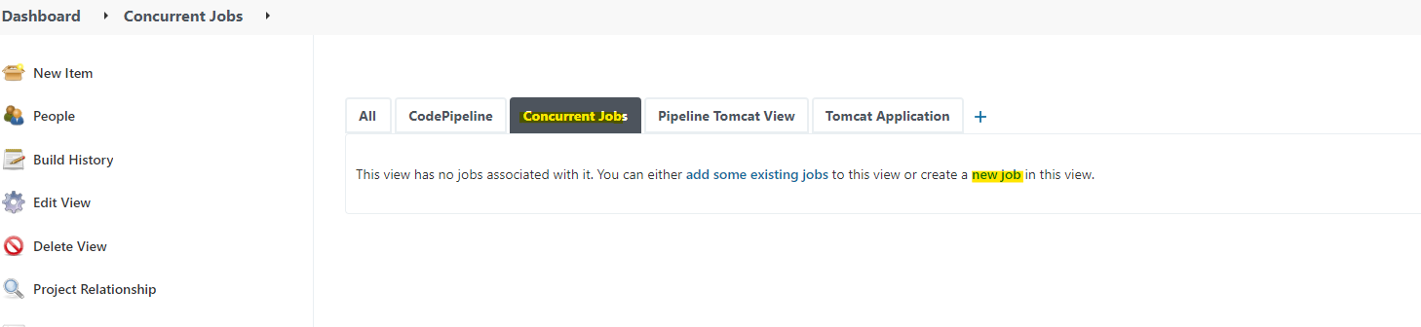

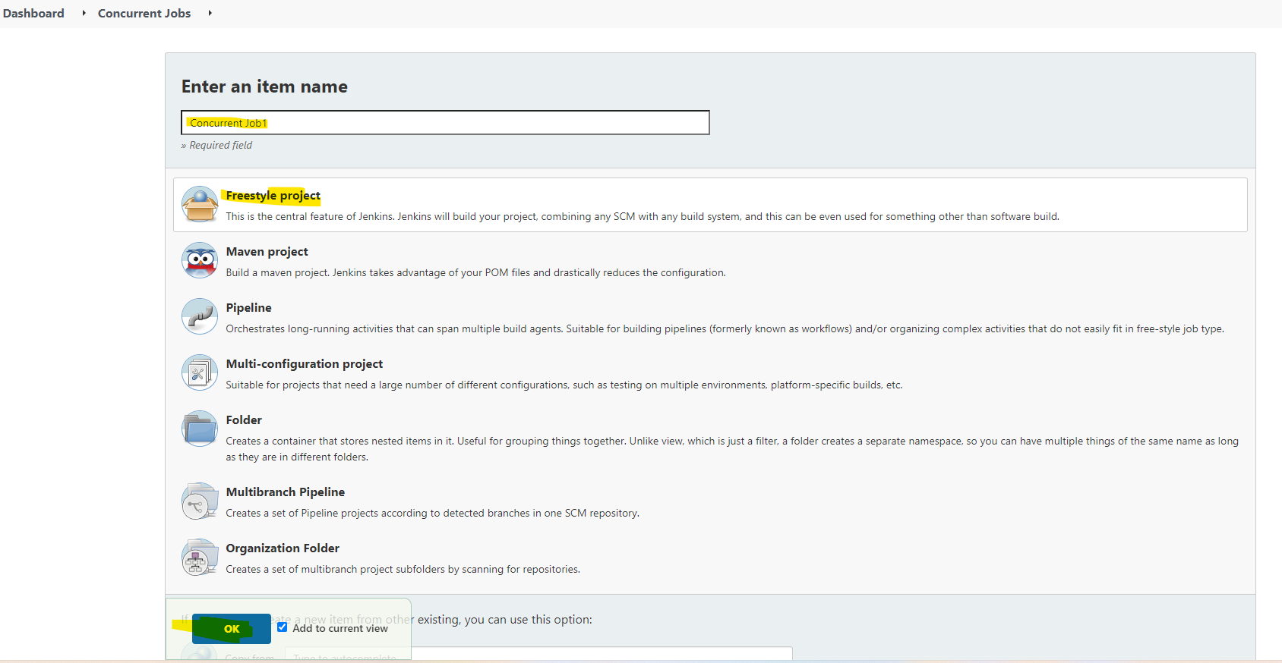

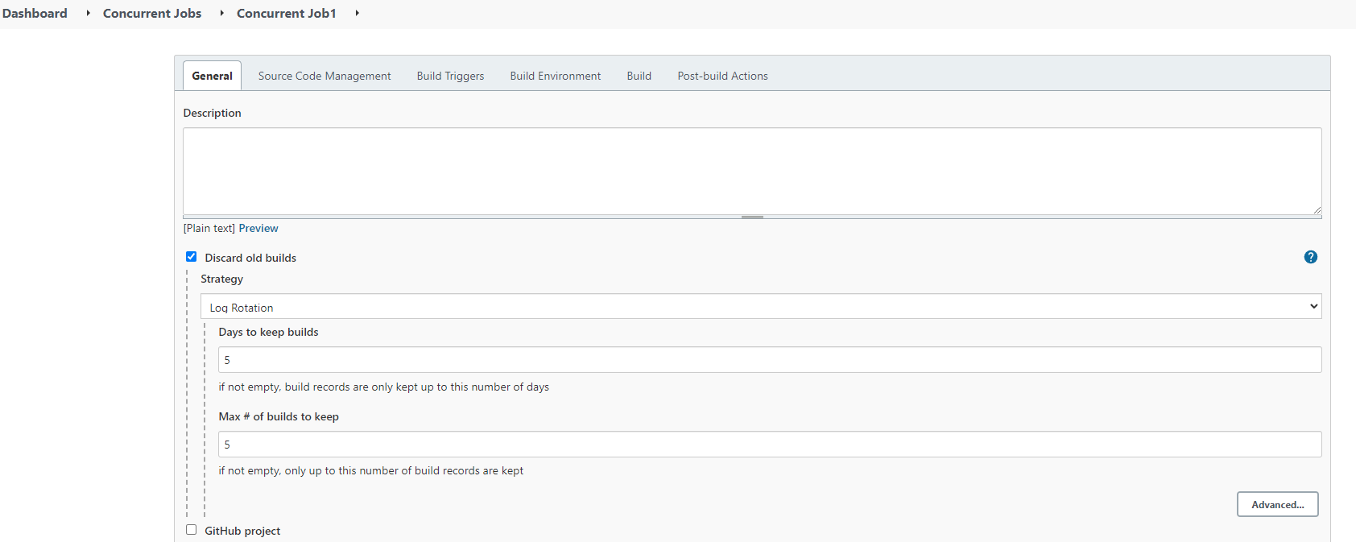

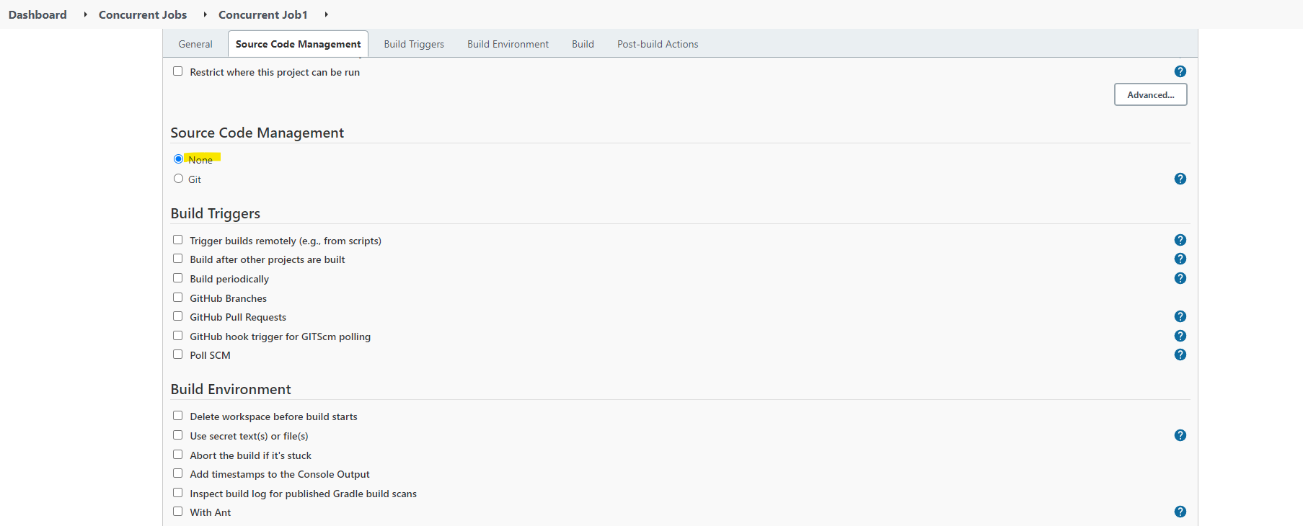

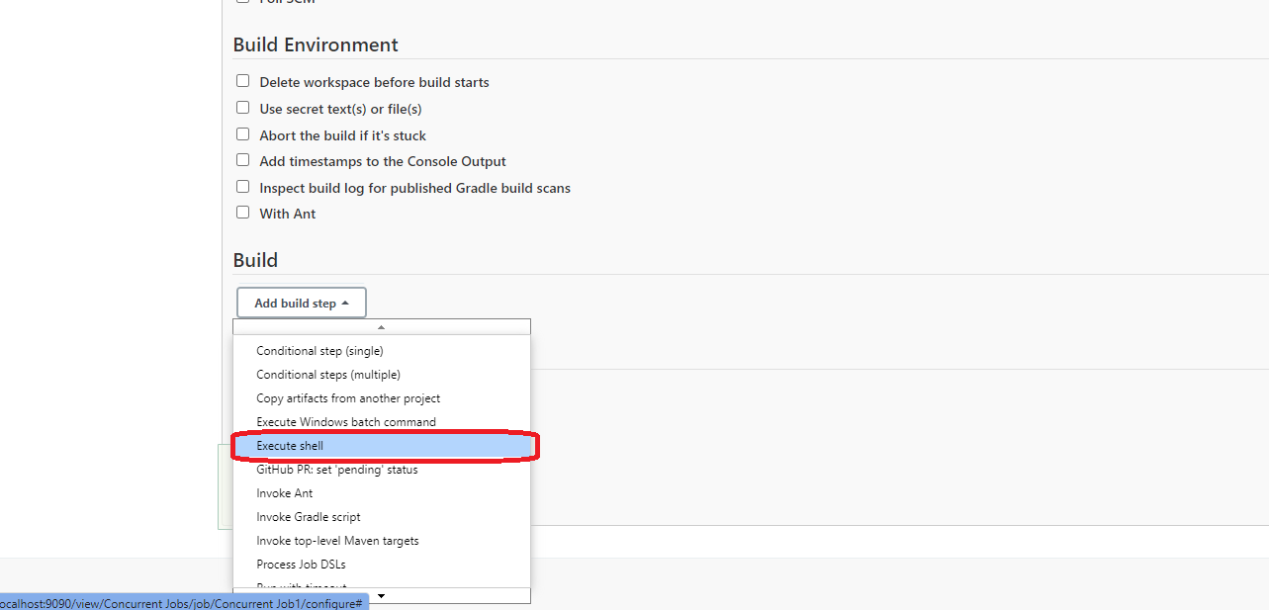

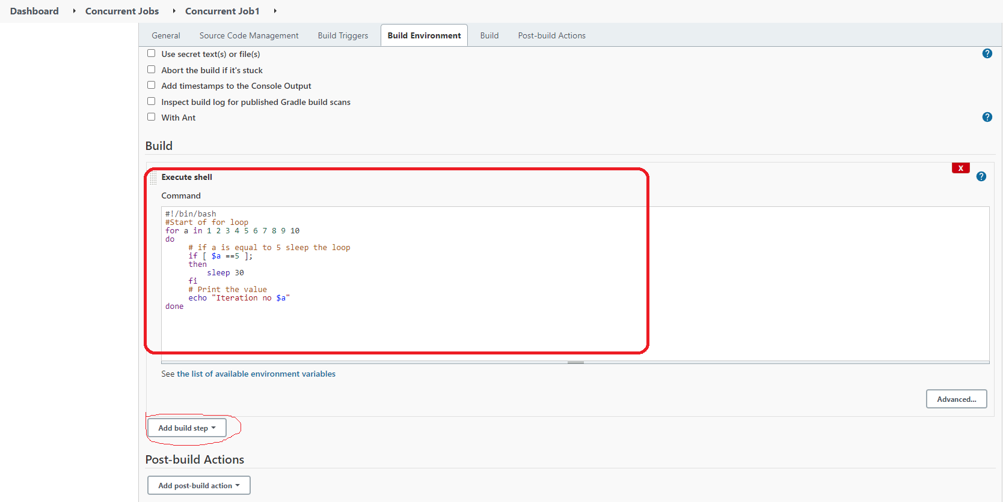

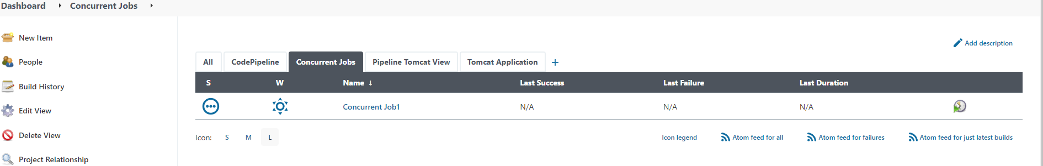

On similar base, I will create another two Jobs “Concurrent Job2” & “Concurrent Job3”

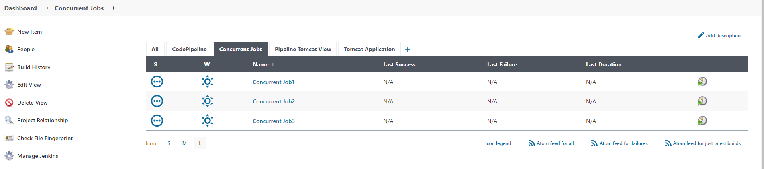

Now I will execute those jobs all of them at parallel time.

Few of them will execute on master and few of them will execute on Salve node. Up to now Master server will decide and schedule which jobs can run in which nodes.

Now you can also restrict Jenkins jobs to execute it on particular servers or a node.

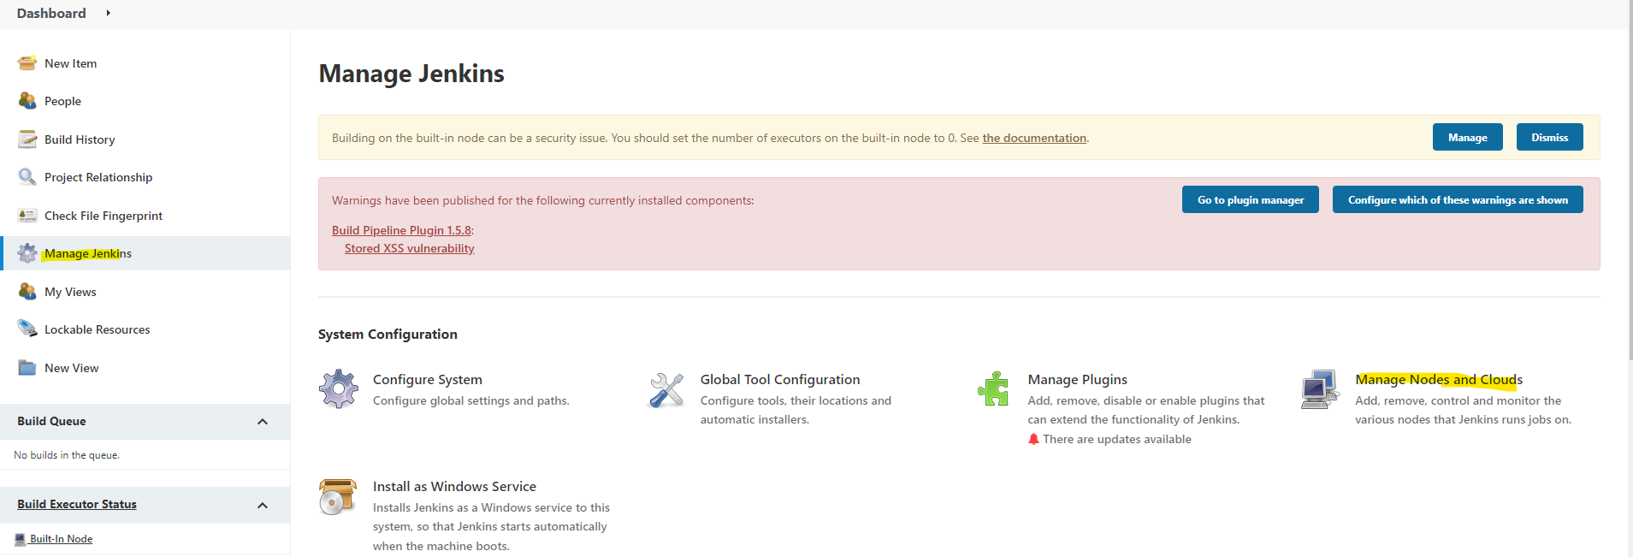

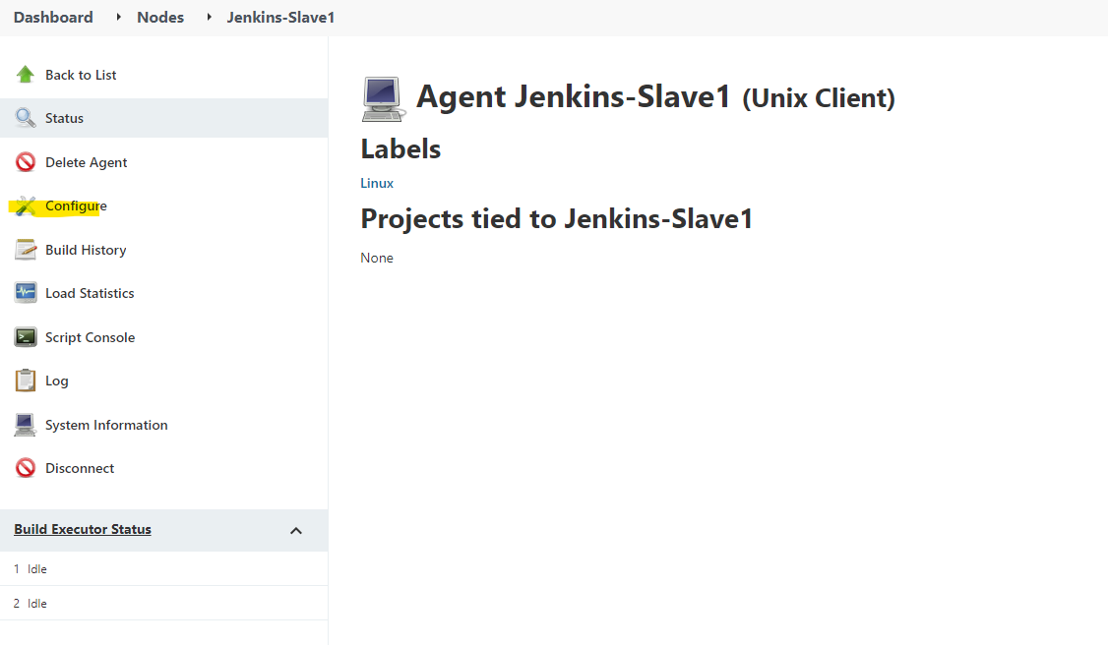

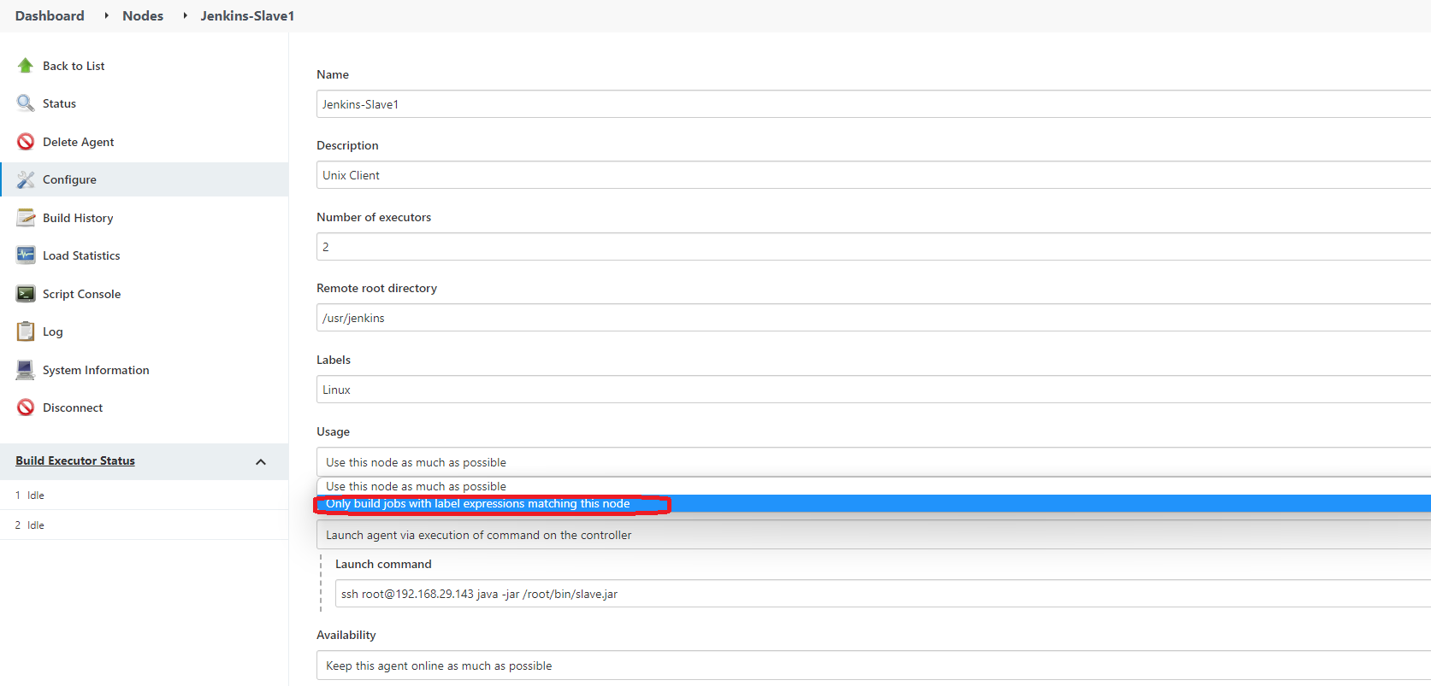

Now configure the jobs to check the label and execute on that node

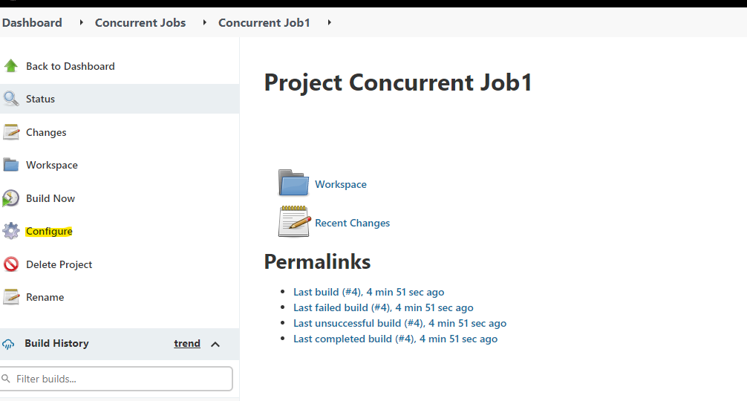

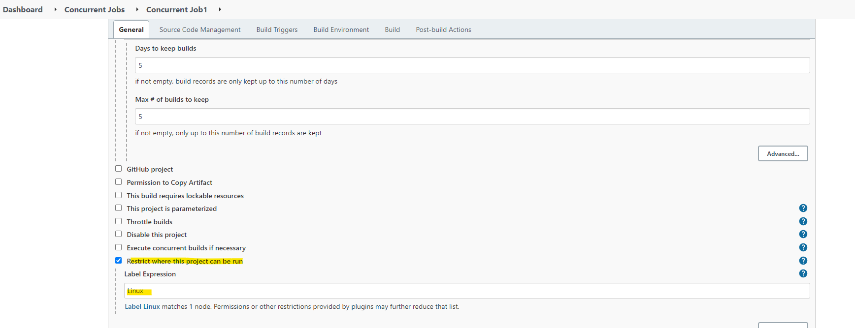

Now do the same for other Jobs also.

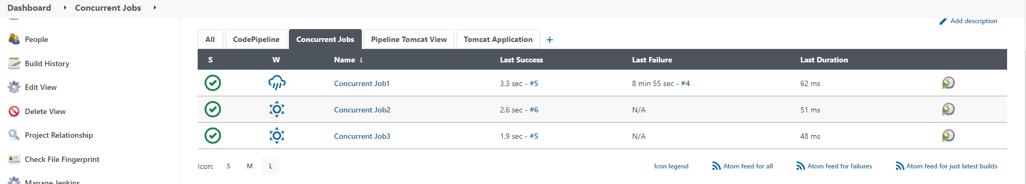

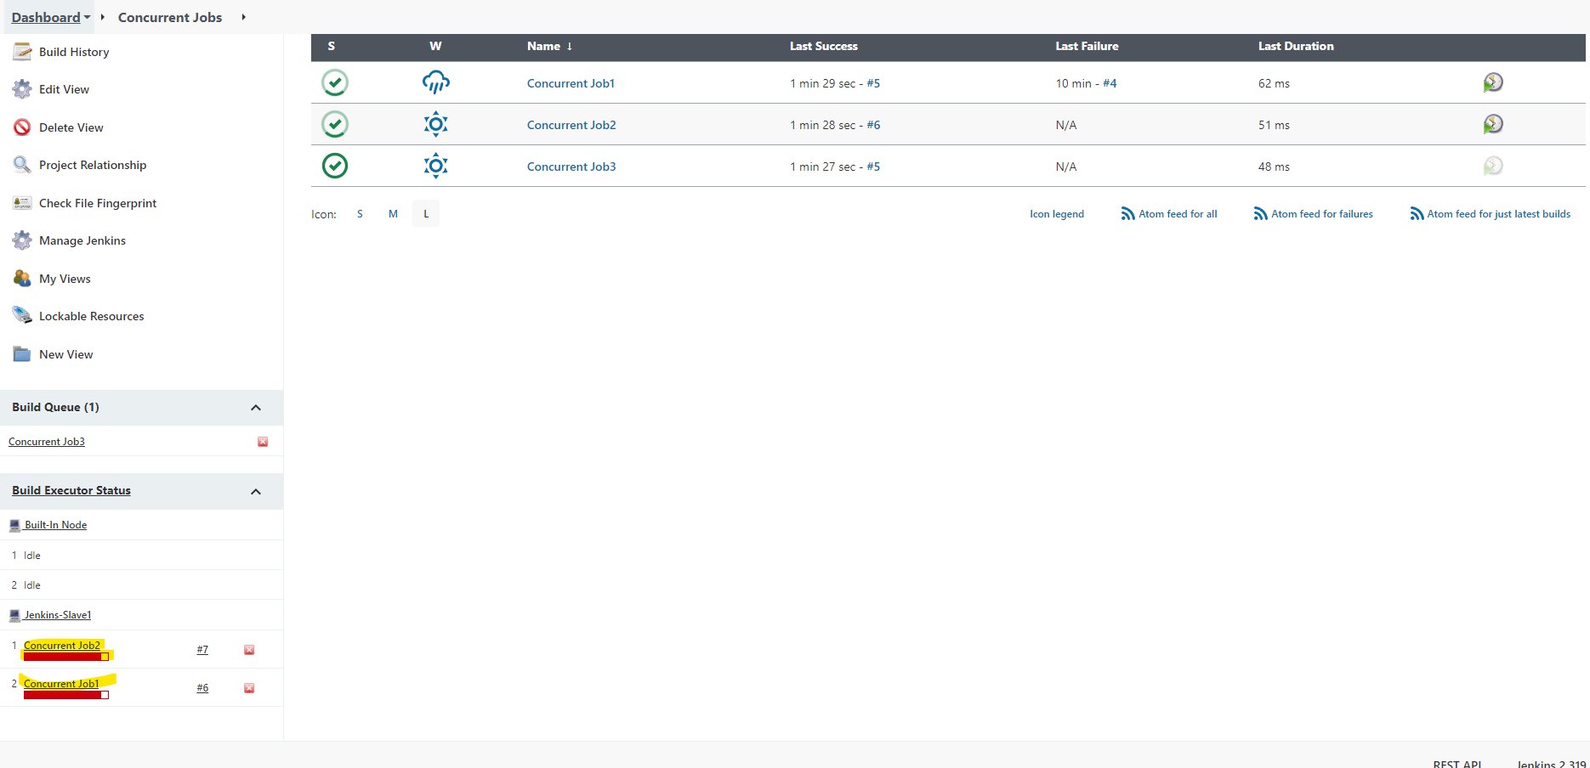

As of now there are only two executors on slave, it is executing 2 jobs and the third is on queue to execute once those above jobs are completed.

